Project Update: September 2007

During the CONSERVATION OF BLAKC INCA HUMMINGBIRD (COELIGENA PRUNELLEI) AND APOLINAR’S WRENS (CISTOTHORUS APOLINARI) AND TURQUOISE DACNIS-TANAGER (DACNIS HARTLAUBI) IN TENA (CUNDINAMARCA – COLOMBIA) last fieldwork in Tena from 13 July to 11 August, the team conducted the following environmental education activities: (1) Biodiversity Exhibit, (2) Coloring Contest, (4) Face-painting, (see photos in Appendix 1). After the seminar in each region, updates were provided on the conservation action plan which was developed during the community consultations last August 2007.

1. Biodiversity Exhibit ~ 14 to 31 July 2007
Theme: "Natural Treasures of Black Inca Hummingbird” The exhibit featured 6 endemic and/or threatened species found in Tena. Information on the conservation status, distribution, population, ecology, and threats were provided for each species. The booth was visited by people mostly children each day during the exhibit's duration.

2. Coloring Contest ~1-10 August 2007
Visitors at the exhibit were encouraged to join the coloring contest. Crayons and Coloring sheets featuring 6 endemic/threatened Birds wildlife were provided. Colored sheets judged most realistic were given prizes. Judging was done in four age categories: 5-8, 9-12, 13-16, 17-up. This activity was very popular among children and served to familiarize the participants with the appearance of local wildlife as well as develop their artistic skills. 700 coloring sheets were distributed during the duration of the activity.

4. Face-painting ~ 1-10 August 2007
Children considered this a treat and queued to have their arms and faces painted with Birds wildlife designs. The number of volunteers doing the face-painting was however too few that only a few children were able to avail of this.

COMMUNITY CONSULTATIONS

A conservation action plan was developed by stakeholders on Tena last May after a series of consultation activities covering 8 sitios the region. The action plan includes activities that contribute to major goals such as: slash-and-burn farming, providing livelihood assistance, intensifying information and education campaigns, establishing a protected area or sanctuary and strengthening enforcement of environmental laws.

Appendix 1

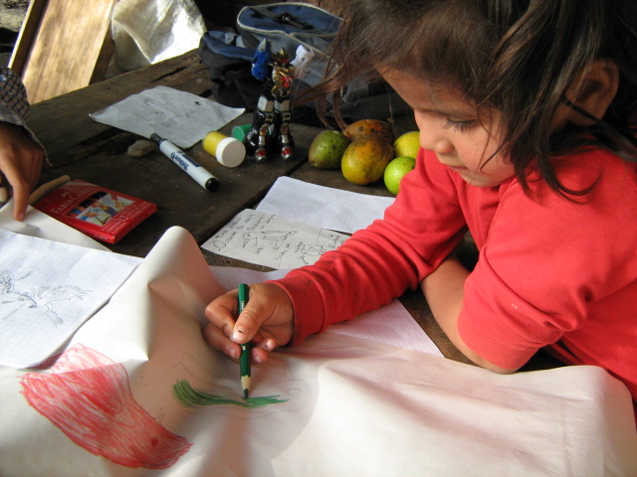

For the first time children had seen how close to the human settlements could be such beautiful, interesting and important species of birds as egrets, herons, swans, geese, ducks, harriers etc. They study how to behave in the nature conditions to watch birds, how to identify species and how to do notes.

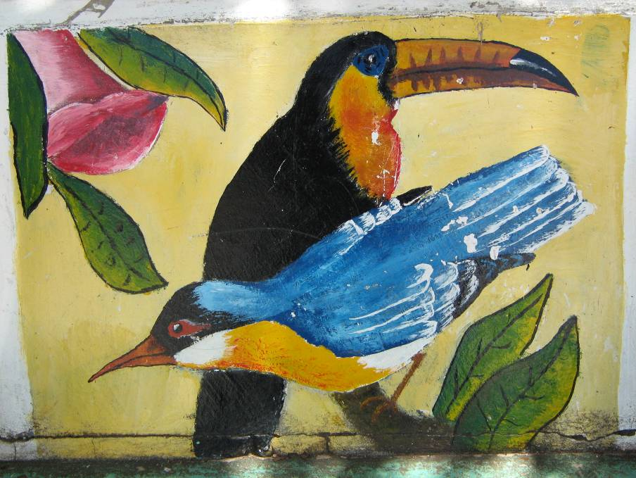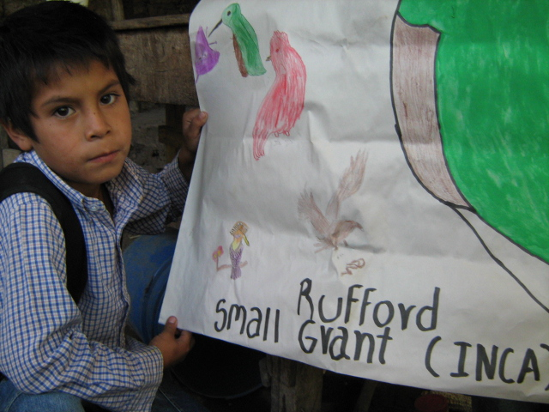

Showing children a slide show of the Awareness campaign among school student
Tena' biodiversity. and teachers

