ECOLOGICAL INTERACTIONS BETWEEN WILD AND DOMESTIC UNGULATES IN HORN OF AFRICA ARID ECOSYTEM: A CASE STUDY OF THE ENDANGERED HIROLA ANTELOPE (BEATRAGUS HUNTERI), KENYA

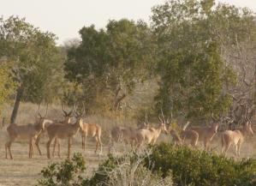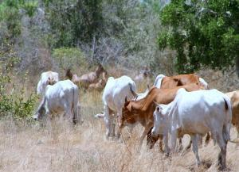

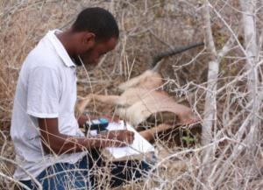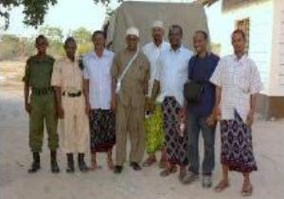

ANNUAL PROGRESS REPORT TO THE HIROLA MANAGEMENT COMMITTEE AND IUCN/SSC ANTELOPE SPECIALIST GROUP

HIROLA CONSERVATION AND RESEARCH PROJECT
Organizations: University of Wyoming and National Museums of Kenya

Abdullahi H. Ali¹ and Jacob R. Goheen²

¹Department of Zoology and Physiology, University of Wyoming and National Museums of Kenya, ²Department of Zoology and Physiology, University of Wyoming.

Email:aali5@uwyo.edu

TABLE OF CONTENTS

ACKNOWLEDGMENTS 5
EXECUTIVE SUMMARY 6
1.0 BACKGROUND AND JUSTIFICATION 7
1.1 Study objectives 8
2.0 CAUSES AND CONSEQUENCES OF LANDSCAPE CHANGE 9
2.1. Hirola historic range collapse and range degradation 9
2.2. Future plans: Causal factors underlying tree encroachment and range degradation 9
3.0 HIROLA RESOURCE SELECTION 10
4.0 HIROLA DEMOGRAPHY, POPULATION VIABILITY ANALYSIS, AND RISK OF
EXTINCTION 14
4.1 Ground surveys 14
4.2 Population viability analysis, and risk of extinction 16
4.3 Assessing hirola mortality 18
5.0 HIROLA POPULATION GENETICS 18
6.0 COMMUNITY KNOWLEDGE, EDUCATION AND OUTREACH 19
6.1: Indigenous knowledge and attitudes 19
6.2 Education and outreach 20
7.0 CHALLENGES FACED DURING THE PROJECT 22
8.0 CONCLUSIONS AND FUTURE DIRECTIONS 23
9.0 PLANS FOR RESULTS DISSEMINATION AND COMMUNICATIONS 24
10.0 REFERENCES 25
11.0 APPENDICES 27

LIST OF PLATES
Plate 1: Common tsetse fly (Glossina spp.) in Ishaqbini Community Conservancy 12
Plate 2: Seasonally flooded ditches dominated by Echinochloa and Oryza spp.
preferred by hirola 12
Plate 3: Cattle grazing and community control burns in Qotile area near Ishaqbini Community Conservancy 13
Plate 4: Dead foliage of Drake-brockmania somalensis in Ishaqbini Community Conservancy 13
Plate 5: Hirola grazing with zebra and topi within Ishaqbini Community Conservancy 14
Plate 6: Our research team and local scouts sampling the herbaceous vegetation inside
Ishaqbini Community Conservancy 14
Plate 7: Local scout and Mr. Ali on routine distance sampling exercise within Ishaqbini
Community Conservancy 15
Plate 8: Some of the other large mammals in Ishaqbini Community Conservancy 15
Plate 9: One of the groups we are monitoring (note the unique horn shape) 16
Plate 10: Mr. Ali recording and inspecting dead hirola carcasses in the field 18
Plate 11: Hirola faeces within Ishaqbini Community Conservancy 19
Plate 12: Scouts assisting in vegetation sampling in Ishaqbini Community Conservancy 20
Plate 13: Mr. Ali sensitizing community members about the plight of hirola in Fafi District 21
Plate 14: One of the images uploaded into Arkive website 22
Plate 15: Similarity in horn shape and annuli among typical adult hirola 22
Plate 16: Stakeholders attending hirola workshop in June 2011, held in Ijara, Kenya 24

LIST OF FIGURES
Figure 1: Population declines of hirola and elephants in Ijara District, Kenya 8
Figure 2: Changes in tree cover and hirola range size between 1978 and 2006 9
Figure 3: Population estimates of cattle, sheep, and goats in Garissa, Ijara, and Fafi
Districts, 1977-2001 11
Figure 4: Community perspective of ungulates trends in the hirola range over the past
10 years 20

ACKNOWLEDGMENTS
There are many people whose help was vital to this research. In particular, we would like to thank the Association of Zoos and Aquariums, Denver Zoo, International Foundation for Science, Mohamed Bin Zyed Species Conservation Fund, National Museums of Kenya, People’s Trust for Endangered Species, Rufford Foundation, St. Louis Zoo’s Center for Conservation in the Horn of Africa, University of Wyoming’s Haub School, and Zoological Society of London’s EDGE Programme for funding this work. Much appreciation also goes to Kenya Wildlife Service (KWS), Hirola Management Committee (HMC), National Museums of Kenya (NMK), Northern Rangelands Trust (NRT), Zoological Society of London (ZSL) and the Ishaqbini Community Conservancy (ICC) for their assistance and support during this period. We especially thank Dr. Samuel Andanje (KWS), Dr. Charles Musyoki (KWS), Dr. Rajan Amin (ZSL), Dr. Juliet King (NRT), Dr. David Mallon (IUCN), and Dr. Idle Omar Farah (NMK). Special thanks go to the scouts and community members, particularly Arawale and Ishaqbini communities whose useful contribution, participation and insight have made the trainings and data collection successful. In this regard, we would like to acknowledge the tireless effort made by local administrations and partners for facilitating all of our work.

EXECUTIVE SUMMARY

This report covers the first 12 months of our four year (2011-2014) hirola research project in Ijara and Fafi Districts, Kenya. Our research forms the basis of Mr. Ali’s PhD dissertation at the University of Wyoming and is focusing on hirola population dynamics, habitat use, and the effects of land-use change in north-eastern Kenya for hirola. Additionally, we have worked with individuals in Ishaqbini Community Conservancy, and Arawale, Gababa, and Galmagalla communities to better understand local perceptions. These are knowledge gaps that have been consistently identified as research priorities for future hirola conservation since 2000. Hirola are the least known large mammals in Africa and, although they have never been common, they have dwindled in numbers from roughly 10,000 in 1970 to somewhere between 300-500 today. The reasons for these declines (and those preventing contemporary recovery) are mysterious; formal research in this geographic area has been logistically difficult given political unrest and tribalism. We suspect a combination of habitat degradation, competition with livestock, and disease are responsible for historic declines, with habitat degradation and predation combining to suppress contemporary populations. Through our ongoing work, we hope to quantify the relative importance of predation versus habitat quality in preventing the recovery of hirola populations. Here, we report preliminary findings from the first phase of the project, which will be submitted for publication in 2012. This initial phase of the project was valuable in 1) demonstrating that range contraction of hirola has coincided with an increase in woody cover in Ijara and Fafi Districts, Kenya; and 2) initiating long-term research in the hirola’s geographic range to understand resource selection, demography, and distribution.

Additionally, we administered a structured questionnaire in Bura, Galmagalla, Gababa, Qotile, Hara and Masalani to gain better insight on the historical distribution of hirola in the region, attitudes toward hirola, threats to livestock from hirola, threats to hirola from people, and the future of wildlife in these areas. This effort used both field-based data and community meetings to meet its objectives. Preliminary results from this work suggest that communities are responsive and amenable to hirola conservation; increasingly, intensive livestock production is viewed as unsustainable and, already, locals have benefitted from employment associated with conservation efforts (both through this work and through Northern Rangelands Trust). Local scouts in Ishaqbini, Arawale and Gababa received onsite training in distance sampling, vegetation sampling, and wildlife monitoring as well as aspects of environmental education. In so doing, we facilitated community-wide consultation in several parts of the hirola’s range.

We contributed popular publications to several media outlets including Swara, AZA’s Connect magazine, The Standard (one of Kenya’s leading newspapers) and local FM radio stations in the region. In this regard, we have tried to raise awareness and promote better appreciation for hirola within Kenya and in the international community. Further, we suspect that increasing human/livestock populations, infrastructure development, expanding farmlands and quarry/sand harvesting activities in eastern Masalani are major threats to the persistence of hirola. Although it has been reduced in Ishaqbini, poaching continues to be a major threat in rest of the range especially in Arawale along the riverine farming communities. Outside Ishaqbini, the remaining groups of hirola are at the threshold of being lost if financial and technical support is not found and maintained. To ensure adequate conservation and buffer against future environmental stochasticity, viable, free-ranging populations must be established outside Ishaqbini through the revival of Arawale; we should attempt to duplicate the success of Ishaqbini elsewhere in the native range.

1.0 BACKGROUND AND JUSTIFICATION

Sub-Saharan Africa is a region with a staggering diversity of both wildlife and human cultures. This is especially so in arid pastoral systems, where livestock and people coexist with the most diverse array of wild ungulates on earth (Kock et al. 2002). In these ecosystems, ungulates exhibit strong seasonal variation in abundance and distribution as a consequence of variability in the availability of food and water (Sinclair, 1983). Both resources are driven partly by the erratic and unreliable rainfall characteristic of arid lands and, historically, rainfall-mediated changes in the abundance and distribution of resources drove the abundance and distribution of wildlife (Western, 1975). However, with an increase in sedentary pastoral practices, the influence of humans and their livestock often overrides such natural, historical drivers, leaving wildlife and livestock to vie for scarce resources (Colin et al. 2007).

The hirola (Beatragus hunteri) is the most endangered antelope in sub-Saharan Africa, and it is one of the most critically-endangered species of mammal’s worldwide (IUCN, 1996; IUCN, 2008). Indeed, the hirola was recently identified by the EDGE (Evolutionary Distinct and Globally Endangered; Isaac et al. 2007) project as one of the top-10 focal species at risk of imminent extinction, and thus in dire need of intensified conservation efforts in the immediate future. Historically, hirola probably were always rare within a restricted geographic range, being confined between the lower Tana River in eastern Kenya and the River Juba in south-western Somalia (Bunderson, 1972; Kingdon, 1982). Although hirola have been legally protected in Kenya and Somalia since the 1970s, their numbers have declined by more than 80% since 1976 (Ottichilo et al. 1995; Magin, 1996; Butynski, 2000). Remaining populations occur almost solely on pastoral lands with no formal government protection, while the few conservation areas that do exist within the hirola’s native range (e.g., the Arawale National Reserve and the eastern part of the Tana Primate National Reserve) lack adequate protection and attention from the international conservation community. Thus, ironically, the hirola ranks high as one of Africa's greatest conservation concerns, but public knowledge regarding its plight is almost entirely lacking outside of north-eastern Kenya. Through his Ph.D. research, Mr. Ali is quantifying the interactions between hirola, humans, and their livestock to inform management and conservation efforts within both pastoral lands and the Ishaqbini Community Conservancy.

Despite chronic security threats, high abundances of wildlife persist in many areas of north-eastern Kenya, particularly arid and semi-arid areas with low human population densities. However, arid and semi-arid rangelands are notoriously sensitive to disturbance, and overgrazing by livestock is implicated in recent declines of wildlife populations. However, the mechanisms through which livestock lead to reduced populations of wildlife are unclear. A number of biologists have argued that food limitation resulting from competition with livestock is the primary factor underlying declines in hirola populations (Wargute & Aligula 1993; Wargute, 1994; Agatsiva, 1995; Margin, 1996; Dahiye, 1999; Andanje, 2002). Hirola populations have exhibited steady declines since the 1970s; these declines have coincided with 1) an increase in livestock numbers stemming from a shift from traditional Somali nomadism to sedentary pastoralism; 2) fire suppression; and 3) a 98% decline in elephant numbers throughout the geographic range of hirola in north-eastern Kenya (Butynski, 2000; Fig 1); and 4) range degradation (e.g., tree encroachment) produced by a combination of 1-3 (Ali et al. 2012).

Hirola subsist almost entirely on grasses and understory forbs (Kingdon 1982); therefore, any factors shifting open, grass-dominated savannah to tree-encroached woodland have the potential to negatively impact hirola populations. Through interviews with local communities and aerial surveys conducted by the Kenya Wildlife Service (KWS) and Kenya’s Department of Resource Surveys and Remote Sensing (DRSRS), we strongly suspect that tree encroachment throughout Ijara and Fafi has converted historically-open rangeland into dense woodland with little forage available for hirola or other wildlife. Thus, one of our objectives in this research centers on analyses of remotely-sensed imagery to disentangle if and the extent to which each of the above factors have contributed to long-term range degradation through tree encroachment throughout Ijara and Fafi Districts. Identifying the causal mechanism(s) responsible for tree encroachment will enable us to make informed management recommendations to HMC and KWS and Northern Rangelands Trust (NRT).

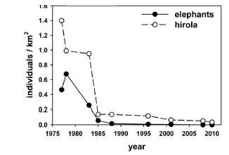

Figure 1: Population declines of hirola and elephants in Ijara District, Kenya.

Our recent analyses with AVHRR data (Fig. 2) demonstrate that the native range of the hirola has contracted with increasing tree cover in Ijara. Both fires and elephants reduce trees, and tree cover is negatively correlated with understory (i.e., hirola and livestock forage). Thus, while fire suppression or reductions in elephant numbers may have been responsible for triggering the declines in hirola populations, food limitation stemming from competition with livestock almost undoubtedly exacerbates this problem and may be the most serious contemporary issue facing hirola today (Ali et al. 2012). While information critical to the conservation of hirola has been gathered over the past decade (e.g., Butynski, 2000), the few ecological studies conducted in the region have either targeted hirola in isolation, or have been restricted to opportunistic sample counts through aerial surveys (Dahiye and Aman, 2002; Andanje, 2000; Dahiye, 1999; Department of Resource Survey and Remote Sensing (DRSRS), 1997; Magin, 1996; Ottichilo et al. 1995). This information is key for monitoring long-term population trends (e.g. Ottichilo et al. 2000); however, it is difficult to understand the processes responsible for declines in hirola populations from aerial surveys. This study aims to 1) uncover the mechanisms underlying hirola declines; and 2) formulate conservation and management strategies that integrate local pastoral communities.

1.1 Study objectives
- Investigate how overgrazing by livestock, fire suppression, and extirpation of the elephant population in Ijara and Fafi relates to hirola declines through tree encroachment.
- Assess seasonality in hirola resource selection, spatial distribution, and movements.
- Conduct population viability analyses (PVA) to assess the risk of extinction of hirola populations under various levels of predation and range quality.
- Foster long-term conservation by involving local communities through education and outreach programs.
- Make management recommendations to HMC, KWS, NRT and IUCN based on findings from Objectives 1-4

2.0 CAUSES AND CONSEQUENCES OF LANDSCAPE CHANGE

2.1. Hirola historic range collapse and range degradation
From analysis of remotely-sensed imagery and field vegetation surveys, we have been able to show how the hirola’s geographic range collapsed over the past 30 years (Fig. 2). More importantly, we have shown hirola persist today only in areas of low tree cover (Fig. 2). Hirola lost much of their suitable habitat because of tree encroachment, and we suspect that this is due to fire suppression, elephant declines and severe range degradation (Fig.3)

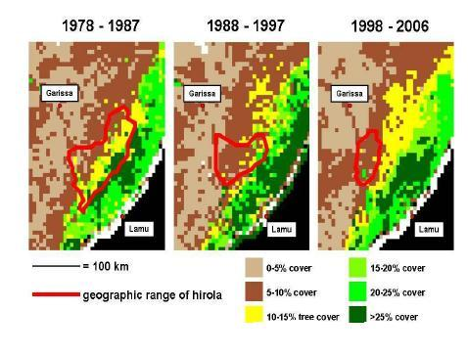

Figure 2: Changes in tree cover and hirola range size between 1978 and 2006.

Note that hirola persist mainly in areas of low tree cover (Fig.2). Advanced Very High Resolution Radiometer (AVHRR) data were acquired from the International Livestock Research Institute GIS database. Range maps were acquired from unpublished data from Department of Resource Surveys and Remote Sensing and the Kenya Wildlife Service.

2.2. Future plans: Causal factors underlying tree encroachment and range degradation
In 2012, we will contract the acquisition of high-resolution (60 cm) Quickbird satellite images (Digital Globe, Fort Collins, CO) across our study sites in Ijara and Fafi Districts. Images will be acquired in February at the peak of the dry season to reliably distinguish tree cover from understory. For each image, we will perform an unsupervised classification through isoclustering and maximum likelihood classification to group pixels with similar spectral reflectance. We will assign pixel groups into the following classes: 1) tree; 2) understory; 3) bare ground; 4) recently burned; 5) settlement; and 6) water. We will then ground-truth classifications of pixel groups against each class in the field in 2012 by selecting 50-100 points in each class. In particular, we will ground-truth classifications against tree cover in 2011 by counting and recording every tree within a series of 0.25 ha plots. We will record trees with a high-resolution global positioning system (GPS; Corvallis Microtechnologies, Corvallis, OR) with sub-meter accuracy. Then, we will correlate numbers of trees from ground surveys with tree cover from Quickbird classifications.

Following ground-truthing, we will train Landsat satellite imagery of Ijara and Fafi Districts against the Quickbird classification. Although Landsat images lack the resolution of Quickbird images, they are freely available from 1972 to present from the U.S. Geological Survey (http://eros.usgs.gov). Resolution of Landsat imagery tends to decline with older imagery; Landsat ETM+ (1999-present) consists of 15-60 m multispectral data, Landsat MSS (1982-present) consists of 30-120 m multispectral data, and Landsat TM (1972-1992) consists of 80 m multispectral data. Our classifications will effectively provide a 39-year time series (1972-2011) of changes in 1) tree cover; 2) understory (forage) abundance; and 3) fire history within Ijara and Fafi Districts. Thus, classifications of Landsat imagery potentially offer unprecedented opportunity to link hirola declines to habitat degradation via tree encroachment and loss of forage.

3.0 HIROLA RESOURCE SELECTION
While predation, disease, and poaching have been implicated in the decline of hirola (Wargute & Aligula, 1993; Wargute, 1994; Agatsiva, 1995; Margin, 1996; Dahiye, 1999; Andanje, 2002), it is difficult to imagine a scenario in which the above factors would initiate and sustain ongoing declines in hirola populations. On the other hand, there is abundant evidence that increasing pressure from humans and their livestock have coincided with, if not driven, hirola declines. For example, in 1976, the biomass density of cattle in south-eastern Kenya ranged from about 16-350kg/km2, or 12 times the biomass density for hirola (Bunderson, 1981). Over the next 20 years, biomass density of cattle increased steadily while hirola declined, such that biomass density of cattle was more than 400 times that of hirola in 1996 (Butynski, 2000; Andanje, 2002). Cattle and hirola are both grazers that prefer areas of low woody cover and short grass, and cattle consume large amounts of forage that otherwise would have been available to wild herbivores such as hirola. In particular, competition is expected to be present during droughts when food is especially scarce (Bell, 1970; Sinclair, 1975; Bunderson, 1981; Butynski, 2000; Andanje, 2002).

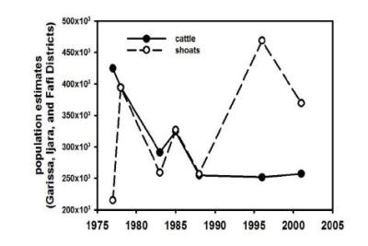

Figure 3: Population estimates of cattle, sheep, and goats in Garissa, Ijara, and Fafi Districts, 1977-2001.

In light of the landscape change we have documented, we suspect that hirola are faced with acute food limitation and habitat loss resulting from a combination of overgrazing, fire suppression, and extirpation of elephants particularly in more inland areas covering the northern and eastern part of the former range. Hirola groups seems to have either been largely displaced or lost from major seasonal concentration areas such as Arawale, Galmagala, Dagega, Hulugho and Sangailu; these areas currently contain very small and highly fragmented groups. These areas comprise of arid Acacia/Commiphora and Acacia/ Grewia bushlands and grasslands and although severely degraded remain the most crucial hirola habitats for long-term survival. As a response to these factors, hirola groups are moving southward into the open grasslands of Boni forest. However, prior to recent years, these areas was avoided by hirola especially during the wet season. This avoidance may be due to tsetse flies (Plate 1) and unpalatable grasses.

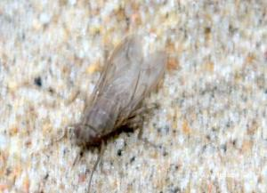

Plate 1: Common tsetse fly (Glossina spp.) in Ishaqbini Community Conservancy.

Although it has been suggested that the geographic range of hirola is limited by trypanosomiasis to the south (Bunderson, 1976), it is most likely that hirola are immune to trypanosomiasis and a combination of habitat unsuitability and tsetse flies nuisance may be limiting the southern boundary of the range. The persistence of hirola groups in these areas despite high level of ticks and tsetse flies coupled with unfavourable habitat could be an indication of further range collapse. Even in ectone habitats like Ishaqbini and the boundaries of Boni forest, hirola seem to be selecting open bush grassland and lush savannah areas. In particular and especially during the dry season, hirola seem to prefer seasonally flooded lowlands and ditches dominated by tall tough green grasses such Echinochloa haploclada, Oryza punctata, and Sporobolus helvolus.

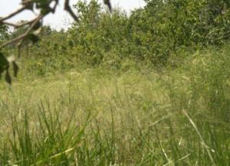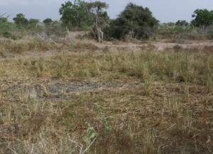

Plate 2: Seasonally flooded ditches dominated by Echinochloa and Oryza spp. preferred by hirola.

These habitat at the edge of Boni forest are not the best hirola habitats; in optimal conditions hirola prefer short green grasses (Andanje et al. 1999) maintained by the combination of grazing and fire (Bunderson, 1976). Such a combination of grazing and fire is typically employed by Somalis in the edges of Boni forest and outside Ishaqbini in Qotile (Plate 3) but is unusual in other parts of the hirola range that lack enough understory to carry fire. The spatial and seasonal variation in resource selection of hirola will be detailed in our next progress report in 2013.

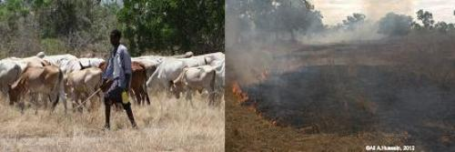

Plate 3: Cattle grazing and community control burns in Qotile area near Ishaqbini Community Conservancy

It is important to note that other grasses, such as Chloris and Cenchrus, are still present in low densities across the native range of hirola. In addition, grasses such as Drake-brockmania somalensis and Eragrostis aethiopica (Plate 4) also occur in Ishaqbini, and are largely avoided by hirola, other wildlife, and livestock.

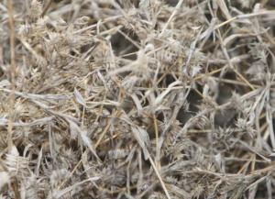

Plate 4: Dead foliage of Drake-brockmania somalensis in Ishaqbini Community Conservancy.

Hirola often are found in close proximity to other wildlife such as plains zebra (Equus quagga), gerenuk (Litocranius walleri), topi (Damaliscus lunatus), and oryx (Oryx beisa). They avoid close association with domestic cattle, perhaps indicating intra/interspecific competition.

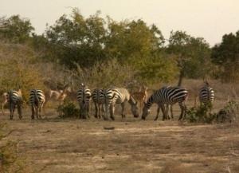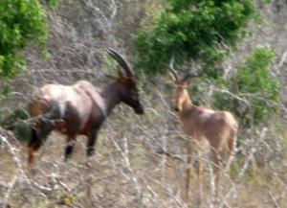

Plate 5: Hirola grazing with zebra and topi within Ishaqbini Community Conservancy.

We have sampled herbaceous and woody cover in areas with major concentrations of hirola within Ishaqbini and Arawale. We used a 10-point pin frame (Plate 6) to assess understory composition of herbaceous plants associated with each hirola herd. Frames were placed in the middle of each plot and the number of individual green leaves hitting the pins counted. We are using compositional analysis (Aebischer et al. 1993) to quantify hirola resource selection.

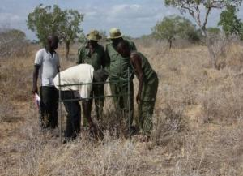

Plate 6: Our research team and local scouts sampling the herbaceous vegetation inside Ishaqbini Community Conservancy.

In conjunction with our work, we collected herbaceous and woody vegetation in these areas and could make available a reference collection within Ishaqbini Community Conservancy in the future (see Appendix 3 and Plate 12).

4.0 HIROLA DEMOGRAPHY, POPULATION VIABILITY ANALYSIS, AND RISK OF EXTINCTION

4.1 Ground surveys
We initially proposed to work across the entire range and cover areas such as Arawale, Gababa, Galmagalla, Garaswno, Hulugho and Sangailu. As demonstrated by both the recent NRT/KWS aerial survey (King et al.2011) and our ground surveys, we found hirola numbers to be extremely low in Arawale, Gababa, Galmagalla, Garasweno, Hulugho and Sangailu; locating herds proved to be extremely difficult, time consuming, and expensive. Therefore, we restricted the collection of demographic data to Ishaqbini Community Conservancy, which houses the greatest concentration of hirola in their remaining range (130-150 individuals). We therefore established 12 lines transects of 2-3km each within Ishaqbini Community Conservancy (Plate 7).

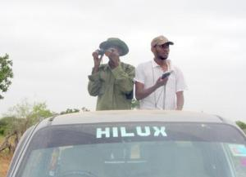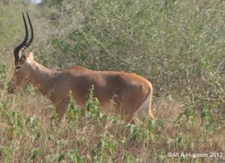

Plate 7: Local scout and Mr. Ali on routine distance sampling exercise within Ishaqbini Community Conservancy.

We are using distance sampling (Buckland et al. 2000) to enumerate population densities of hirola and other large mammals in the area (Plate 9). We are estimating abundances of hirola and other wild ungulates using Program Distance (Buckland et al. 2001). We are using abundance and age-structure data to build projection matrices for hirola. These matrices will be used to perform population viability analyses (PVA) for each population of hirola as a function of predators, livestock, and tree abundance. PVA is a powerful tool to compare among relative risks of extinctions for multiple populations, and for identifying key life stages (i.e., calves, juveniles, or adults) to target in conservation efforts (Morris and Doak, 2002). Our transects are inaccessible by car and are traversed on foot every end of month.

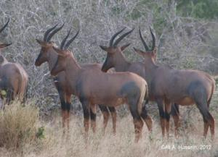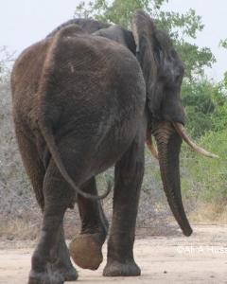

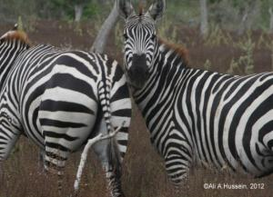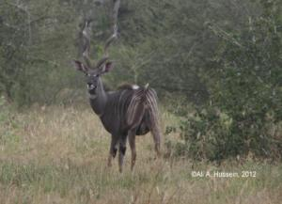

Plate 8: Some of the other large mammals in Ishaqbini Community Conservancy

4.2 Population viability analysis and risk of extinction Along with the translocation effort into the predator-proof sanctuary and in conjunction with distance sampling, we will conduct mark-resight and sight-resight analyses on adult female hirola (the demographic class most responsible for driving population change). This work will commence in September 2012. We will target herds under three scenarios:

1) INSIDE SANCTUARY, INSIDE ISHAQBINI characterized by low livestock grazing (equating to high range quality) + low predation
2) OUTSIDE SANCTUARY, INSIDE ISHAQBINI characterized by low livestock grazing (equating to high range quality range quality) + high predation
3) OUTSIDE SANCTUARY, OUTSIDE ISHAQBINI characterized by high livestock grazing (equating to low range quality) + low predation

Scenario 1 involves the translocation of 50-60 hirola from the outskirts of Boni Forest (roughly 30 km to the east) into the predator-proof sanctuary within Ishaqbini. This effort is underway and will occur sometime between June and August 2012. During processing, capture technicians will fix uniquely-numbered ear tags to individuals to aid in future identification. We intend to obtain blood samples to evaluate serum chemistry and pregnancy hormones. Animals within this sanctuary will be protected from predators and will experience high-quality range stemming from the absence of cattle.

Scenario 2 involves the identification of individuals with unique marks and horn shapes (Plate 9). Since initiating our work in Ishaqbini, we have identified eight adult individuals that we use to track eight groups of hirola within Ishaqbini. These groups are faithful to particular areas and rarely stray outside the bounds of Ishaqbini, presumably because of high-quality range and heavy presence of livestock and humans in the surrounding buffer zones. Hirola within Ishaqbini are in the process of being habituated for future tourism ventures and will not be captured and moved into the predator-proof sanctuary. Hirola within Ishaqbini but outside the sanctuary will experience the same high-quality range as animals in Scenario 1, but will be exposed to lions and other predators.

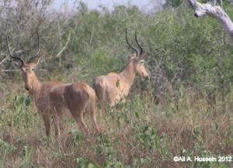

Plate 9: One of the groups we are monitoring (note the unique horn shape).

Scenario 3 involves the capture of hirola from herds at the periphery of this species' geographic range from Arawale, Gababa, Gallmagala, and Sangailu communities. We will fit GPS collars on 10 adult (>3 years old) females from 10 different herds to both estimate survival rates of collared individuals and relocate associated herds. Hirola will be immobilized with Carfentenil Citrate delivered remotely from helicopters by field veterinary staff from the KWS and ZSL. During processing, capture technicians will draw a blood sample (15 ml) from the jugular and fix uniquely-numbered ear tags to individuals to aid in future identification. Blood samples will be screened to evaluate serum chemistry and pregnancy hormones; serologic testing will be conducted for antibodies to relevant diseases and blood will also be used for an ongoing genetic study. It is not feasible to mark and resight (as in Scenario 1) or sight and resight (as in Scenario 2) these animals, as our preliminary data demonstrate that herds at the periphery of the range are extremely dispersed and wide-ranging. GPS radio collars will record one GPS location every three hours throughout the year. Each collar will be equipped with a VHF (Very High Frequency) signal as well that will emit 50 pulses per minute for monitoring, or 30 pulses per minute to indicate mortality if the individual has not moved for eight hours or more. VHF signals will be used to relocate animals visually twice per week, to note the presence or absence of calves. GPS collars will be scheduled to drop off remotely in June 2014, when they will be collected for downloading of the accumulated data.

We will employ mark-resight and site-resight methods (Johnson et al. 2010) to estimate survival of 10 adult female hirola (the age class most affecting population growth) in each of the above scenarios. We will conduct population viability analyses (PVA) of hirola herds under each of the three scenarios detailed above (Morris and Doak 2002). We will build matrix population models and conduct life table response experiments (LTRE) to attribute differences in the annual rate of population change (λ) to some combination of predation and range quality (Maclean et al. 2011). Specifically, from the LTRE between Scenario 1 and Scenario 2, we will be able to quantify the effect of varying risk of predation on population growth of hirola. Similarly, from the LTRE between Scenario 1 and Scenario 3, we will be able to quantify the effect of varying range quality on population growth of hirola. Thus, PVA will permit us to quantify the relative impacts of predation and range degradation, and will permit us to make informed management decisions to maximize the chances of long-term persistence.

For the radio-collared hirola from outlying herds, we will construct resource selection functions (RSFs; Boyce and McDonald 1999) to quantify the extent to which particular habitat features (distance to water, distance to settlement, percent grass cover, percent for cover, percent tree cover, etc) are selected or avoided by hirola. Our RSFs will be used to inform future reintroduction efforts of sanctuary-bred animals.

As with many declining species, more than one factor probably underlies the plight of hirola. It is possible (and indeed, likely), that some combination of predation and range degradation is responsible for the apparent inability of hirola to recover in eastern Kenya. Documenting the relative influence of these two factors in the field holds promise as to what steps can and should be taken to maximize the chances of hirola persistence in the future.

For example, if predation (or poaching) is the primary factor suppressing hirola numbers, we anticipate rates of population change to exceed 1.0 within the predator-proof sanctuary, indicating positive population growth. Under this scenario, future management efforts would be well-advised to focus on some combination of 1) community education and outreach in attempt to minimize poaching; 2) training anti-poaching squads; and 3) identifying reintroduction sites where the risk of predation and/or poaching is minimal.

On the other hand, if predation (or poaching) is an important but secondary factor suppressing hirola numbers and range condition drives hirola numbers, we anticipate rates of population change to increase within the sanctuary, but below the expected rate (i.e., with predation removed). If this is the case, we would expect hirola outside Ishaqbini--where Chloris and Cenchrus are even rarer than within Ishaqbini--to exhibit lower survival and birth rates, regardless of whether they were contained in the predator-proof sanctuary. In the event of these results, future management efforts should focus on range improvement strategies (e.g., holistic management, bush clearing, etc) in outlying areas in attempt to improve habitat and bolster hirola numbers. The massive undertaking of creating and maintaining a predator-proof sanctuary to serve as a source for future reintroductions will only be successful if the major threats outside the sanctuary (i.e., in the reintroduction sites) are identified and mitigated.

Of equal importance to this effort will be the use of RSFs to identify sites suitable for the reintroduction of sanctuary-bred hirola. We anticipate the reintroduction of hirola into outlying areas of Ijara 3-4 years after the translocation into the predator-proof sanctuary (i.e., June 2015 or June 2016). To maximize the chances of successful reintroduction, it is imperative that we understand the landscape (distance to nearest settlement, distance to water) and vegetation (percent shrub cover, percent annual grasses, percent perennial grasses) features that hirola select or avoid so as to target reintroductions in areas that share these attributes.

4.3 Assessing hirola mortality
Throughout our study sites, we are opportunistically recording carcasses of hirola and other ungulates to draw conclusion on mortality rates of hirola in each of these areas. If possible, causes of mortality will be recorded. This data will be used to complement the demographic data described in above.

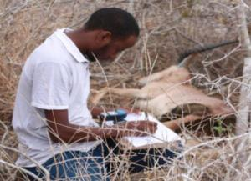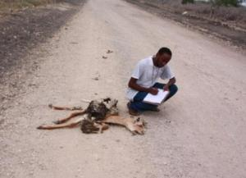

Plate 10: Mr. Ali recording and inspecting dead hirola carcasses in the field

5.0 HIROLA POPULATION GENETICS
To address whether the current range of hirola reflects range collapse or a range shift, we are collecting faecal samples to amplify DNA that is shed when the animal defecates. This will allow us to demonstrate whether the hirola in Ijara have either 1) persisted in this area while trees have encroached over the past 30-40 years; or 2) been "pushed" into the suitable habitat (low tree cover) that remains following elephant extirpation, overgrazing, and/or fire suppression. Further, we will address if ongoing declines of hirola could be partially due to inbreeding depression, compare effective population size to census size, and develop genetic mark-recapture methods for long-term population monitoring.

We recently collaborated with Dr. Melanie Murphy a landscape ecologist and population geneticist at the Department of Renewable Resources, University of Wyoming. Dr. Murphy has major interests in population genetics. Her involvement is crucial to understanding the demographic and genetic consequences of range collapse in hirola.

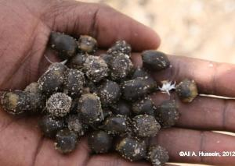

6.0 COMMUNITY KNOWLEDGE, EDUCATION AND OUTREACH

6.1: Indigenous knowledge and attitudes
Increasingly, indigenous knowledge and local participation are key components of conservation efforts. As yet, little documentation of Somali pastoralist’s ecological knowledge exists, and even less is known about how this knowledge is, or can be, applied to hirola management and conservation. We will outline the ecological knowledge of Somali nomadic pastoralists and its role in hirola conservation in Ijara and Fafi Districts.

In 2011, we administered a structured questionnaire to gain a better insight on the historical distribution of hirola in the region, attitudes toward hirola, threats to livestock from hirola, threats to hirola from people, and the future of wildlife in these areas (Fig. 4). The questionnaires were distributed to homesteads in Arawale, Gababa, Bura, Galmagalla, Hara, Masalani and Qotile. We are analysing survey data using factor analysis (Legendre and Legendre, 1999) to identify linear combinations of predictor variables accounting for community perceptions of hirola.

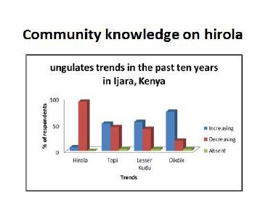

Figure 4: Community perspective of ungulates trends in the hirola range over the past 10 years

6.2 Education and outreach
Because they are large, charismatic, and indicative of high-quality rangeland, hirola can be utilized as both indicator and flagship species for semi-arid ecosystems in the Horn of Africa. However, despite international concerns and government protection through the Wildlife Act (Cap 376), hirola remain poorly understood and virtually unknown outside of north-eastern Kenya. Therefore, raising well-informed future generations with strong commitments to sustained management through education is an important activity for hirola conservation in the medium to long-term. Education and outreach efforts stemming from this research will be targeted toward local communities from the main villages in the hirola range. Early efforts suggest that communities are responsive and amenable to hirola conservation; increasingly, intensive livestock production is viewed as unsustainable and, already, locals have benefitted from employment associated with conservation efforts (both through this work and through the NRT).

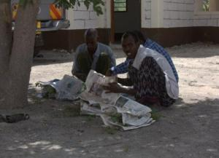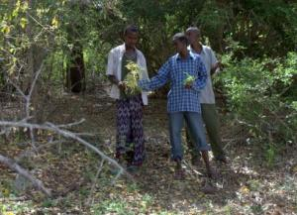

Plate 12: Scouts assisting in vegetation sampling in Ishaqbini Community Conservancy

Since 2009, we have been holding a series of village-based community meetings in both Ijara and Fafi Districts (Plate 13). In the coming years we will continue with these efforts as locals acclimatize to this research and our findings will be disseminated, through the use of local barazas (village meetings) and also through simple materials such as brochures, posters, and leaflets. This way, local leaders and the general public will be exposed to the need for them to betake responsibility in the conservation of natural resources within their own communities through sustainable natural resource management.

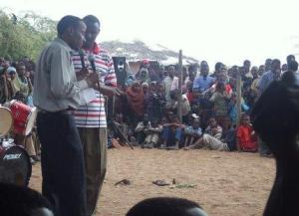

Plate 13: Mr. Ali sensitizing community members about the plight of hirola in Fafi District

Further, we will be approaching the media (local dailies, radio and television) to provide time slots or print space on hirola conservation initiatives in the region in order to broaden public awareness. Our work was recently covered in the Kenyan media where Mr. Ali (the Principal investigator of the project) was featured in The Standard, one of Kenya’s leading national newspapers: http://www.standardmedia.co.ke/specialreports/InsidePage.php?id=2000035100&cid=259&
As part of our sustained effort to curb the decline of this species, Mr. Ali has also conducted live radio interviews with the Kenya Broadcasting Corporation highlighting the plight of the hirola (see Appendix 1). We published an introductory article in the January issue of Swara, a popular publication of the East African Wildlife Society to further highlight the plight of the species to the broader East African and international conservation networks. For the first time in the history of this species, we were able to submit several high resolution field photos to Arkives (a global initiative with the mission of "promoting the conservation of the world's threatened species, through the power of wildlife imagery”), some of which are already uploaded to their site (Plate 14). We have a plan of submitting field videos of hirola to Arkives as part of sustained effort to create a hirola multimedia conservation education tool for public use. We think this will further illuminate and create interest in the conservation of what is arguably the world's most endangered antelope.

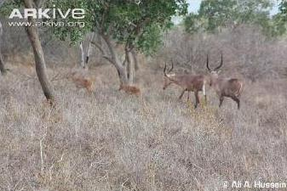

Plate 14: One of the images uploaded into Arkive website

7.0 CHALLENGES FACED DURING THE PROJECT
In early 2011, Mr. Ali spent several months trying to identify individual hirola within Ishaqbini to construct demographic models and better understand factors underlying the decline of this species. Initially, we had hoped to identify hirola through horn annuli and unique, naturally-occurring marks (scars, albinism, horn shape). However, this proved slow and difficult because hirola are very skittish, and because we suspect a significant amount of “mixing” of individuals between herds. In addition, hirola are highly mobile, and herds often would disappear and re-emerge over the course of weeks in the communities outlying Ishaqbini. Recently, however, we have made significant progress in constructing reliable demographic models for this species. In the long run, we hope to develop a photographic database of all individuals within Ishaqbini Community Conservancy.

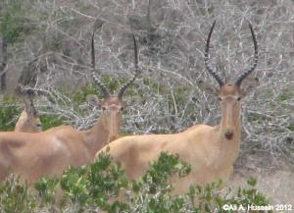

Plate 15: Similarity in horn shape and annuli among typical adult hirola

8.0 CONCLUSIONS AND FUTURE DIRECTIONS
Along with that of our collaborators, our work promises to make the necessary next steps to inform the conditions under which these future reintroductions are most likely to succeed. Thus, with the support of groups like KWS and NRT, it is possible (and indeed likely) that we will make real headway toward the conservation of this unique animal. In our opinion, the most important priority is to address habitat improvement measures within the hirola’s native range, particularly in Arawale National Reserve. We have been in discussions with KWS, NRT, and ZSL representatives about this effort.

Importantly, and unlike many critically-endangered species, we suspect that a modest amount of funding can actually make a substantive impact with respect to hirola populations, for two reasons. First, the primary factor responsible for hirola declines—range degradation—is reversible, given local support and financial investment. This is because the fate of hirola is linked to the long-term sustainability of livestock production in this region, because both hirola and cattle require open grasslands and, at appropriate densities, cattle and hirola can coexist. Because Somali elders have witnessed range degradation through time, they are now eager to implement improvement measures (Ali et al. 2012). Second, the Somali clans in this region (Abdalla and Abudwaq Somalis) typically do not poach or eat bush meat, and ascribe to hirola a near-mythical status. Thus, locals in this area have both economic and cultural incentives to protect hirola, providing a legitimate chance against extinction for this unique species. It is our goal that the uniqueness of hirola will be continue to recognized by the community leaders and members in the region, thus strengthening long-term conservation efforts. Importantly, we have already built strong collaborative linkages with KWS, HMC, and NRT to manage the project in the long-term, thereby maximizing chances of success of the proposed research.

Finally, in the coming years, we will continue with the resource selection and demographic field studies of hirola within the Ishaqbini Community Conservancy. Through this work, we will continue making management recommendations to the HMC, KWS and other collaborators NRT. We continue to compile data into reports that will be submitted to funding institutions, the KWS, HMC, NRT, Garissa, Ijara and Fafi County Councils, and the NMK. We work to maintain good working relations with these groups, all of whom are regularly updated on our recent findings.

9.0 PLANS FOR RESULTS DISSEMINATION AND COMMUNICATIONS
Our work is still in progress and we have been updating stakeholders and communities through HMC meetings (Plate 16) and other forums such as village meetings (Plate 13). At the end of the study, data will be compiled into a comprehensive report that will be submitted to funding institutions, the KWS, HMC, NRT, Ijara-Fafi County Councils, and the National Museums of Kenya (NMK). We maintain excellent working relations with these groups, all of whom are regularly updated on project recent findings. Thus, we are hoping filling these knowledge gaps and raising awareness about the plight of the hirola within Ijara and Fafi Districts would technically constitute “success”.

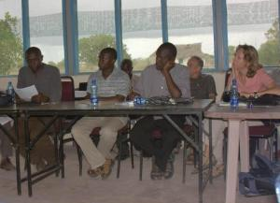

Plate 16: Stakeholders attending hirola workshop in June 2011, held in Ijara, Kenya

10.0 REFERENCES

Aebischer, N.J., P.A. Robertson, and R.E. Kenward. (1993) Compositional analysis of habitat use from animal
radio-tracking data. Ecology 74:1313-1325.

Agatsiva, J.L. (1995). Conservation and Management of the Hirola in Kenya. Unpublished report. Hunter’s
Antelope Task Force: Nairobi. 41 pp.

Ali A.H., J.R., Goheen, R. Sivanpillai, and J.S. Evans. (in prep). Causes and consequences of landscape change
for hirola populations in Ijara, Kenya.

Ali. A.H., J.R. Goheen, and Samuel Andanje. (in prep). Implication of indigenous knowledge for the
conservation of the critically endangered hirola antelope (Beatragus hunteri) in Ijara and Fafi Districts, Kenya.

Andanje, S.A. (2000) Factors limiting the Abundance and Distribution of the Hirola in Tsavo and Tana River
Districts, Kenya Unpublished report, KWS Biodiversity Conservation Unit and Zoological Society of London.

Andanje S. (2002) Factors Limiting the Abundance and Distribution of Hirola (Beatragus hunteri) in Kenya.
PhD dissertation, Evolution and Behaviour Research Group, Department of Psychology, University of Newcastle upon Tyne; Newcastle, UK.

Andanje, S.A. & W.K. Ottichilo. 1999. Population status and feeding habits of the translocated sub
population of Hunter’s antelope or hirola (Beatragus hunteri, Sclater, 1889) in Tsavo East National Park, Kenya. African Journal of Ecology 37: 38-48.

Boyce, M.S. and L.L. McDonald. (1999) Relating populations to habitats using resource selection functions.
Trends in Ecology and Evolution 14:268-272.

Buckland ST, Goudie IBJ, Borchers DL (2000) Wildlife population assessment: Past developments and future
directions. Biometrics 56:1-12

Buckland, S.T., D.R. Anderson, K.P. Burnham, J.L. Laake, D.L. Borchers, and L. Thomas, (2001) Introduction
to Distance Sampling. Oxford University Press; 432 pp.

Bunderson, W.T. (1976). The Numbers, Distributions and Densities of the Hunter’s Antelope in the Southern
Garissa and Lamu Districts of Kenya. Unpublished interim report. Research Division, Kenya Wildlife Conservation and Management: Nairobi. 19 pp.

Butyniski, T.M. (2000) An independent evaluation of hirola antelope (Beatragus hunteri): Conservation
status and conservation action in Kenya. Unpublished Kenya Wildlife Service Interim Report. 192 pp.

Colin, B., Weaver, D. and Fanning, E. (2007) Livestock and large wild mammals in Kilombero Valley, in
Southern Tanzania. African Journal of Ecology. 46: 1-6.

Dahiye, Y.M. (1999) Population size and seasonal distribution of the Hunter’s antelope or hirola (Beatragus
hunteri), Sclater 1889) in southern Garissa, Kenya. MSc Thesis. Addis Ababa University.

Dahiye, Y.M. and Aman, R.A. (2002) Population size and seasonal distribution of the hirola antelope
(Beatragus hunteri, Sclater 1889) in southern Garissa, Kenya. African Journal of Ecology 40: 386-389.

DRSRS (1997) Summary of aerial surveys for Garissa District, MPND.DRSRS. Nairobi.22 pp.

Gaillard, J.M., M. Festa-Bianchet, N.G. Yoccoz, A. Loison, and C. Toigo. (2000). Temporal variation in fitness
components and population dynamics of large herbivores. Annual Review of Ecology and Systematics 31:367-393.

Isaac, N.J.B., S.T. Turvey, B. Collen, C. Waterman (2007) Mammals on the EDGE: conservation priorities
based on threat and phylogeny. Proceedings of the Library of Science (PLoS) One 2:e296. doi:10.1371/journal.pone.0000296

IUCN SSC Antelope Specialist Group 2008. Beatragus hunteri. In: IUCN 2011. IUCN Red List of Threatened
Species. Version 2011.1. <www.iucnredlist.org>.

IUCN SSC Antelope Specialist Group. (1996) Evaluation of Antelopes using IUCN red list Categories. IUCN
Antelope’s Survey Updates 2:57-72.

Johnson, H.E., L.S. Mills, J.D Wehausen, and T.R. Stephenson. (2010). Combining ground count, telemetry,
and mark-resight data to infer population dynamics in an endangered species. Journal of Applied Ecology 47:1083-1093.

Kingdon, J. (1982) East African Mammals. An Atlas of Evolution in Africa. Bovids. Oxford University Press.
393 pp.

King, J., S. Andanje, C. Musyoki, R. Amin, J. Goheen, D. Lesimirdana & A. H. Ali
Aerial survey of hirola (Beatragus hunteri) and other large mammals in south-east Kenya. Unpublished report to the Kenya Wildlife Service.

Kock M.D., Mullins G.R., Perkins J.S. Wildlife health, ecosystems, and rural livelihoods in Botswana. In:
Aguirre AA, Ostfeld RS, Tabor GM, House C, Pearl MC (eds).Conservation Medicine: Ecological Health in Practice. New York, USA: Oxford University Press; 2002.pp.265–275.

Legendre, P. and Legendre, L. (1998) Numerical Ecology. Elsevier Science. 870 pp.

Maclean, J.E., J.R. Goheen, D.F. Doak, T.M. Palmer, and T.P. Young. (2011) Cryptic herbivores mediate the
strength and form of ungulate impacts on a savannah tree. Ecology 92:1626-1636.

Magin, C. (1996) The Hirola Recovery Plan. IUCN Gnus Letter 15:2-9.

Morris, W.R. and Doak, D.F. (2002) Quantitative Conservation Biology. Sinauer Associates. 480 pp.

Ottichilo, W.K., J.M. Mirangi, G. Muruiki, and R. Kock (1995) The status of the Hunter’s hartebeest (hirola) in
Kenya. Unpublished Kenya Wildlife Service Interim Report. 34 pp.

Ottichilo, W. K., J. de Leeuw, A. K. Skidmore, H. H. T. Prins, and M. Y. Said. (2000). Population trends of large
non-migratory wild herbivores and livestock in the Maasai Mara ecosystem, Kenya, between 1977 and 1997. Afr. J. Ecol 38:202-216.

Sinclair, A.R.E. (1983). The adaptations of African ungulates and their effects on community functions. In:
Bourlière, F. (ed) Ecosystems of the world, vol 13. Tropical savannas. Elsevier, New York, pp 401-426.

Wargute, P.W. (1994). The Abundance, Distribution, and Trend of Hunter’s Hartebeest (Damaliscus hunteri)
in Kenya. Unpublished report. Hirola Task Force: Nairobi. 35 pp.

Wargute, P.W. & H.M. Aligula. (1993). The Status of the Hunter’s Hartebeest in Kenya. Unpublished report.
East African Wild Life Society & Department of Resource Surveys and Remote Sensing: Nairobi. 24 pp.

Western, D. (1975). Water availability and its influence on the structure and dynamics of a savannah large
mammal community. East African Wildlife Journal 13: 265-285.

11.0 APPENDICES

Appendix 1: A sample of unedited text messages from locals in response to KBC Talk

Day Time Phone Concerns/questions by communities Wednesday, July 07, 2010 | 8:28 PM | 254715254808 | Som mohamed Hamd guhad ojogo sangailu carawlaha noloshisa meshe uwangsantahay mamesha qawoba amah mesha kulul  Translation: which is the most preferred hirola habitat? By Mohamed from Sangailu.
Wednesday, July 07, 2010 | 8:26 PM | 254716888732 | SOM What is da lifespan of da said animal ? From Hassan Golo Moyale ETHIOPIA.  Translation: What is the lifespan of hirola in the wild?
Wednesday, July 07, 2010 | 8:11 PM | 254717313696 | WHERE DO HIROLLA ORGINATED? WHY ONLY FOUND IN GARISSA .?IS IT BEC OF HOT CLIMATE.?.BY MOHAMED MAHAT.HODAN.WAJIR
Wednesday, July 07, 2010 | 8:10 PM | 254723178698 | Som =mudu star dhagahaley carowluhu wamuhiim laakiin dowlada ayaakagaabise in uutarmo waa inloosameeya dhulbaag ah iyo ceelal  Translation: the government should establish a national park for hirola for long-term solution.
Wednesday, July 07, 2010 | 8:03 PM | 254726574789 | som. Hay k.b.c. Iam maankow of wajir bulla jogoo,idle i want to ask mr Abdullahi what is the benefit that antelop has than other wild animals.  Translation: why is hirola important compared to other wild animals?
Wednesday, July 07, 2010 | 8:00 PM | 254717313696 | WHAT MEASURES ARE TAKEN TO SAFE THE ENDENGERED SPICES FROM HUNTERS.OR LIONS.ETC.TO AVERT DECREASING NUMBER FROM 4000 TO 600.BY MOHAMED MAHAT.HODAN.WAJIR
Wednesday, July 07, 2010 | 7:54 PM | 254717313696 | HOW MANY TOURIST VISIT ANNUALLY TO SEE HIROLLA.? IF ANY.HOW MUCH MONEY RECIEVED? BY MOHAMED MAHAT.HODAN.WAJIR
Wednesday, July 07, 2010 | 7:47 PM | 254729662479 | Som, is that type of animal exist in Nep,issa bangal pharmacy  Translation: Does such an animal so special and critically endangered exist in north-eastern Kenya?

Appendix 2: Checklist of plants in and around Ijara area

Species | Family | Growth form | Local name (Somali)
Elytraria acaulis (L.f.) Lindau | Acanthaceae | herb
Baleria sp. | Acanthaceae | Qothahtol
Barleria eranthemoides R.Br. | Acanthaceae | Herb
Barleria acanthoides Vahl | Acanthaceae | Herb
Ecbolium subcordatum C.B.Clarke | Acanthaceae | Herb
Mollugo nudicaulis Lam | Aizoaceae | Herb
Gisekia pharnaceoides L. var. pharnaceoides ceoides L. | Aizoaceae | Herb
Zaleya pentandra (L.) Jeffrey | Aizoaceae | Herb
Achyranthes aspera var. perphyristachya Hook F. | Amaranthaceae | Herb | Get Biret
Aerva lanata (L.) Juss | Amaranthaceae | Herb
Puppalia lappacea(Linn.) Juss | Amaranthaceae | Herb
Digera muricata (L.) Mart. | Amaranthaceae | Herb
Amaranthus graecizans L. | Amaranthaceae | Herb
Alternanthera pungens Kunth | Amaranthaceae | Herb
Carissa edulis (Forssk.) Vahl | Apocynaceae | Shrub
Asparagus falcatus L | Asparagaceae | Shrub
Cordia sinensis Lam. | Boraginaceae | Tree
Heliotropium longiflorum (A.DC.) Jaub. & Spach ssp. undulatifolium (Turrill) Verdc. | Boraginaceae | Herb | Goreya kaharis
Heliotropium steudneri Vatke | Boraginaceae | Herb
Bourreria teitensis (Gürke) Thulin | Boraginaceae | Shrub
Farsetia stenoptera Hochst. | Brassicaceae | Herb
Erucastrum arabicum Fisch. & C.A.Mey. | Brassicaceae | Herb
Commiphora campestris Engl. | Burseraceae | Tree
Commiphora bruceae Chiov. | Burseraceae | Shrub or Tree
Commiphora africana (A.Rich.) Engl. | Burseraceae | Shrub or Tree | Kura
Maerua denhadtiorum Gilg | Capparaceae | Shrub or Tree | Ohia
Maerua angolensis DC. | Capparaceae | Shrub or Tree
Cadaba farinosa Forssk. | Capparaceae | Shrub | ohia sagar
Cleome gynadra L. | Capparaceae | Herb
Maerua mungaii Beentje | Capparaceae | Shrub
Maerua decumbens (Brongn.) De Wolf | Capparaceae | Shrub
Maytenus undata (Thunb.) Blakelock | Celastraceae | Shrub or Tree | ilimdes
Salsola dendroides Pall. | Chenopodiaceae | Shrub | durte
Chenopodium opulifolium Schrad. ex Koch | Chenopodiaceae | Herb
Terminalia parvula Pamp. | Combretaceae | Shrub or Tree | Qordaboo
Combretum hereroense Schinz ssp. volkensii (Engl.) Wickens | Combretaceae | Shrub or Tree
Commelina benghalensis Wall. | Commelinaceae | Herb | Bar
Blepharispermum minus S.Moore | Compositae | Herb | Yumarug
Seddera hirsuta Hallier f. | Convolvulaceae | Herb
Momordica spinosa (Gilg) Chiov. | Cucurbitaceae | Shrub or Climber | Mathah bubuq
Momordica foetida Schumach. | Cucurbitaceae | Herb
Coccinia grandis (L.) Voigt | Cucurbitaceae | Herb
Cyperus prolifer Lam. | Cyperaceae | Herb
Diospyros consolatae Chiov. | Ebenaceae | Shrub or Tree
Spirostachys venenifera (Pax) Pax | Euphorbiaceae | Tree | haya
Acalypha volkensii Pax | Euphorbiaceae | Herb | Kashimuda
Tragia hildebrandtii Müll.Arg. | Euphorbiaceae | Herb
Jatropha prunifolia Pax | Euphorbiaceae | Herb
Phyllanthus maderaspatensis L. | Euphorbiaceae | Herb
Phyllanthus somalensis Hutch. | Euphorbiaceae | Shrub | Kamora
Euphorbia hirta L. | Euphorbiaceae | Herb
Euphorbia prostrata Aiton | Euphorbiaceae | Herb
Flagellaria guineensis Schumach. | Flagellariaceae | Herb
Endostemon tereticaulis (Poir.) Ashby | Lamiaceae | Herb
Strychnos decussata (Pappe) Gilg | Loganiaceae | Shrub or Tree
Lawsonia inermis L. | Lythraceae | Shrub or Tree | Elan
Hibiscus micranthus L.f. | Malvaceae | Herb | Balambal
Pavonia arabica Hochst. ex steud. | Malvaceae | Herb | Moresa
Pavonia zeylanica Cav. | Malvaceae | Herb
Senra incana Cav. | Malvaceae | Herb
Abutilon pannosum (G.Forst.) Webb | Malvaceae | Herb
Thespesia danis Oliv. | Malvaceae | Shrub or Tree | Kabhan
Abutilon wituense Baker f. | Malvaceae | Herb
Acacia zanzibarica (S.Moore) Taub. | Mimosaceae | Shrub or Tree
Acacia elatior Brenan | Mimosaceae | Tree | Bura
Acacia hamulosa Benth. | Mimosaceae | Shrub or Tree | adad
Acacia reficiens Wawra ssp. misera (Vatke) Brenan | Mimosaceae | Shrub or Tree | rig/qansah
Albizia anthelmintica Brongn. | Mimosaceae | Shrub or Tree | Hamasha
Commicarpus helenae (Roem. & Schult.) Meikle | Nyctaginaceae | Herb
Boerhavia erecta L. | Nyctaginaceae | Herb
Ochna sp. |  | Ochnaceae
Ximenia americana L. | Olacaceae | Shrub or Tree | Mandaru
Tephrosia pumila (Lam.) Pers. | Papilionaceae | Herb
Indigofera tinctoria L. | Papilionaceae | Herb
Indigofera schimperi Jaub. & Spach | Papilionaceae | Herb
Rhynchosia minima (L.) DC. | Papilionaceae | Herb
Indigofera spicata Forssk. | Papilionaceae | Herb | Darqa
Leptochloa obtusiflora Hochst. | Poaceae | Herb | Bayo
Eleusine indica (L.) Gaertn. | Poaceae | Herb
Digitaria pennata (Hochst.) T.Cooke | Poaceae | Herb
Brachiaria leersioides (Hochst.) Stapf | Poaceae | Herb | aws danan/dadii
Dactyloctenium scindicum Boiss. | Poaceae | Herb
Enteropogon macrostachyus K.Schum. ex Engl. | Poaceae | Herb
Eragrostis ciliaris (L.) R.Br. | Poaceae | Herb
Eragrostis cilianensis (All.) Link ex Lutati | Poaceae | Herb
Setaria verticillata (L.) P.Beauv. | Poaceae | Herb
Chrysopogon plumulosus Hochst. | Poaceae | Herb
Aristida adoensis Hochst. | Poaceae | Herb
Enteropogon barbatus C.E.Hubb. | Poaceae | Herb
Tragus berteronianus Schult | Poaceae | Herb
Sporobolus helvolus (Trin.) T.Durand & Schinz | Poaceae | Herb | Jarbi
Chloris roxburghiana Schult. | Poaceae | Herb
Chloris virgata Sw. | Poaceae | Herb
Cenchrus ciliaris L. | Poaceae | Herb | Darema
Echinochloa haploclada (Stapf) Stapf | Poaceae | Herb
Chloris mossambicensis K.Schum. | Poaceae | Herb
Digitaria abyssinica (A.Rich.) Stapf | Poaceae | Herb
Eragrostis tenuifolia (A.Rich.) Steud. | Poaceae | Herb
Schoenefeldia transiens (Pilg.) Chiov. | Poaceae | Herb
Cynodon dactylon (L.) Pers. | Poaceae | Herb
Drake-brockmania somalensis Stapf | Poaceae | Herb
Dinebra retroflexa (Vahl) Panz. | Poaceae | Herb
Brachiaria serpens (Kunth) C. E. Hubbard | Poaceae | Herb
Calyptrotheca somalensis Gilg | Portulacaceae | Shrub | Dumey
Portulaca oleracea L. | Portulacaceae | Herb | antalaa
Portulaca kermesina N.E.Br. | Portulacaceae | Herb
Polysphaeria parvifolia Hiern | Rubiaceae | Shrub or Tree
Zanthoxylum chalybeum Engl. var. chalybeum | Rutaceae | Tree | Miiya Shabel
Dobera glabra (Forssk.) Poir. | salvadoraceae | Shrub or Tree | Garas
Salvadora persica L. | salvadoraceae | Shrub or Tree | athey
Thesium kilimandscharicum Engl. | Santalaceae | Herb
Lepisanthes senegalensis (Poir.) Leenh. | Sapindaceae | Tree
Lecaniodiscus fraxinifolius Baker ssp. scassellatii (Chiov.) Friis | Sapindaceae | Shrub or Tree
Solanum coagulans Jacq. | Solanaceae | Herb
solanum incanum L. | Solanaceae | Shrub
Sterculia stenocarpa H.J.P.Winkl. | Sterculiaceae | Shrub or Tree | Qaranri
Grewia villosa Willd. | Tiliaceae | Shrub | Kamasha
Grewia bicolor Juss. | Tiliaceae | Shrub or Tree
Corchorus trilocularis L. | Tiliaceae | Herb
Grewia stuhlmannii K.Schum. | Tiliaceae | Shrub
Chascanum hildebrandtii (Vatke) Gillett | Verbenaceae | Herb
Rinorea elliptica (Oliv.) Kuntze | Violaceae | Shrub or Tree
Rinorea ilicifolia (Oliv.) Kuntze | Violaceae | Shrub
Tribulus terrestris L. | Zygophyllaceae | Herb

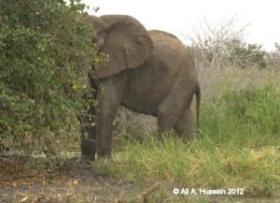

Elephants slowly returning to parts of the hirola range

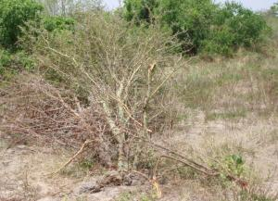

Elephants knocking down acacias in Ishaqbini improving the habitat for hirola

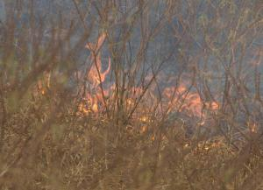

Community controls burns in Qotile area, near Ishaqbini

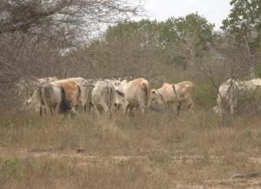

Cattle grazing in the buffer zone of Ishaqbini Community Conservancy

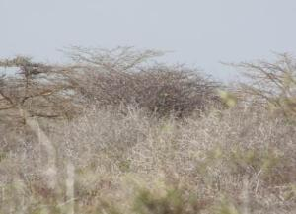

Bush encroachment in Arawale National Reserve

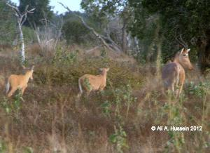

Adult female hirola and two calves inside Ishaqbini Community Conservancy

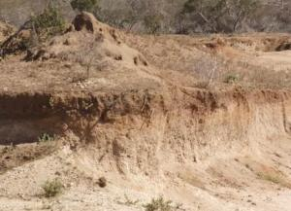

Quarrying activities in Dubandesa area, East of Masalani thought to be important hirola dispersal and grazing area.

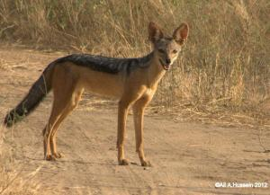

Black backed jackal often sighted within Ishaqbini Community Conservancy

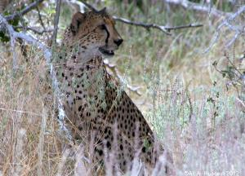

Cheetahs are common predators within Ishaqbini community conservancy

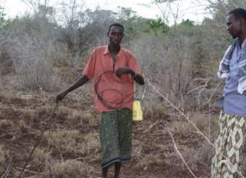

Snares are easily found within the hirola range; poaching still a challenge in Arawale and the Tana River flood plains

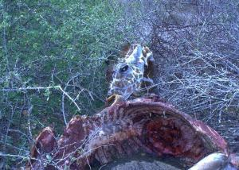

Giraffe killed and eaten by poachers in Arawale National Reserve

