Project Update: November 2012

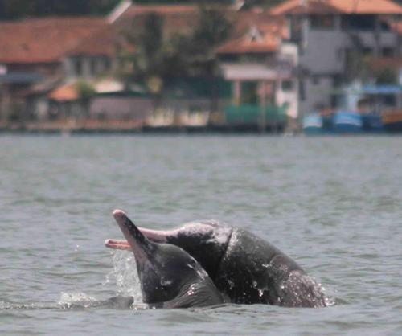

Objectives for the study:
- Assessing the distribution and demography of dolphins in and around the study sites.
- Assessing intensity of estuary use by Indo-pacific humpback dolphins and identifying key factors that could influence their distribution.
- Assessing variations in immediate behavioural responses in Indo-pacific humpback dolphins to ecological and anthropogenic factors.
- Evaluating attitudes of and raising awareness among coastal stakeholders.

The differential use of estuaries and variations in surface behaviours by Indo-pacific humpback dolphins was assessed across major (Kochi Port), intermediate (Ashtamudi harbour) and minor ports (Munambam estuary) (see Fig 1). During pre-monsoon (April-May), monsoon (Aug-Sep) and post monsoon (Oct-Nov), shore based scan sampling was carried out to assess the estuary use and behaviour of dolphins in the three study sites from prefixed observation points. Other parameters such as the tide, beaufort, depth, turbidity, salinity, pH, fishing intensity, number of boats, boat type were also recorded simultaneously. Group composition assessments and (surface) behavioural observations in the estuaries were also carried out from these observation points. Photo-identification of dolphins was carried out to examine number of individuals using the estuarine areas. Preliminary analysis has been carried out to assess the time activity budgets of the dolphins in all three estuaries for the pre-monsoon season. Data exploration was done to assess the interactions of boat traffic and dolphins using the area. Non-parametric tests such as the G test of independence and G test of goodness of fit were used to statistically test the variation in surface behavioural responses of S.chinensis in the study area.

RESULTS:
From the preliminary results it is clear that dolphins are using the major and minor ports differently. We hypothesise that type of vessel traffic, depth of water column, salinity and prey availability are the key factors that might influence space use. The number of observed and expected dolphin sightings clearly show that Kochi should be having more than double the present number of dolphin sightings. This could be due to the high amount of boat traffic or limited prey availability. While there was no marked pattern in space use by dolphins in relation to vessel traffic in the minor and intermediate ports, there was a marked overlap of space use by dolphins and shipping traffic in Kochi, This might be implying that dolphins are using the shipping channels in the estuary, and their behavioural patterns around these vessels need to be studied to address conservation concerns.

In the time activity budgets of dolphins, foraging was the predominant activity, indicating that dolphins are using the estuaries primarily as feeding grounds (see Fig 2). However the proportion of foraging in Kochi was lower and traveling was twice as compared to Ashtamudi and Munambam. This could be a factor of the high boat traffic seen in the Kochi estuary that could be causing displacement among dolphins. Dolphins sighted in the Kochi estuary exhibted a higher proportion of socialising (18.1%) as opposed to Munambam (1.3%) and Ashtamudi (0%), this could be to maintain communication in a landscape dense with vessel traffic and noise.

GAPS AND FUTURE WORK
The study will continue over the next few months, to compare estuary use and behaviour over pre-monsoon, monsoon, post-monsoon and dry seasons, in all three study areas. Data on ecological parameters will be used to create habitat models and gain insights into the relation of dolphin sightings with these ecological covariates which could be governing dolphin movement and use. A coastal survey just outside the estuaries is also to be carried out to assess range of the dolphins that use the estuaries, create a photo catalogue of all individuals around the estuary, and study the behaviour and group sizes of dolphins in these areas. Interview surveys would be carried out during the months of Feb and March 2013 to evaluate perceptions of stakeholder activities. Raising of awareness would be done during the months of April-May 2013.

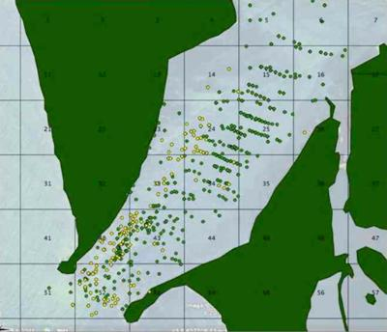
Figure 1a: Shows dolphin (yellow dots) and boat (green dots) locations in the Munambam estuary.

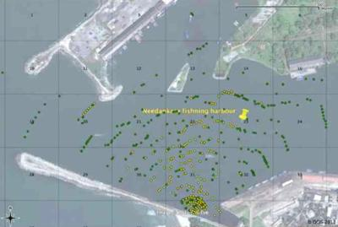
Figure 1b: Shows dolphin (yellow dots) and boat (green dots) locations in the Ashtamudi Estuary.

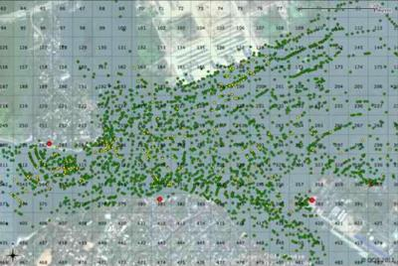
Figure 1c: Shows dolphin (yellow dots) and boat (green dots) locations in the Kochi Estuary.

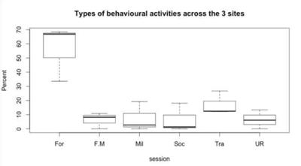
Figure 2: Time activity budget across the three sites (For:Foraging in one area, F.M:Foraging while moving locations, Mil: Milling, Soc: Socialising, Tra: Travelling, UR: Other activities)

