Project Update: April 2013

List of activities accomplished in the period:

- Four field trips to the wild swamps in collaboration with specialists from the Faculty of Biology, National Enterprise for the Protection of Flora and Fauna, guides from the Protected Areas, and undergraduate students from the National Institute of Design.
- Sample collection from Zapata Swamp, Birama Swamp (South Las Tunas-eastern part of the island), and North Las Tunas in association with the specialists of the National Enterprise for the Protection of Flora and Fauna.
- Coordination trips for establishing the logistics bases for the last trips organised under the current project.
- DNA extraction from the samples already collected, increasing the DNA bank available for additional analysis.
- DNA Genotyping using the nine pair of primers previously standardised (Cj16, Cj18, Cj20, Cj35, Cj109, Cj119, Cj127, Cj131 and CU5-123) and sequencing of control region of mtDNA. Further tests continue to reveal new information.
- Preliminary analysis of the 3D scans already generated.
- A complete update of the results generated so far, and their implications for Cuban Crocodylus conservation have been presented at the Rufford Small Grantees Workshop held in Havana. More details can be found at: http://www.rufford.org/news/grant_recipients_conference_cuba_2013
- Draft of a paper in preparation to be submitted to a scientific journal
- Manuscript in preparation to be included in a monograph about the Cuban crocodilian.

Indirect activity accomplished favoured by the project:

Partial results were also presented by Sheila Ribalta Mena (undergraduate student completing her Bachelor thesis under our supervision) at the Scientific Forum for undergraduate students held at the Faculty of Biology.

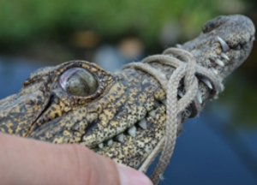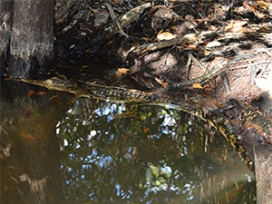
Immobilised Cuban crocodile during a sampling trip in Zapata Swamp Picture

Suspected hybrid between the Cuban crocodile and the American crocodile in the wild Zapata Swamp

