Project Update: November 2013
The 2013 sampling is complete, totalling 6 months of field work (from May to October). From 50 corridors that we planned to sample, we managed to sample 45, because some landowners changed their minds about supporting an ecological study and permitting access to their lands. All landscape and vegetation variables that will be used in the statistical analyses have also been collected.
At the end of this year's sampling, all landowners received a photographic report of the species found in their lands.
We have sampled 24 terrestrial mammal species: red-rumped agouti (Dasyprocta leporina), lowland paca (Cuniculus paca), nine-banded armadillo (Dasypus novemcinctus), southern naked-tail armadillo (Cabassous unicinctus), giant armadillo (Priodontes maximus), white-lipped peccary (Tayassu pecari), collared peccary (Pecari tajacu), red-brocket deer (Mazama americana), gray-brocket deer (Mazama gouazoubira), tapir (Tapirus terrestris), giant ant-eater (Myrmecophaga tridactyla), southern ant-eater (Tamandua tetradactyla), puma (Puma concolor), jaguarundi (Puma yagouaroundi), jaguar (Panthera onca), ocelot (Leopardus pardalis), margay (Leopardus wiedii), crab-eating fox (Cerdocyon thous), bush dog (Speothos venaticus), tayra (Eira barbara), coati (Nasua nasua), crab-eating racoon (Procyon cancrivorus), capybara (Hydrochoerus hydrochaeris), and giant river-otter (Pteronura brasiliensis).
In the next year's dry season, the same 45 corridors will be sampled, altering the order of sampling.
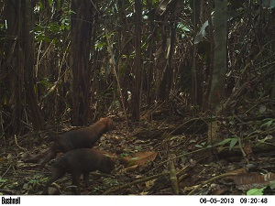
Bush dog (Speothos venaticus)
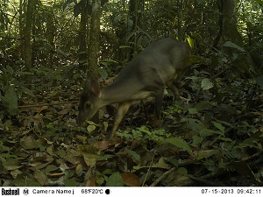
Gray-brocket deer (Mazama gouazoubira)
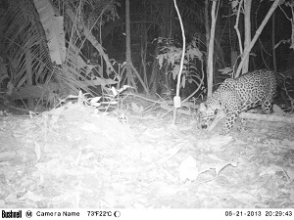
Jaguar (Panthera onca)

