Project Update: May 2014
The first project activities started in July 2013 with field surveys in southern Serbia, where we visited six localities. Only in Miratovac we found small population of Bradyporus dasypus, and also one interesting finding is Saga pedo, a species which is classified as vulnerable on IUCN Red List of Threatened Species. Also in Pcinja River Valley we found two new species for Serbian fauna (Metaplastes ornate and Andreiinimon nuptialis).

We prepared promotional T/shirts and pamphlets, and held few courses and more are in preparation. Also two papers about B. dasypus distribution and about new species for Serbian fauna are in preparation.

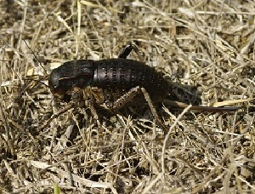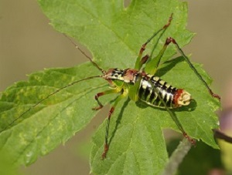
Left: Bradyporus dasypus, female. Right: Metaplastes ornata - new species for Serbian fauna

