Project Update: July 2014
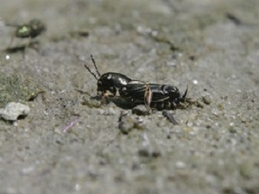
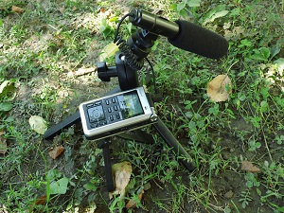
In 2014, we started the season recording songs of Orthoptera with audio equipment. Also we found one more new species for Serbian fauna (Xya pfaendleri (below)) near Pcinja River Valley. A colleague who also working on RSG project, Milos Popovic and his team, reported finding one more new species for Serbian fauna - Anacridium aegyptium.

Except in Miratovac, Bradyporus dasypus is not found on other localities, and Callimenus macrogaster and Saga natoliae are not found at all.

Future plans are for more field research and also education of local people for easier recognition of these specific insects. These findings show that this area is not well investigated.

