The Rufford Small Grants Foundation

Final Report
--------------------------------------------------------------------------------------------------------------------------------------
Congratulations on the completion of your project that was supported by The Rufford Small Grants Foundation.
We ask all grant recipients to complete a Final Report Form that helps us to gauge the success of our grant giving. We understand that projects often do not follow the predicted course but knowledge of your experiences is valuable to us and others who may be undertaking similar work. Please be as honest as you can in answering the questions – remember that negative experiences are just as valuable as positive ones if they help others to learn from them.
Please complete the form in English and be as clear and concise as you can. We will ask for further information if required. If you have any other materials produced by the project, particularly a few relevant photographs, please send these to us separately.
Please submit your final report to jane@rufford.org.
Thank you for your help.
Josh Cole
Grants Director
--------------------------------------------------------------------------------------------------------------------------------------
Grant Recipient Details
Your name | Zeeshan Mirza
Project title | Bio-inventory of Mygalomorph spiders of India
RSG reference | 14300-1
Reporting period | December-January 2014
Amount of grant | £6000
Your email address | snakeszeeshan@gmail..com
Date of this report | 24/12/2014

1. Please indicate the level of achievement of the project’s original objectives and include any relevant comments on factors affecting this.

Objective | Not achieved | Partially achieved | Fully achieved | Comments
Documentation of diversity of mygalomorph spiders |  | + |  | Given that India is really vast with several biogeographic realms, it’s not possible to cover all with a small grant
Scientific publications on the discovery |  |  | + | Several papers are in review and will get published in due course
Popularising research and need of conservation of mygalomorph spider |  | + |  | Posters on the findings will be sent in school, colleges and forest department in a few months with RSG logo
Legal protection to Indian tarantulas |  | + |  | A manuscript is in review which will help get tarantulas in the US Fish and Wildlife Service Red List to stop pet trade of Indian tarantulas which will be further used to advocate Indian tarantulas in the upcoming amendment to the Indian Wildlife Schedule
A data and specimen resource for Indian researchers and forest department |  |  | + | Given that most of the specimens of Indian species are housed in the Natural History Museum, London and other European museums, it is difficult for Indian researchers and forest department officials to get access to the data and specimens. With the tarantula project, I have managed to make a database and repository of specimens at the National Centre for Biological Sciences

2. Please explain any unforeseen difficulties that arose during the project and how these were tackled (if relevant).

3. Briefly describe the three most important outcomes of your project.

- Baseline for research on mygalomorph spiders in India
- Data on trade of Indian tarantulas which can help stop pet trade
- Photo documentation of species useful for field identification of species which be of handy to the forest department and custom officers.

Scientific publications as results of the conducted surveys:
Mirza, Z.A., Sanap, R. & Bhosale, H. 2014. Description of a new species of arboreal tarantula of the genus Poecilotheria Simon, 1885 (Araneae: Theraphosidae) from Satpura hills, central India. Journal of British Tarantula Society 29(2): 60–65.
Sanap, R. & Mirza, Z. A. 2014. A new iridescent tarantula of the genus Thrigmopoeus Pocock, 1899 from Western Ghats, India, C. R. Biologies, http://dx.doi.org/10.1016/j.crvi.2014.06.003
Sanap, R & Mirza, Z.A. in review. A new species of trapdoor spider of the genus Heligmomerus Simon 1892 from Western Ghats, India.
Mirza, Z.A. & Sanap, R. under review. Systematics of tarantulas of the subfamily Thrigmopoeinae with description of two new genera and seven new species from Western Ghats, India
Mirza, Z.A., Sanap, R., Raju, D., Gawai, A. & Ghadekar, P (2014) A new species of lizard of the genus Eublepharis (Squamata: Eublepharidae) from India. Phyllomedusa, 13(2): 75–90.
Sanap, R. & Mirza, Z.A. (in review) Three new species of trapdoor spiders of the genus Tigidia Simon 1892 (Araneae: Barychelidae) from India.

4. Briefly describe the involvement of local communities and how they have benefitted from the project (if relevant).

Surveys were conducted with the help of local tribal people and/or forest department. During the surveys, I helped them learn to use device like GPS and its uses. Furthermore I showed them how to locate tarantulas and differentiate between different species.

5. Are there any plans to continue this work?

I am continuing the work and are in the process to publish a book on Indian tarantulas as well as an android app from the data generated through this project. Surveys in the Himalayas and parts of northeast India are pending and hence will try to seek funding to continue fieldwork.

6. How do you plan to share the results of your work with others?

As mentioned earlier, I am working on a book and an android app on Indian tarantulas. I have submitted a few scientific papers based on findings of the project which will be publishes in some time.

7. Timescale: Over what period was the RSG used? How does this compare to the anticipated or actual length of the project?

Given that the project aimed to cover several parts of the country, the anticipated time of a year was too less but nonetheless a lot of ground was covered and enough support has been gathered to fight illegal pet trade not only for tarantulas but also reptiles.

8. Budget: Please provide a breakdown of budgeted versus actual expenditure and the reasons for any differences. All figures should be in £ sterling, indicating the local exchange rate used.

Item | Budgeted Amount | Actual Amount | Difference | Comments
Fellowship for researcher @ 100 per month x 12 months | 1200 | 1200
Field assistant wages @ 50 per month x 8 months | 400 | 400
Food allowance for researcher @ 60 per month x 10 months | 600 | 800 | 200
Local transport for 12 months | 1200 | 1500 | 300 | Due to petrol shortage, it was too expensive to travel in some parts of northeast India
Accommodation for 8 months | 1500 | 1500
Batteries, alcohol, vials, torch, internet | 600 | 750 | 150
Poster printing and awareness material | 200 | 200
Canon 60mm macro | 300 | 330 | 30 | Had budgeted for a field microscope but had to buy this as my macro lens stopeed working in field in northeast India
TOTAL | 6000 | 6680 | 680

9. Looking ahead, what do you feel are the important next steps?

Continue with fieldwork to get exact estimates of the diversity of tarantulas and assess threats faced by each or a group of species. Which in turn will be helpful for their conservation.

10. Did you use the RSGF logo in any materials produced in relation to this project? Did the RSGF receive any publicity during the course of your work?

RSG was acknowledged in all scientific publication and the posters which are to be send to schools, colleges and forest department bears the logo of RSG.

Pictures

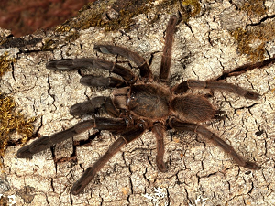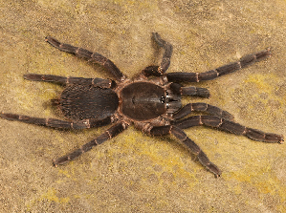
Left: An undescribed tarantula from Kerala. Right: Chilobrachyus sp from Tripura.
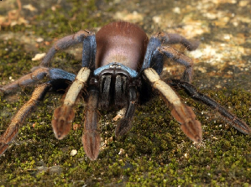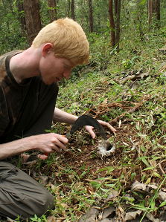
Left: Thrigmopoeus psychedelicus a new tarantula from Kerala. Right: Zeeshan Mirza excavating a tarantula burrow.

