Project Update: November 2014

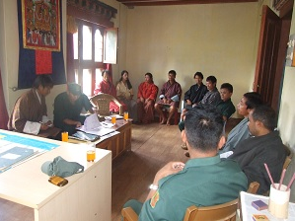
The 1-day stakeholder’s consultation meeting was held at Tarithang regarding the human elephant conflicts. The meeting was attended by 17 representatives from the two gewogs. At the time of themeeting the participants mentioned that they needed the solar fencing to protect the crops from the elephants.

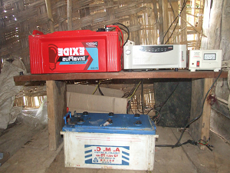
The total of 13.6 km of solar fencing has been done in two gewogs, Tarithang and Umling, covering six villages, Tarithang (A), Tarithang (B), Tarithang (C), Rhizhung, Tashithang and Thongja Zor. The length was 6 km in Tarithang, 3 km in Rhizhung and 4.6k m at Tashithang and Thongjazor.
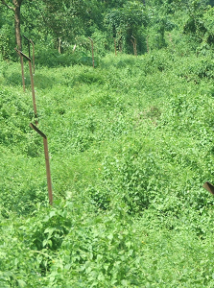
The project has procured all the solar fencing materials such as:

1) Angle posts - 70; 2) Exide car batteries – 3; 3) Inverter IP 1350 – 3; 4) Copper wire – 300 m; 5) G-wire – 400 kg (8 bundles); 6) Insulators – 300; and 7) Cement – 10 bags.
