Project Update: July 2014

The study made possible thanks to the Rufford grant started 11 days ago. So far I have recruited team members, had several meeting with the bureau of fisheries and environment, and the department of tourism.

Workshops and classes on manta ray ecology were given to leading dive masters in the region and the staff at the study site are being briefed daily about our daily progress.

I have scouted and located four sites of the highest ecological role for manta ray wellbeing and health, i.e. cleaning stations, and have deployed the remote surveillance cameras there for 6 days now. The results are promising, touch wood. I managed to get ID photos of seven mantas, and in the case these were not available, a detailed description of the animals.

Also, I have started collecting photos from divers visiting the site so I that we can compare updated photos to past ones. Attached are photos showing the methodology and some footage from the remote cameras.

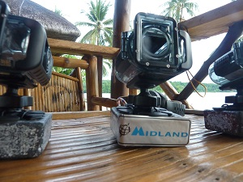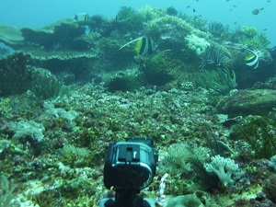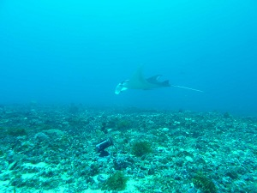
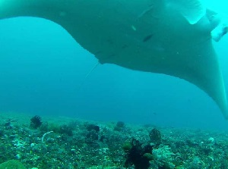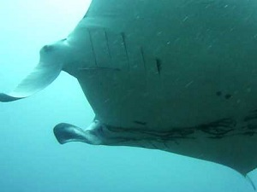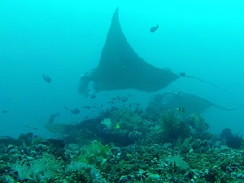

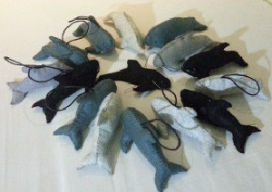
On the capacity building ‘front’, I have started organising a workshop for alternative means of livelihood, in this case, a souvenir doll of a manta or whale shark aptly named ‘sewmate’, made entirely out of recycled fabrics.

All in all we are off to a good start. The data looks promising and the interest on the part of the locals (both civilians and officials) is growing. I hope this trend will go on.

Thank you and the Rufford team for making this possible. This is a big step towards manta ray conservation on the national and global levels.

