Project Update: August 2014

Activities already completed:

- Field trips to Zapata Swamp and the Wildlife Refuge Monte Cabaniguán at Birama Swamp in collaboration with Cuban specialists of the National Enterprise for the Protection of Flora and Fauna.
- Sample collection for genetic analysis.
- Meetings at the Superior Institute of Design (acronym in Spanish, ISDi) and at the Faculty of Biology, with the designers that collaborate in the project. A logo was designed for firstly identifying our research group and properly link the communication actions.
- I have been co-advisor of an undergraduate student that successfully defended her Bachelor Thesis in Biochemistry at the Faculty of Biology at the University of Havana, on June 2014. The main topic of the thesis was related to crocodile’s conservation genetics.
- Publication of a Book Chapter entitled “Genética para la conservación del género Crocodylus en Cuba: pasado, presente y futuro” (Authors: Yoamel Milián-García, Michael A Russello, Georgina Espinosa-López) in the book entitled “Los Crocodylia de Cuba” Publisher: Universidad de Alicante, 2014 (ISBN: 8497173074, 9788497173070). The book was formerly presented by the main editors at the 23rd Crocodile Specialist Group meeting held at the McNeese State University in Lake Charles, Louisiana USA.
http://scholar.google.com.cu/scholar_url?hl=en&q=http://www.google.com/books%3Fhl%3Den%26lr%3D%26id%3D5TykAwAAQBAJ%26oi%3Dfnd%26pg%3DPA7%26ots%3DBxrmGdCm7B%26sig%3DBaUIGr73UK6Xq_QU0mUdouVZC7w&sa=X&scisig=AAGBfm1XA0Duj6SM3ykDhJ3zOAmxkXJJ0w&oi=scholaralrt
- Primers design for sequencing the complete mitochondrial genome of Cuban crocodiles based on complete mitochondrial genome published for congeneric species.
- Paper submitted to Heredity, entitled “Genetic evidence of hybridization between the critically endangered Cuban crocodile and the American crocodile: implications for population history and in situ/ex situ conservation”. The mentioned paper includes the most important information obtained so far during the development of the RSG projects about hybridization in Cuban Crocodylus.
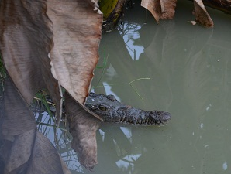
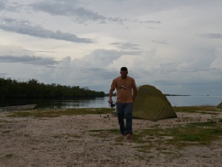
1
2
4
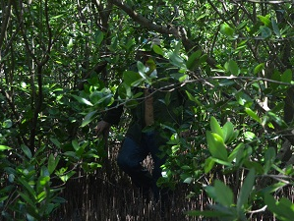
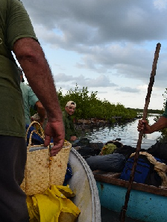
3

3
4

Picture 1. Cuban Crocodylus acutus from the Wildlife Refuge Monte Cabaniguán, Birama Swamp.
Picture 2. Yoamel Milián-García at the Wildlife Refuge Monte Cabaniguán, Birama Swamp.
Picture 3. Specialists from the National Enterprise for the Protection of Flora and Fauna in Cuba/Yoamel Milián-García getting into the Wildlife Refuge Monte Cabaniguán, Birama Swamp.
Picture 4. Yoamel Milián-García at the Cuban wetlands, natural habitat of Cuban crocodiles.

