Project Update: November 2014

Activities completed in the period:

- Field trips to Zapata Swamp jointly with postgraduate students from the Faculty of Biology at the University of Havana and specialists of the National Enterprise for the Protection of Flora and Fauna.
- Sample collection for genetic analysis and interview to members of the local communities in relation to key aspects of the conservation of Cuban crocodiles in the area.
- Designing of posters in collaboration with students of the Superior Institute of Design (acronym in Spanish, ISDi) and at the Faculty of Biology, with the designers that collaborate in the project.
- Primers designed for exploring new nuclear markers in the Crocodylus species.
- DNA extraction and sequencing of the first fragments under study, for the species of crocodiles that inhabits in Cuba.
- Paper published in Heredity, entitled “Genetic evidence of hybridization between the critically endangered Cuban crocodile and the American crocodile: implications for population history and in situ/ex situ conservation”. This paper contains the main results obtained so far with support of the Rufford Small Grant Foundation. http://www.nature.com/hdy/journal/vaop/ncurrent/abs/hdy201496a.html
- Interview organised by Heredity about the work so far completed with support of RSGF. http://www.nature.com/multimedia/podcast/hdy/hdypodcast_1410.mp3

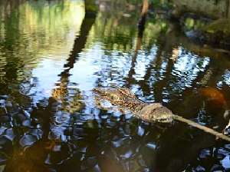
Picture 1. Cuban crocodile caught by the specialists at Zapata Swamp, during sampling collection.

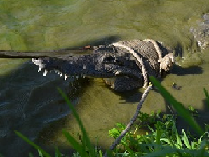
Picture 2. American crocodile caught by the specialists at Zapata Swamp, during sampling collection.

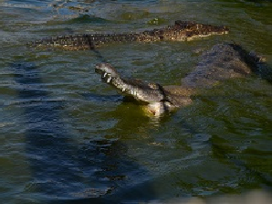
Picture 3. Cuban and American crocodile at Zapata Swamp.

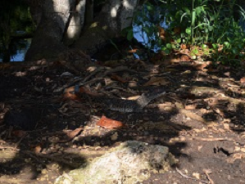
Picture 4. Cuban crocodile at Zapata Swamp.

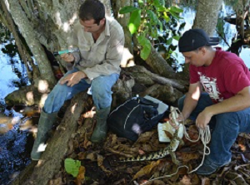
Picture 5. From left to right: Etiam Pérez Fleitas and Yoamel Milián-García during sampling collection.

Picture 6-10. Posters designed as the communication action initiative for preserving Cuban crocodiles.

