Participatory monitoring of fisheries and Beach Management training in Kenyan South Coast

Progress Report

for the period October-December 2014

Rufford Foundation Grant 15290-1

Paul Tuda


Introduction
This project addresses the issue of fisheries resource use by artisanal fishers and their active participation in resource management by working with locally established Beach management units (BMU) at the Kenyan south Coast.

Beach Management Units (BMUs) are legally empowered community based organizations/ institutions that bring together all fisheries stakeholders (boat owners, boat crew, traders, processors, boat builders and repairers, net repairers) including the poor and marginalized and give them a platform for decision making on sustainable management and exploitation of fisheries resources.

The main objective of the BMUs is to strengthen the management of fish-landing stations, fisheries resources and the aquatic environment by improving the participation of the local resource users in the decision making process. In line with its contribution to long term effective management of the coastal fisheries resources, Rufford Foundation supported the BMU orientation training among four BMUs (Msambweni, Gazi, Chale and Mwaepe) to refresh both the executive and assembly members on the various aspects of BMU operations, facilitate the training and monitoring of fisheries catch data and possibly expand the model to other BMUs for future planning based on the lessons learnt.

Working with the local staff from the Ministry of fisheries at the county level, and the local Non governmental organization (NGO) technology and care for improved livelihood (TECAFILI), a series of workshops were held with the view of (1) introducing the project to the community and other stakeholders working with the community, (2) orient and train the Selected BMUs units on agreed topics based on current issues.
The field Reconnaissance and consultation meetings with Beach management units (BMUs) leaders, State Department of Fisheries and County Government offices was held on 8th and 13th November 2014 respectively. The meetings were used to announce the project to the BMUs leaders, frontline fisheries Officers and to the County Government and to jointly plan with them on the training timelines, agenda and it was also meant to discuss and agree on the training venue and representation of the participants from each of the four beach BMUs.

Purpose of the Trip

As highlighted above, the objectives of this trip were:

- Acquaint the project team with project areas and touch base with communities.
- Introduce the project to the target community (Trainings)
- Get feedback with regards to the training needs and how best the training should be conducted
- To get familiarized with current projects and organizations working on the ground

Stakeholders Consulted

1. The top officials from 4 Beach Management Units (Msambweni, Mwaepe, Gazi and Chale)
2. County Government of Kwale especially the Ward Administrator – Kinondo ward
3. State department of fisheries and the county fisheries officers – Diani and Msambweni

Approach

To achieve the objective of the reconnaissance trips, a question guide was developed to assist the team on areas of focus to allow an understanding of the Beach Management Units and existing activities/engagements.

Interactive Meetings were held with fisheries officers, County Government of Kwale officials in the location. Our focus was on the currents status the Beach Management units in particular the challenges facing them and possible solutions.

Results

Overall, the reconnaissance visit found the following: -

- Participants confirmed that there is still a very poor understanding on the BMU concept. The challenge is that in most cases only the official were trained but most of the official were not facilitated to pass the information to the assembly members. Further, some of the officials were voted off in the BMU elections paving way for new untrained officials wit no idea on the functioning of the BMU.
- Trainings should shift from the leadership to the wider membership and preferable be conducted on-site so that all the members of the BMU assembly are well acquainted with their roles and be in a position to put the leaders to task.
- Beach Management Units are still faced with leadership wrangles particularly the BMUs with many fish landing sites. The worst hit BMUs includes Mwaepe and Chale-Kinondo.
- The current devolved government structure operating at the County level is keen to strengthen fisheries development by providing appropriate fishing gears to BMUs. However, past experiences have shown that without proper capacity building and follow-up such initiatives collapse due to lack of commitment from the communities
- There is also need to train the government officials on BMU operations as most of them lack the basic trainings on monitoring the progress and development of BMUs
- There is a need to strengthen the BMU network and activate the continuous meeting of officials at the county levels so as to share ideas
- There is an urgent need to change the current content of BMU training to include the development of action/BMU plan to ensure consistency with other BMUs and also facilitate easier monitoring of the progress made against the set time lines. This should include basic action that the BMUs can implement with minimal budget and basic training. This should include;

  - Membership registration
  - Gear and vessel registration
  - BMU assembly meetings every three months
  - Official Meeting every month
  - Fisheries data collection at least twice a week

- The fisheries and the county Government of Kwale applauded the project and promised their commitment in working together and developing a proper plan for the training events events

Training workshops

Following the deliberation at the stakeholders level a series of training workshops were organized and held for the respective BMUs. Under the first objective of the project geared towards building the capacity of the BMUs to undertake co-monitoring and management of artisanal fisheries 3 BMUs (Mwaepe BMU- consisting of 4 landing sites, Chale BMU and Gazi BMU) were initially targeted due to their close proximity and commonality in the usage of the fishing sites.

The approach involved on site brainstorming sessions with the BMU assembly members to identify the current challenges facing their BMUs and offer practical solutions. The training was then tailored to meet the identified needs and strengthen on the areas that would improve the BMU operation as a whole. The initial idea was to train one BMU after another, but after consultation with the county fisheries officers it was agreed that the BMUs with conflicts should be targeted first. This would allow for sufficient time for deliberations with the assembly members and enable exchange of ideas with other BMUs to resolve the impending conflicts existing over boundaries and fishing sites. Consequently, Mwaepe BMU was considered first for the training.

Mwaepe BMU is one of the first established BMUs at the coast, which has had long-standing conflicts and has been occasioned by poor performances. The BMU is large because it consist of four landing sites combined together each having an average of 20-30 members. The first training workshop brought together 31 participants at the Mwaepe landing site.

During brain storming session the participants were divide in to groups to try and identify the issues that were impeding the progress of their BMU and offer some solutions that might improve the current management. Some of the challenges that were identified during the brain storming session include

- Limited understanding of BMU and co management concepts
- Non-compliance to rules and regulations
- Conflicts and leadership wrangles among BMUs (largely due to combing many landing sites together to form a common BMU)
- Poor planning and lack of action plans to be implemented
- Financial misappropriation on the part of leaders and lack of proper accounting procedures
- Introduction of numerous BMUs fees/tax on its membership but with no feedback service from the BMU to the members
- Limited financial and infrastructural resources and inadequate fisheries field staff supervisory capacity
- The government officials have given the BMUs a hands off approach and are only involved in the annual fishers/vessel registrations but provide no mentoring nor training opportunities to the BMUs,
- Various NGOs and organizations working with the BMUs already have their agendas and do not consider what the BMUs need (hence the urgent need to develop plans for BMus so that external projects can fit in to the BMUs plan and not vice versa)
- There is currently a new buzz for forming locally managed areas (LMAs) seen to be more lucrative to communities due to the prospects of getting funds. However, the key institution charged with the implementation (BMUs) have been neglected causing conflicts among resources users and BMUs over boundaries and fishing sites

These have contributed greatly to failure of co management and the promotion of unsustainable fishing practices and conflicts in BMUs.

The training session

The training was focused the importance of BMU as an institution and the role of BMU in the co-management structure. It was important to emphasize on the general structure of the BMU and how the membership works. This has been on of the key issues generating conflicts, as most BMUs tend to isolate the women from BMU activities considering the BMU as fisher’s only affair.

In addition the operating procedures of the BMU including the various roles played by the various offices were also highlighted in the training. The training points were extracted from the BMU manual and the lessons emphasized based on the points discussed during the brainstorming session. Three facilitators were involved in the exercise.

Conclusion

It was evident that the training awakened a lot of issues that had not been brought out before and some of the issues revisited by the participants include

- Most of the fishers present admitted that despite their long years of fishing they hardly participated in BMU activities.
- Since the inception of the BMUs, the focus of the training has targeted only the leaders, hence membership have no knowledge of their roles in the BMU framework
- BMUs have been turned in to money collecting schemes where the membership are taxed for almost everything including but not limited to membership, landing fee,
- There is no direct service that the BMUs offer to their membership of concern was the fact that whenever the fishers vessels are damaged, the BMU has not helped them to undertake repairs though they are asked to contribute finances to the BMUs activities.
- The State Department of Fisheries should continue with the mentoring process and not only be interested in forming BMus and collection of revenues
- The women folk should be encouraged to participate in the BMU activities and even be included in the leadership positions. This has been shown to increase the transparency particularly in the BMUs around Lake Victoria. However, due to the cultural differences at the coast, women in fisheries have been marginalized and even disregarded when it comes to leadership positions

The topics agreed upon for the training should be focused on all the members of the BMU, this should be done in a open forum where the BMU members can openly give their views on the current status of their BMUs and offer solutions while planning for the future. This will increase the ownership of the BMU and rid the members of the notion that BMUs are a preserve of the official and the government agencies. It was agreed that a second session of the training be held and plans made to come up with action plans that the BMU membership would follow-up on.

Next Steps for the January – April

- The second phase of training at Mwaepe and development of action plans
- Training of Chale, Gazi and Msambweni BMU
- Data collection review and training of data collector
- Follow-up of action plans for each BMU

Beach Management Unit Orientation Meeting

Program for the training
0800-0900 | Arrival and registration
0900-0915 | - Introduction of participants
0900-0930 | - Welcome speech from the BMU Chairperson-Mwaepe & State Department of Fisheries
0930-1030 | Agenda 1tem & Overview  - Rufford Foundation Grant  - The definition of a Beach Management Unit (BMUs),  - Importance of a BMU
1030-1045 | Health Break
1045-1215 | Agenda Item 2: Cont.  - Role of a BMU in a Co-Management Structure  - Structure of a BMU  - Procedures of establishing a BMU
1215-1400 | Lunch Break/prayers
1400-1600 | Agenda Item 3  - Operating a BMU, Finances  - Acquisition of Assets  - Economic and Social cost of a BMU  - Discuss challenges expected and how to mitigate the challenge
1600-1615 | Closing Remark & Departure

Summary of the training session and topics
Content | Training Points | Methods
Introduction | - Definition of BMU  - Importance of BMU  - Position of BMU in a co- management structure | - Brainstorming  - Lecture  - Chart
Development | - Need for BMUs  - Structure of BMU (Membership of BMU assembly and committee; the organogram)  - Operating procedures of a BMU (Roles,)  - Finance and requisition of assets | - Questions and answers  - Lecture  - Group discussions  - Charts
Conclusion | - Summary of main issues arising from the training session | - Plenary
Participatory monitoring of fisheries and Beach Management training in Kenyan South Coast

Work plan/Activity Schedule
Activity Description | Time Frame
Reconnaissance and consultation meetings with BMUs, Fisheries and County Government | 08th- 13th November, 2014
General BMU orientation workshop/induction | 20th – 22nd November, 2014
Group dynamics, leadership, conflict management and resolution training | 13th-15th December, 2015

List of participants
No | Names | Institution/Institution | Position
1 | Elefu Tungu | Mwaepe | Chairman
2 | Suleiman Kizuka Mohamed | Mwaepe | V/ Chairman
3 | Juma Mohamed Mwadzambo | Mwaepe | Committee Member
4 | Kassim Abdulkahim | Mwaepe | Secretary
5 | Bakari Hamadi Boi | Mwaepe | Member
6 | Francis Chunegu | Mwaepe | Member
7 | Saidi Salim Kajimbi | Mwaepe | Member
8 | Omari Koi | Mwaepe | Member
9 | Bakari Juma | Mwaepe | Member
10 | Yassir Mohamed | Mwaepe | Member
11 | Mohamed Said | Mwaepe | Member
12 | Juma Bakari | Mwaepe | Member
13 | Hamisi Salim | Mwaepe | Member
14 | Salim Mashoud | Mwaepe | Member
15 | Elefu Juma | Mwaepe | Member
16 | Rajab yusuf | Mwaepe | Member
17 | Athman Khalid | Mwaepe | Member
18 | Ali Juma Nyoka | Mwaepe | Member
19 | Mashoud Shaban | Mwaepe | Member
20 | Kombo Makama | Mwaepe | Member
21 | Juma Kongoriko | Gazi | Ass. Secretary
22 | Athman Suleiman | Gazi | Secretary
23 | Mwana Hawa Chirumo | Gazi | Committee Member
24 | Kwekwe Hamadi | Gazi | Committee Member
25 | Iddi Abdallah Juma | Gazi | V/Chairman
26 | Juma Mkuu | Gazi | Chairman
27 | Hamisi Salim | Chale Kinondo | Chairman
28 | Suleiman Mwinyi | Chale Kinondo | Secretary
29 | Omar Rashid | Chale Kinondo | Treasurer
30 | Abdallah Salim | Chale Kinondo | Committee Member
31 | Omar Suleiman Juma | Chale Kinondo | Committee Member
32 | Mwanakombo Omar Kilalo | Kinondo | Ward Administrator
33 | Stephen Oluoch | CORDIO | Researcher
34 | Barua Mshenga | TECAFILI | Researcher
35 | Kitema | State Department of Fisheries | Fisheries Officer
36 | Ali Salim | TECAFILI | Research Officer
37 | Paul Tuda | Student

Photos

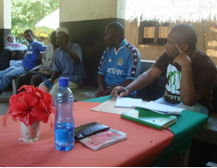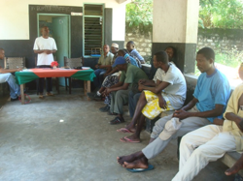
Figure 1 Meeting with the BMU leaders & State Department of Fisheries Officials in Mwaepe
Figure 2 Mwaepe BMU Chairman giving a welcoming speech

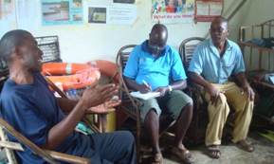
Figure 3 talking to the BMU officials together with the fisheries officer
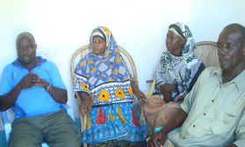
Figure 4 A section of the participants listening to the proceedings

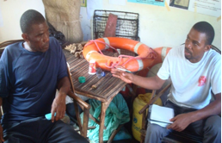
Figure 5 interviewing some of the members on the BMU performance

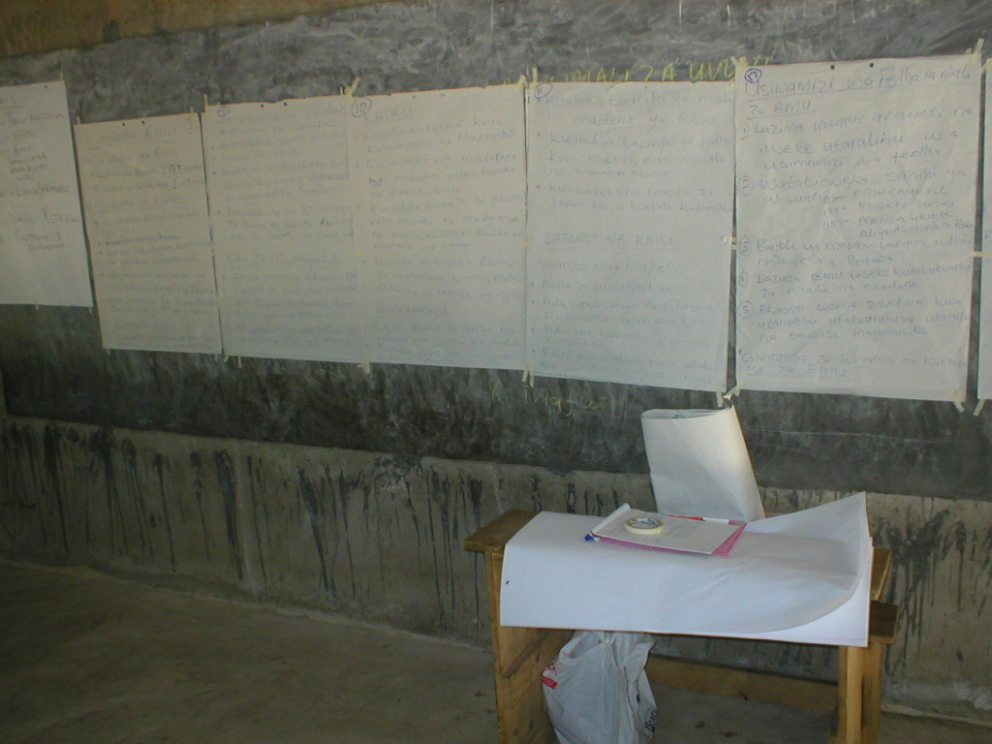
Figure 6 A sections of the training materials in class

