Project Update: April 2015

Introduction
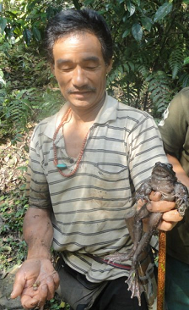
Himalayan bull frog is locally known as gold species whereby only the luckiest person can encounter and apprehended. Its biological values are commensurate by the highly tagged medicines for various ailments. Natural home range for these species is very peculiar from other frog species. Normally, this frog is usually found in pollution-free streams, brook and crooks; abundant rock crevices as it will serve as suitable confinement; undisturbed broadleaved forest and under water temperature below 20̊˚ C within the altitudes ranges of 1000-4000 m (Daniel, 2002).

Today due to the socio-economic development, remotes forests were not only experiencing deteriotion, but also detrimented natural habitats of flagship species including Himalayan bull frog due to farm road construction and electric transmission connectivity between the villages, blocks and districts. The second round of my report shall basic report on preliminary finding on potential anthropologic threats which will likely affect/disturb the prime habitat of Himalayan bull frog that falls along the proposed Gong-Jigmecholing farm road and electric line connection. Simkharthang watershed has good coverage of swampy land with intact forest coverage which serves as a hotspot for conserving reptile and amphibian species due to favourable micro-climatic condition. However, recent ongoing farm road construction and fell of trees along the electric lines corridor (approximately 10 m widths) would cause major anthropologic threat to the core habitat of Himalayan bull frog.

Objectives
The main objective of second round study is:

- To ascertain the anthropologic threat along the natural home ranges of Himalayan bull frogs along the course of Simkhar Rivers and its tributaries

Methodology/approaches

Anthropologic threat survey
Major work for ongoing farm road earth cutting work (picture attached) is in motion. Further, mass felling of trees along Gong-Jigmecholing electric line corridors (picture attached) and electrification works are also underway involving more labors. Camping of labour (four camps each in two locations) deliberately dispose of both degradable and non-degradable wastes in existing camp sites. “This same camp will be made when it reach within the prime habitat of habitat Himalayan bull frogs”, exclaim sites supervisor. If same undesirable disposal continues within the primes habitat area, then population disturbances is predicted to happen as bull frog is very sensitive to effluent. Grazer camps located new to tributaries was the another threats. This is how the socio-economic development would compromises the conservation which was seen during our field visit.

Consultative Meeting on Farm Road and Electric line alignment committees

I had a brief on how environmental degradation causes implication to the sensitive flagship fauna especially Himalayan bull frog which will be passing by. Local government leaders, community leaders, sites labourers and technical heads had deliberation on how to become eco-friendlier with minimum impact farm road construction along the prime habitat. Meanwhile, sites supervisor were brief on proper management of site labourers.

Conclusion

During the second round report, researcher had basically undertaken primary data collection on existing as well as potential anthropologic threats to the habitat of Himalayan bull frog. Ongoing farm road construction, mass felling of trees along the corridor and progression of electrification works involving huge labours were found as possible anthropologic threats seen during our survey. However, consultative meeting with local leaders on possible adaptation of mitigation measures would help them in downsizing the negative impacts for long term sustainability of Himalayan bull frog within their natural home range in future.

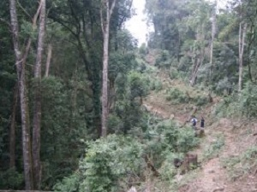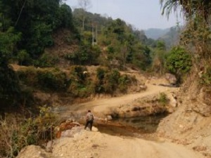
Left: Tree felling on the electric line nearby habitat of Himalayan bull frog. Right: Farm earth cutting nearing to habitat of bull frogs.

