The Rufford Foundation

Final Report
Congratulations on the completion of your project that was supported by The Rufford Foundation.

We ask all grant recipients to complete a Final Report Form that helps us to gauge the success of our grant giving. The Final Report must be sent in word format and not PDF format or any other format. We understand that projects often do not follow the predicted course but knowledge of your experiences is valuable to us and others who may be undertaking similar work. Please be as honest as you can in answering the questions – remember that negative experiences are just as valuable as positive ones if they help others to learn from them.

Please complete the form in English and be as clear and concise as you can. Please note that the information may be edited for clarity. We will ask for further information if required. If you have any other materials produced by the project, particularly a few relevant photographs, please send these to us separately.

Please submit your final report to jane@rufford.org.

Thank you for your help.

Josh Cole, Grants Director

Grant Recipient Details
Your name | Katrina Fernandez
Project title | Status of the Hairy Nosed Otter (Lutra sumatrana) in Peninsular Malaysia.
RSG reference | 16226-1
Reporting period
Amount of grant | £4089
Your email address | Katrina.fernandez@gmail.com
Date of this report | 19th March 2016

1. Please indicate the level of achievement of the project’s original objectives and include any relevant comments on factors affecting this.

Objective | Not achieved | Partially achieved | Fully achieved | Comments
Establish the distribution and abundance of hairy nosed otter populations in Peninsular Malaysia |  | ✓ |  | Unfortunately I did not find evidence of the existence of hairy nosed otter along the River Relau and the River Cheruai in Taman Negara despite camera trapping and extensive surveying. I did however see and record evidence of a healthy population of small clawed otters along both these rivers. I have also recorded a healthy population of smooth coated otters on the periphery of the national park and their primary habitats are the tin mine lakes (old tin mines that have now become lakes).
Gather information on the habitat, ecology and threats to hairy nosed otter populations |  | ✓ |  | I collected ecological data along both rivers and the tin mine lakes where otter species were present. Within the park I captured (on camera trap) evidence of poachers walking along the banks of the rivers in areas where otters were present. The trade in live otters as well as in their fur and other body parts is still significant in South East Asia and I worked with TRAFFIC South East Asia to build up data records of illegal seizures from all countries in the region. This will be made into a TRAFFIC report and presented at the IUCN OSG congress in July 2016. Other threats to otters include an increase of tourist traffic on the Relau, especially of people tubing down the river. Outside of the park where the smooth coated otters are, there is conflict between fish farmers and otters in the tin mine Lakes.
Identify areas for species-based conservation and engage local communities |  |  | ✓ | The rivers within Taman Negara as well as the Sungai Yu which is in the corridor outside of the park is a stronghold for small clawed otters and potentially the hairy nosed otter (if this species can make a come back). The wider sections of these rivers also have smooth coated otters and there is a significant population of smooth coated otters that are thriving on the scattered tin mine Lakes in the area. All of these areas are important areas for conservation. These are also significant areas when considering engaging local communities because there are a large number of local guides from Merapoh village that support tourism within the park. There are also park rangers, palm oil plantation workers and owners (otters have been seen in the streams on their properties) and fishing communities. By engaging with them I have been able to spread the word about otters amongst a much wider community.
Develop a model for in situ conservation of otters in Southeast Asia |  | ✓ |  | Although this was originally the plan, I could not do this within the national park because the permits that I was issued wouldn’t allow me to do so. All of the community outreach was done from park headquarters or in Merapoh Village. I also spent a lot of time in the jungle camps of indigenous communities teaching them about the different species. More time is required on this part of the project for it to be entirely successful. However, on the periphery of the park where there is conflict with fish farmers on the tin mine lakes I was able to suggest solutions such as fencing and extra nets that have so far proved successful.
Establish a regional network of support for otter conservation |  |  | ✓ | This was the easiest part of the project. I had easy access to public meetings to engage with conservationist, was able to give public lectures (via Monash University and the Zoo), increased my network via TRAFFIC South East Asia, spoke to people who walked the tiger trails through MYCat, presented at the Borneo Wildlife Festival, engaged with ECOTEER volunteers and their teams, engaged with foreign tourists that were visiting the national park. I also use social networking as a tool to keep people interested and updated. I also took groups of people out of Kuala Lumpur on weekends to explore the tin mine lakes and to learn otter identification skills and give them a first hand experience of otter habitats and conservation efforts.

2. Please explain any unforeseen difficulties that arose during the project and how these were tackled (if relevant).

To begin with the project took off on very different date than anticipated. First there were visa issues and then there were research permit issues. Furthermore, my initial collaboration with Monash University was not acceptable to the Economic Planning Unit, the government arm responsible for issuing the permits. They required me to partner up with one of their own public universities and this took a few weeks to achieve. Although my application to them stated that I wished to survey all rivers in Taman Negara I was granted permission to conduct my survey only on the Relau. I managed to get permission to do another river from the local park headquarters a little later on in the project. Initially I was allowed to use the Bateq, the indigenous people as guides, as well as a field assistant, Angela Smith, a British national. However, after one of my cameras was stolen from the south bank of the Relau, about 1.5 km away from park headquarters, the park authorities tried to place blame my team and after this incident I wasn’t allowed to take any of them in. The park headquarters assigned one of their park rangers to me for the rest of fieldwork, (which was thankfully after I had done all the ecological data collection) inside of the park. However, outside of the park, I continued to use my original team.

3. Briefly describe the three most important outcomes of your project.

1) I was not able to determine the presence of the hairy nosed otter in Taman Negara despite extensive camera trapping and surveying which suggests that they are no longer present or that the small clawed otter population has displaced a much smaller hairy nosed otter population to other areas in the park, although the literature suggest that the two species could live sympatrically.

2) I did record a widespread population of small clawed otters and smooth coated otters both inside the park and on its periphery and corridor outside of the park. I was also able to determine the most significant threats to these populations.

3) I interacted with a lot of people, local, regional and international to spread the word on otter conservation by:
- Presentation at Borneo Rhythms of Rimba Wildlife Festival 2015.
- Visiting the Centre for Marine and Coastal studies in Penang to teach and train students about otters, otter habitats and otter research.
- Guiding a Honours project at Monash University on smooth coated otters.
- Taking local people (who are interested in the outdoors) walks to Kuala Selangor Nature Park - and talking to them about otters and their importance to ecosystems.
- Taking people on otter walks and showing them how we set up camera traps at Taman Negara and talking about otters and the need for otter conservation.
- Teaching the younger generation of the Bateq community about the importance of otters
- public lecture at Monash University about the trade in otters in South East Asia

4. Briefly describe the involvement of local communities and how they have benefitted from the project (if relevant).

Bateq – Through my interaction with the Bateq people and by showing them numerous images of different species of otters I had gathered that their identification skills for the different species was inconclusive. Over time, working with me, my guides, learned to identify the different species that we were looking for based on their physical appearance as well as the subtle differences in their scats (smell, texture and contents) and footprints. I have seen these skills being passed on to the next generation. My field assistant Angela Smith and I spent two afternoons a week interacting with the Bateq children (of all ages), teaching them English and incorporated otters into their English language learning activities. We also gave them drawing and colouring exercises that included otters. We had photo and video sessions. We also took them to jungle school, which was a day out in the jungle, walking along the river banks trying to identify different foot prints, significant vegetation in the area and other signs of wildlife.

The non-indigenous local communities – I spent a lot of time with the local farmers, some of who were trained guides that were employed by the park to take tourists into the park. I used photos and videos of otters to capture their interest in the animals and eventually showed them what to look for in the field and why they are important and need to be protected. Similar strategies were used in local schools as well. Interesting to note that this resulted in my getting notified every time an otter was spotted any where of a 50 km radius of Merapoh village. This was very useful for me to keep track of otter presence and confirm this presence by surveying that area.

5. Are there any plans to continue this work?

Yes, I am hoping to continue this work in the future. I have a 2-year postdoctoral commitment that I need to fulfil in Australia beginning in July 2016, but I will continue to advocate for the species in Malaysia and elsewhere in Asia. And I hope to return in a couple of years and complete what I have started. I have left the camera traps in Malaysia with colleagues, who will continue to collect data for me. And I will make this available to the public as I get it.

6. How do you plan to share the results of your work with others?

I will be publishing a report that will be made available of research gate as well as on the Otter Specialist Group website. A copy will also be sent to Rufford. I will also share the results via special media and on my blog. The IUCN Otter Congress 2016, which is going to be held in July 2016 in Singapore, is also an outlet for my results.

7. Timescale: Over what period was The Rufford Foundation grant used? How does this compare to the anticipated or actual length of the project?

The grant has been used over a 1-year period as per the original proposal but with changes to the schedule. The project started in March 2015, and it started with verbal surveys, fieldwork outside the park and outreach (while I was waiting for the permits to be issued). Fieldwork inside the park began in May 2015. Rather than doing the conservation outreach at the end as indicated in the proposal, I continued to do this throughout the year. I will spend the next 2 months compiling the data and writing up reports.

8. Budget: Please provide a breakdown of budgeted versus actual expenditure and the reasons for any differences. All figures should be in £ sterling, indicating the local exchange rate used.

Item | Budgeted Amount | Actual Amount | Difference | Comments
Bushnell Cameras | 900 | 1006.8
Bushnell Security Case | 120 | 152
Python Locks | 72 | 105.6
GPS | 210 | - |  | Borrowed from the university
Transportation to the park | 360 | 360
Accommodation | 672 | 672
Transportation in the park | 150 | 150
Park fee | 30 | 30
Solar charger | 103 | 90
Food | 400 | 360
phone | 180 | 180
Stationary | 50 | -
Tablet | 400 | - |  | Did not procure
Camera for field work | 442 | 469
Customs and GST on cameras and cases | - | 91.36
Amazon Shipping to US address | - | 21.65
Shipping from US to Malaysia | - | 370.58
SD Cards for cameras | - | 33
Total | 4089 | 4091.99

9. Looking ahead, what do you feel are the important next steps?

I feel that the search for the hairy nosed otters needs to be extended to other areas in the peninsula. A lack of knowledge about the different otter species that are present in the region, and their importance in their ecosystem, and how these animals are exploited in the pelt and pet trade amongst many other threats are some of the factors that need to be addressed. From my experience, this past one year, involving the community is a necessary and significant approach to otter conservation in the region. Talking to people, showing them images of otters and detailing the threats they face has made a difference in attitudes towards the species.

10. Did you use The Rufford Foundation logo in any materials produced in relation to this project? Did the RSGF receive any publicity during the course of your work?

Yes, I made sure that the Rufford Foundation was and is acknowledged in all of my presentations and on social media in connection with my project.

This includes university lectures, other public talks, the Borneo Wildlife Festival, my talk at the Fishing Cat Symposium in Nepal, in flyers distributed for the jungle walk, on my blog, twitter, Facebook, Instagram, and on any presentations.

11. Any other comments?

I would like to thank The Rufford foundation for making it possible for me to do this project in Malaysia. I have gained a tremendous amount of experience and knowledge, both professionally and personally from this project, which would not have been possible without your funding programme.

Annex - Pictures

Outreach at Kuala Selangor nature Park
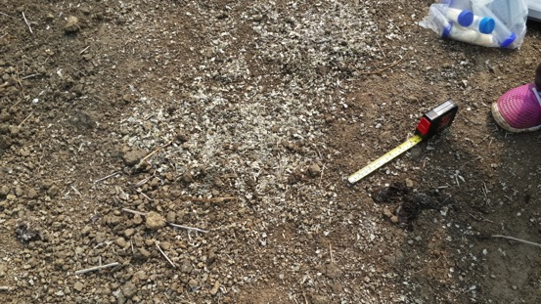
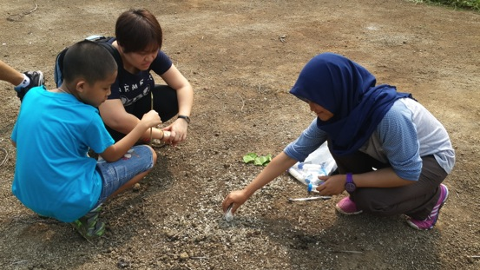

Outreach with the Bateq - Children
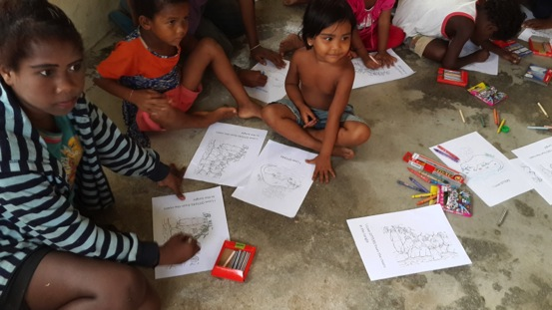
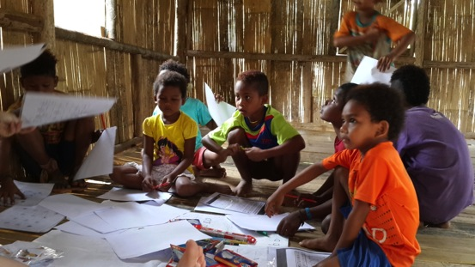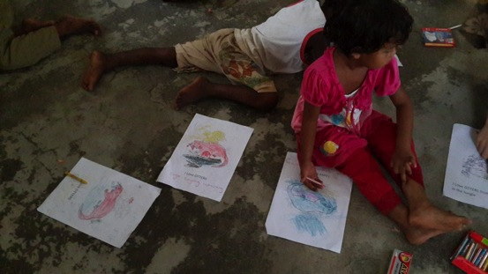
Otter Signs along the river 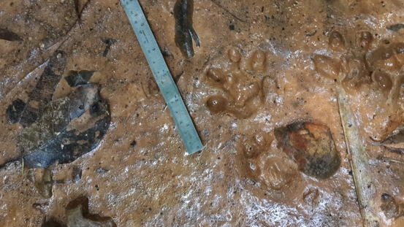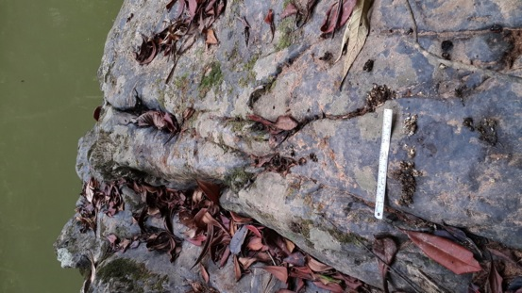

Otters in the Tin Mine Lake

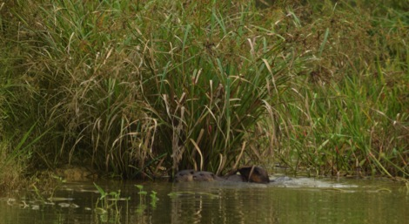
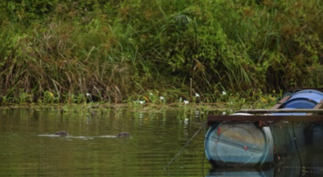

Fisheries

