Project Update: July 2015

We have concluded agreement with Gorgany Natural Reserve on its territory exploring, installation of signage elements and providing of an ecotrail with educative materials. We’ve been granted precise GPS coordinates of perimeter line which has already been published in the latest area’s tourist map to indicate true protected area’s border and provide more thorough territory’s control by reserve’s guards. After the snow came down, in April-May 2015 we’d been exploring 40 km of reserve’s perimeter in search for outdated, damaged or missing elements. Also we were searching for any illegal logging or other law’s violation that may’ve taken place. The lumber and construction materials for eco-boards have been supplied as well.

We’ve strengthened partnership with Precarpathian National University and Carpathian National Nature’s Park while discussing ecoactions’ holding at Pip-Ivan observatory and “CleanLakes of Carpathians” at Maricheyka and Hereshaska lakes which would take place in the end of August 2015.

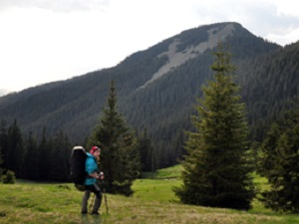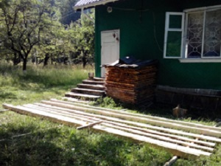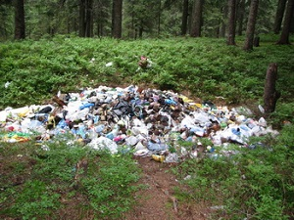
Left: Exploring reserve's perimeter. Middle: Processing lumber for Eco boards. Right: Rubbish at Maricheyka Lake.

