Project Update: March 2010

Field surveys
Five field surveys of 8 days each were conducted from November 2009 to February 2010. The surveys were organized in Djoum and Lomié and each involved a team of five people composed of the Principal investigator, an Ecoguard from ECOFAC, a member of ASED and two hunters from the neighboring village who help in the identification of bongo tracks. Observations started after the crossing of the Dja River. In order to study the diet of the bongo, we followed four bongo tracks across the forest for a total distance of 49 km. Plant density was evaluated in five plots (10 x 5m) on each track for a total of 20 plots. Plants were considered eaten by bongo when only the footprints of bongo were identified near the plant and signs of leaves removal were noted.

Outputs
Bongo feed on the leaves of 14 plant species including two species of grasses, and fruits of four species. Most frequent species that were part of the diet and showed higher frequency of eating signs on leaves included Calancoba welwitchii, Landolphia dulcis, Strombosia grandifolia. Footprints were observed under Anonidium manni, Cephaelis mannii, Myrianthus arboreus and Irvingia gabonensis, suggesting that bongo may eat the fruits on the ground. An unspecified grass and Emilia praetermissa were obtained by incubating bongo scats in plastic pots. These grasses were the dominant species around the larger lick in Djoum.

Table1: List of plant species eaten by bongo and their frequency in ten plots (10x5m) in the Dja Reserve

Plant species | Family | Count | Part eaten | Plants with eating signs
Aframomum danielli | Zingiberaceae | 17 | leaves | 2
Anonidium mannii | Annonaceae | 18 | fruits | 0
Barteria fistulosa | Passifloraceae | 15 | leaves | 1
Calancoba welwitchii | Flacourtaceae | 19 | leaves | 6
Cephaelis mannii | Rubiaceae | 12 | fruits | 0
Dialium pachyphyllum | Cesalpiniaceae | 7 | leaves | 4
Diospyros crassivora | Ebenaceae | 12 | leaves | 2
Emilia praetermissa | Compositae | -- | leaves | --
Gilbertiodendron dewevrei | Cesalpiniaceae | 11 | leaves | 1
Irvingia gabonensis | Irvingiaceae | 8 | fruits | 0
Landolphia dulcis | Apocynaceae | 33 | leaves | 6
Landolphia ligustrifolia | Apocynaceae | 12 | leaves | 4
Mannyophytum fulvum | Ebenaceae | 9 | leaves | 2
Myrianthus arboreus | Cecropiaceae | 10 | fruits | 0
Undertermined | Compositae | --- | leaves | --
Palisota hirsute | Commelinaceae | 34 | leaves | 2
Stombosia grandifolia | Olacaceae | 29 | leaves | 4
Vitex sp | Verbenaceae | 19 | leaves | 1

Habitat characterisation
The most noticeable feature along the bongo track is the presence of water points (licks). The germination from bongo scats of grass that covers licks is an indication that this constitutes an important component of their home range. Two resting sites were identified on the border of the lick of Ebale and one in Lomié. The later was identified as a solitary resting site where those in Ebale was group resting sites (3 and 5 resting places) according to the number of footprint and dejections on the site. The Ebale lick is completely opened (about 200 m x 200 m), almost entirely cover with grass and delimited from the forest by plants of Campylospermum excavatum (Ochnaceae). Fresh scats of Bongo were observed with a total of six heaps of faeces.

Main difficulties
The main constraint we are facing in the implementation of the project is the permanent hunting activity as empty shot capsules were found during our investigation in the forest. Furthermore, two dead elephants without their tusks were found in decomposition and the nasty odor released might have act as repellent to other animals. Because of these recent signs of permanent human presence, animals had probably run into the deep forest.

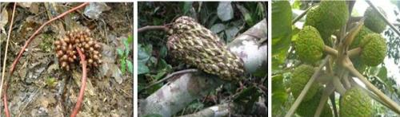
Fruits from trees around which footprints of Bongo were observed. Cephaelis mannii (left) Anonidium mannii (middle) and Myrianthus arboreus (right)

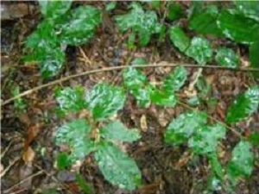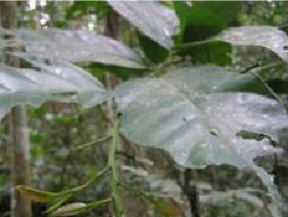
Some common plants eaten by Bongo in the Dja reserve: Landolphia dulcis (left) and Stombosia grandiflora (right)

