Project Update: November 2009

The bongo (Tragelaphus eurycerus) is the largest and heaviest forest antelope.Very little data exist on the ecology and distribution of this species in the southern Cameroon rainforest. Habitat disturbance and poaching of bongo have caused severe reductions of populations of this species in this area. Thus, few bongo observations had been reported over the last few years in southern Cameroon rainforest.

This project was initiated by Yede, a member of the Association for Environment and Sustainable Development (ASED), which works in collaboration with the Conservation Service of the Dja Reserve (ECOFAC).

The project intended to provide insight on the bongo abundance and distribution in the Dja Reserve and characterize habitat and diet. The perception of the people living around the reserve on the status of this species was also to be evaluated.

Field Surveys

Six field surveys of 8 days each were conducted from May 2009 to October 2009. The surveys were organized in two out of four areas of the Dja Reserve (Djoum and Lomie), based on the highest probability of finding Bongo Individuals. This information was provided by the Conservation Service of the Dja Reserve.

Each survey involved a team of five people composed of the Principal Investigator, an Ecoguard from ECOFAC, a member of ASED and two hunters from the Baka tribe whose populations border the reserve. Observations started after the crossing of the Dja River till we reached ca. 40 km inside the reserve. Information to be noted on the prepared data sheet included the number of individuals encountered along the path, their behaviour, the description of plant species in habitats where individuals or identified signs could be recorded. Special attention was paid around a saline identified in the Djoum area, where animals usually come to drink. Tracks were recorded using a GPS.

Outputs
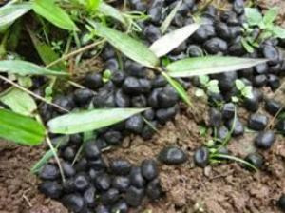
No bongo individuals have been observed along the paths surveyed so far. However, footprints and faecal pellets were confidently identified by the trackers. A skull was identified and recorded by trackers in the Djoum area, but the cause of death could not be assessed confidently, although the trackers attributed it to panthers.

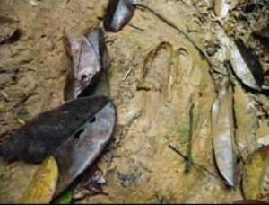
The vegetation in which these indices were found were found was characterized by measuring in a 20 x 2 m² quadrat around identified signs, the plant species collected are summarized in table 1.

Table 1. List of plant species found around bongo footprints, faecal pellets and skeleton.

Plant species Family Stratum
Spermacoce princea Rubiaceae Shrub
Cnestis ferruginae Zingiberaceae Shrub
Sida alba Malvaceae Herb
Terminalia superba Combretaceae Tree
Campylospermum excavatum Ochnaceae Shrub
Emilia praetermissa Compositeae Herb
Desplatia dewervrei Tiliaceae Shrub
Undetermined Gramineae Herb
Undetermined Tree

Pooling of Hunter's Perception

Thirty-two hunters completed a questionnaire about their perception of bongo density in the Dja reserve. Questions addressed included their age, how often they entered the reserve, the average area they could cover in the reserve, and whether or not they often encountered Bongo groups

Villagers use three common names for Tragelaphus eurycerus. These are “ezona” or “izona” used by Fang-Bulu tribe and “bongo” used by Baka tribe.

Interviewed hunters have been involved in hunting for 25 years on average. No-one interviewed has ever killed a bongo but 14 of them know someone who has killed a bongo at least once. On average each hunter enters the reserve once a week for 2 or 3 days. During this period, they can cover more than 100 km. They justified these long treks by the scarcity of the animal they hunt. Only four hunters have ever seen a bongo (a group of one to five individuals) in the Dja Reserve; this was 2-4 years ago.

Way forward

Current efforts are being devoted to field sampling in the Dja Reserve. Some locations where bongo could be encountered were mentioned by hunters, namely Kika, Yoko and Ndelele. Plans are being made to visit those locations. Some of the plant samples collected in the area where faecal pellets were collected are being identified at the Cameroon national herbarium. Collected faecal pellets are kept in the fridge for detailed examination which could reveal some of their components.

