

PARTICIPATORY SURVEY AND CONSERVATION OF ENDANGERED
SAVANNAH ELEPHANTS OF KAMUKU AND ITS ENVIRONS, NIGERIA

BEING A FINAL PROJECT REPORT

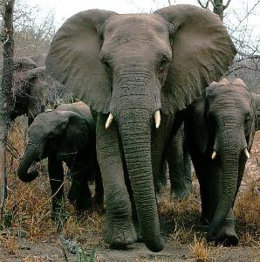

Prepared By
AMUSA, Tajudeen Okekunle

SUBMITTED TO
RUFFORD SMALL GRANTS FOUNDATION
(FOR NATURE CONSERVATION)
www.ruffordsmallgrants.org

RUFFORD SMALL GRANTS FOUNDATION
6th Floor, 248 Tottenham Court Road London W1T 7QZ

MARCH 2011

PROJECT BRIEF

Title: Participatory Survey and Conservation of Endangered
Savannah Elephants of Kamuku and its environs, Nigeria

Categorization: Mammal

Name of Project Executant: AMUSA, Tajudeen Okekunle
Federal College of Wildlife Management
Forestry Research Institute of Nigeria
P.M.B. 268, New Bussa,
Niger state, Nigeria
Tel: (234) - (805) - 1750289
E-mail: teejayui@yahoo.com; teejayui@gmail.com

Project Duration: 12 Months

Status of Report: FINAL

Date of Submission: MARCH 2011

EXECUTIVE SUMMARY

1. A Participatory Survey and Conservation of Endangered Savannah Elephants of Kamuku and its environs, Nigeria was carried out through a collaborative work involving wildlife researchers, conservation managers and local residents.

2. The main aim of the survey was to strengthen the capacity of Park rangers and locals, and raise
awareness and enlightenment of local communities on the need for conservation of wildlife species, with special focus on the preservation and protection of the endangered savannah elephants of Kamuku National Park and its environs.

3. The project featured sensitization and planning meetings with community stakeholders; communitywide conservation education; establishment of community-based elephant conservation/ monitoring committees; recruitment of survey corps/team and; capacity building program on elephant survey procedure.

4. The participatory survey of elephants in and around the park revealed that elephants with mean group size hovering around thirteen (13) individuals traverse the Kamuku National Park (KNP) area on annual basis, with more indices of elephant occurring in the Doka range.

5. Local residents have varying opinion on whether elephants in the area are increasing or
decreasing, but the likelihood to accept that the Kamuku elephant population is on the rise was more.

6. Crop damage by elephants is a significant and growing problem in the area.

7. The survey also exposed the presence of threats against elephant routes, ranging and dispersal areas. A widespread trait of all the threats to the elephant population is habitat loss and fragmentation.

8. Based on data collected, we suggest the need for habitat improvement as well as restoration of preferred food resources of the animals in and around the park.

9. In the meantime, elephant route need to be protected from various anthropogenic activities such as bush burning, farming, livestock grazing, fuel wood exploitation and logging.

10. There is need for the Park management authorities, community leaders and local residents to jointly work out proactive measures to reduce elephant-induced damage.

11. It is important to identify and understand the movement patterns of the elephants, as well as their resource needs and availability along migration routes.

12. The current move of the Park management authorities to discuss with relevant stakeholders on the need for trans-boundary joint patrol activities and sensitization campaign within the significant towards ensuring the viability of the Kamuku elephants as the game reserve and other areas have been identified as important haven of the elephants. This is also important so as to develop a coherent strategy for the conservation and management of the species.

13. It is further recommended that a more detailed study of elephant movement in the study area using radio/satellite tracking be initiated.

14. There is also the need for continuous sensitization, support and empowerment of local people through community initiatives outside protected areas in the landscape to ensure they participate in the conservation and protection of wildlife and natural resources.

TABLE OF CONTENTS

TITLE PAGE 1
PROJECT BRIEF 2
EXECUTIVE SUMMARY 3
TABLE OF CONTENTS 5
1. INTRODUCTION 7
1.1 Background 7
1.2 Reasons to collect data on elephant range and numbers 8
1.3 The need for a participatory approach 8
1.4 Objective of the Project 8
1.5 Justification 9
2. MATERIALS AND METHODS 10
2.1 The Project Site 10
2.2 Preparatory Work 11
2.2.1 Project planning and setting out 11
2.2.2 Development of Work Plan 11
2.3 Sensitization and planning meetings with community stakeholders 12
2.4 Establishment of community-based elephant conservation/monitoring 12
committees and Recruitment of survey corps
2.5 Gathering qualitative data on elephant status and conservation in KNP and 12
Its Environs
2.6 Capacity building program/workshop on participatory survey, monitoring 13
and reporting for recruited survey corps as well as park rangers on elephant
survey procedure
2.7 Participatory survey of elephants in Kamuku National Park and its environs 13
2.8 Incidence of Crop raiding by a group of elephant 14
2.9 Data Analysis 14
3. FINDINGS AND OBSERVATIONS 15
3.1 Qualitative Data 15
3.1.1 Insight on status of elephants around Kamuku National Park and its Environs 15
3.1.2 Trend in Elephants Population in the Last Five Years 20
3.1.3 Damage caused by Elephants 21
3.1.4 Measures for tackling human-elephant conflict 22
3.1.5 Respondents’ Attitude towards Elephant Conservation 22
3.2 Transect and Recce Survey Findings 23
3.3 Monitoring Elephants’ dung decay Process 25
3.4 Important locations in the landscape 30
3.5 Threats to habitat status and elephant conservation 31
4. SUMMARY OF FINDINGS AND PROJECT ACHIEVEMENTS 33
4.1 Summary of Findings 33
4.2 Project Achievements 33

5. RECOMMENDATIONS AND CONCLUSIONS 35
5.1 Recommendations 35
5.2 Conclusions 36
ACKNOWLEDGEMENTS 37
REFERENCES 38
APPENDICES 39
I. Questionnaire on Qualitative Data Collection 39
II. Recording sheet for Transects and Recce survey 42
III. List of community-based elephant conservation/ monitoring committees 44
IV. List of Recruited Survey corps 45
PHOTO SPEAK 45

1. INTRODUCTION

1.1 Background

The African elephant (Loxodonta africana Blumenbach, 1797) is the world’s largest terrestrial mammal which inhabits a wide variety of habitats, ranging from the arid semi-deserts through the woodland savannah to the dense humid forests. It is an important “keystone”, “flagship” and “umbrella species” for conservation, research and tourism. It plays a key role in the ecology of forests and savannas by influencing the structure of both the plant and animal communities and dominating the biomass in the habitats it occupies.

Today, the African elephants are currently endangered in much of their ranges. Historically, the continental decline of the African elephant population and the contraction of its range are associated with the ivory trade over several centuries, coupled with human population expansion and desertification (Cumming et al., 1990). According to Parker and Graham (1989), the declining elephant population trends in Africa were the result of complex historical processes between humans and elephants, including competition for fertile land and water.

In 1989, the African elephant was placed on Appendix I of the convention of International Trade in Endangered Flora and Fauna (CITES), as a result of the data showing population decline on the African continent as a whole. For West Africa, elephant species are at present found in just 35 isolated populations, containing approximately 4,784 individuals (IUCN, 2003). More disheartening is that only 11 of the 35 populations are thought to contain 100 or more elephants. In actual fact, the picture of African elephant range in the present day is one of scattered, fragmented population south of the Sahara Desert.

As an endangered species, the conservation of African Elephants in their natural habitat and across their historical ranges is of very high priority wherever they occur to ensure the survival of the remaining isolated wild populations. Moreover, as habitats are becoming more fragmented and degraded, it is essential to keep accurate and up-to-date information on size and distribution of population for habitat monitoring and providing conservation and management plans for the species.

This project covers the Kamuku National Park and its environs in Kaduna State, North-western Nigeria. The Park is one of the country’s Key Biodiversity Areas with an enviable biodiversity profile including small but viable populations of the endangered savannah elephants, Loxodonta africana (EN). The migration and marauding of these elephants to surrounding unprotected areas and the stressed human-nature relations in the area has increased the susceptibility of the elephants to major threats including habitat destruction and a lack of conservation action plan. Without corresponding increased protection efforts, it is unlikely that the populations of this savannah elephants will survive long into the future. To avert this, a long road of environmental sensitivity which must include conservation education and joint action is required. Thus, this project represents the first systematic survey of the Kamuku elephants by involving local communities through capacity building and conservation education.

1.2 Reasons to collect data on elephant range and numbers

Information on elephant range and numbers is vital for effective conservation and management of the species. More than ever, wildlife management authorities need to have accurate data on elephant populations to be able to control or reduce human-elephant conflict across their range.

Besides, non-protected areas increasingly constitute the majority of elephant range and national wildlife authorities are faced with the issue of management outside and within national parks and reserves. There is more conflict between man and elephants, especially in agricultural areas which were formally uninhabited by humans, presenting a difficult challenge to conservationists. Thus, there is clearly a need for defined management objectives for both protected and non-protected areas of elephant range; and these cannot be drawn up without accurate information on elephant distribution and numbers.

There is an urgent need to carry out a systematic survey of the Kamuku elephants so that management plans can take account of migration routes and important locations for food or for refuge, as well as identifying areas with concentrations of the animals with potential for ecotourism. This more obviously, will provide a sound structure for effective protection of the species. In essence, without enhanced knowledge on elephant abundance and distribution it will be impossible to develop a coherent strategy for their conservation and management.

1.3 The need for a participatory approach

The unique feature of this project is its participatory approach at ensuring an improved conservation of the Kamuku elephants. A participatory approach shares the planning, research activities and use of the results between different groups of people who have an interest in the sustainability of a project.

The philosophy behind the adoption of a participatory approach stemmed from the fact that solutions to conserving an endangered species are often beyond the technical realm:
▪ that people are part of the solution too;
▪ that stakeholders must work together;
▪ that local people must indeed take the lead in site conservation and;
▪ that partnership is the way forward.

To this end, the guiding principle behind the project is to ensure the active participation of all
stakeholders in the conservation of the Kamuku elephants.

1.4 Objectives of the Project

The broad objective of the project is to strengthen the capacity of Park rangers and locals, and raise awareness and enlightenment of local communities on the need for conservation of wildlife species, with special focus on the preservation and protection of the endangered savannah elephants of Kamuku National Park and its environs. The specific objectives are to:

i. examine the conservation status of the elephant in and around Kamuku National Park;
ii. determine the population status and distribution of elephants in the area;
iii. stimulate environmental sensitivity to elephant conservation through education and joint action and;
iv. identify follow-up work that would lead to the establishment of effective protection for elephants in the project area.

1.5 Justification

Sustainable conservation and management of wildlife species will depend on strengthening the capacity of the local populace, communities and general public to understand and implement conservation initiatives. Participatory survey of endangered savannah elephants of Kamuku and its environs focusing on their population status, distribution and migration pattern in the area is vital to allow development of a conservation plan to offer protection for the species.

Elephants are highly susceptible to disturbance; thus they can be used as an umbrella species to ensure the conservation of other endangered plants and animals. They are not only a flagship species, but also a keystone species across the world particularly for the Sudan-Guinea Savannah vegetation.

In addition, community-based conservation education and training will help raise awareness and enlightenment of local communities on the need for joint action towards protecting the species and securing their supports for future conservation efforts.

This project will also contribute to enhance the protection of the unique Sudan-Guinea Savannah vegetation block in the area. Besides, conservation of wildlife species can only occur if their habitats are well maintained.

Furthermore, the projects expected outcome would make an important connection in stimulation of eco- tourism activities and derivation of other ecosystem services.

2. MATERIALS AND METHODS

2.1 The Project Site

Kamuku National Park (KNP) is located in Birnin Gwari in Kaduna State, North-western Nigeria. It is geographically situated on longitude 100 451 N and latitude 060 301 E (Figure 1) covering an estimated area of 1,120km2. The Park, originally gazetted as Birnin Gwari Native Authority Forest
Reserve in 1936 was upgraded to the status of a National Park in May 1999.

KNP lies within the basement complex region of Nigeria. The soils are shallow ferruginous loams and clays with areas of overlying laterite. The terrain is largely flat, rising gradually eastwards to the Birnin Gwari Ridge (with highest altitude of about 610m), which forms part of the eastern boundary. Elevation is least, averaging 380m around the Mariga River valley on the south-western boundary. Annual rainfall in the area average 1,150 mm with the rainy season occurring between May and October. Temperature ranges between 250c -350c for most part of the year with a generally high humidity. The vegetation is characterized by both Guinea and some transitional Sudan Savannah, representing one of the best remaining blocks of Sudan-Guinea Savannah vegetation in the country’s protected-area system.

KNP is one of Nigeria’s Key Biodiversity Areas with an enviable biodiversity profile. Small but viable populations of elephant Loxodonta africana (EN), roan antelope Hippotragus equinus (LR/cd), water buck Redunca redunca (LR/cd) and western hartebeest Alcelaphus buselaphus (LR/cd) occur in the Park, as do small numbers of lion Panthera leo (VU). While the bulk of management efforts centre on protecting the Park’s large mammal fauna, KNP also provides a unique opportunity to conserve large tracts of intact Guinea and some transitional Sudan Savannah, an increasingly threatened habitat. In addition, some major tributaries of the river Kaduna, which is vital for domestic and industrial activities within the region, have their source inside the Kamuku National Park.

Historically, the Park has some cultural significance with two major tribes, the Gwaris and the
Kamukus. Traditionally, both are mainly farmers with minority being hunters, pastoralists, expert craftsmen, weavers, pottery makers and blacksmiths. Pockets of other tribes such as the Hausa,
Fulani, Yoruba, Ibo, Kataf, Kanikon, Jaba, Marwa and Kogoro are also found in the area as settlers.
Few now work in the modern sector including private and public organizations. Several settlements form the Support Zone Communities of the Park with an estimated population of 30,400 inhabitants (KNP, 2010). Major threats to conservation activities are hunting, illegal cattle-grazing and a lack of management plan since establishment in May 1999 (Ezealor, 2002)*. Kamuku National Park is placed in World Conservation Union (IUCN) Management Category II i.e. Protected Area managed mainly for ecosystem protection and recreation.

*The Park now has the most recent management plan (dated 2010) in the country’s protected-area system.
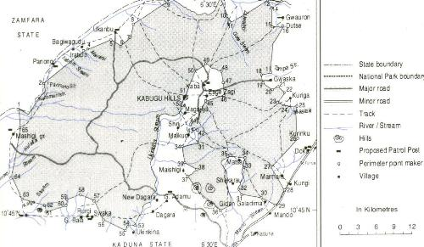

Figure 1: Map of Kamuku National Park showing the supports zone communities

2.2 Preparatory Work

2.2.1 Project planning and setting out:

The project team (gracefully accompanied by the Provost- Federal College of Wildlife Management, Dr. A.J. Meduna) embarked on project initiation and advocacy visit to the management authorities of Kamuku National Park (KNP), Birnin Gwari, and Kaduna State on 13th April, 2010. This was with a view to garnering support and carry out a further evaluation of problem analysis as well as identifying possible challenges/constrains to successful project implementation. The team leader/project facilitator- Mr. AMUSA, Tajudeen Okekunle gave a succinct description of the project. Particular interest was expressed by the Kamuku National Park management authorities (led by the Conservator of Park, Mr. Abdullahi Ahmad) on the need for the project and its willingness to commit resources and logistics to the project’s fruition and sustenance. Copies of the project proposal were submitted for further appraisal.

2.2.2 Development of Work Plan

Since the guiding principle for the project is to ensure the active participation of all stakeholders in the conservation of the Kamuku elephants, the project team engaged in a round table discussion with personnel and field officers of Kamuku National Park to jointly formulate a work plan for the project. Participants included Head of Department, Park Protection and Conservation- Mr. Ayoola, R. Muraina, the Research Officer (KNP), Miss Fxentirimam, I. Jauro and a Conservation education and extension officer (KNP), Mr. Shetima Muhammad. Others were Mr. Gunu, A. Mora, Mrs Sheyin, R. K, Mr. Garba K. A, Mr. B. A. Adam, and Mr. Hassan Danjuma. The project was described by the team leader/project facilitator and series of meaningful inputs were made by participants. Communities were further identified and protocols for engaging them were thoroughly discussed and analysed. A revised and joint work plan for the project was arrived at.

2.3 Sensitization and planning meetings with community stakeholders

Sensitization and planning meetings were carried out with community stakeholders in the support zone area of the Park (communities that lie within 0-5km radius of the Park) on 14th April, 2010.
Communities visited were Kakangi, Dagara I, Dagara II and Bugai. Goron dutse, Kuiga I, Kuiga II,
Gwaska and Nabango were visited on 16th April, 2010. The exercise was premised on the fact that the local communities have the highest stakes in the success and sustainability of the project. In addition, the local communities as custodians of the environment have the knowledge and capacity to contribute to successful conservation of wildlife species. This approach helped to incorporate the views, perceptions, religious beliefs, interests, priorities and realities of the communities in project planning and design. Receptions were generally warm and great in all communities visited. The community leaders and village council specifically promised their commitment towards ensuring the success of the project. To date, we have maintained good relations with the traditional chiefs and councils in these communities.

2.4 Establishment of community-based elephant conservation/ monitoring committees and Recruitment of survey corps

Consultations, meetings and discussions were held with various stakeholders in the selected support zone communities of Kamuku National Park. These included women and youth groups, hunters, pastoralists and farmers. In collaboration with the community leaders and stakeholders, community based elephant conservation/ monitoring committees were established in each of the target villages. These committees served as a village task-force for supervision of community responsibilities relating to organising, implementation and monitoring of project activities in the various communities. In specific terms the community-based elephant conservation/ monitoring committees among others helped to sensitize and educate members of their communities on the need for the protection of elephants in their provinces. They also served as the first contacts in any case of elephant raid of farmlands. In addition, the community taskforce units also served as focal points for recruitment of survey corps for the project.

2.5 Gathering qualitative data on elephant status and conservation in KNP and its environs

Qualitative data on the range of local peoples’ understanding and knowledge of elephant
conservation status in and around KNP were collected. We elicited information through Focus Group Discussion (FGD) involving elders, farmers’ group and youths from each of the communities. Interview schedule (IS) was used to extract information among these groups of respondents. A total of forty-seven respondents were involved. Efforts were made to keep the interview uniform so that whatever bias was present would be consistent throughout. The IS included a mixture of open-ended and fixed-response questions. Open-ended questions were used to elicit information and extensive discussions of some of the issues faced in the conservation of the elephants in KNP especially crop raiding. On the other hand, the fixed-response questions which were in form of attitude statements were drawn on to examine the respondents’ conservation attitudes towards the elephants in the project area.

2.6 Capacity building program/workshop on participatory survey, monitoring and reporting for recruited survey corps as well as park rangers on elephant survey procedure

From June to August 2010, the project team organized capacity building program/workshop on participatory survey, monitoring and reporting for recruited survey corps as well as park rangers on elephant survey procedure. This was based on the fact that sustainable conservation and management of wildlife species will depend on strengthening the capacity of the local individuals, communities and public to understand and implement conservation initiatives. Emphasis was placed on the need to use standardized methods so that survey results can be used to monitor change over time, whether changes are positive as a result of management interventions or negative as a result of unrestrained anthropogenic/ecological factors.

Participants were informed on the need for participatory survey of large mammals; why endangered species must be protected; that solutions are often beyond the technical realm; that people are part of the solution too; that we must work together; that local people must indeed take the lead in site conservation and; that partnership is the way forward.

The training focuses on two methods of elephant census/techniques: The Line Transect Survey
Method (Barnes and Jensen, 1987) and the Short-cut or Reconnaissance (“recce”) Method (Barnes,
1988). Outlines of procedure in each method were thoroughly discussed and analysed. The proper methods for making observations and recording data were covered. Participants were taught on the use of simple instruments employed in data collection. These include maps, compasses, GPS, meter tape and hip chain. Special emphasis was placed on distance measurements and elephant dung categorization. We used power point presentations and Hands-on demonstration to deliver training.

2.7 Participatory survey of elephants in Kamuku National Park and its environs

A first rigorous, participatory and systematic survey of the Kamuku elephants was conducted by the project team and survey corps for both rainy and dry seasons in 2010. Surveys were carried out at the two main ranges of the Park- Doka and Dagara. We relied on the knowledge of locals and experienced rangers for selection of transect lines and recce. The survey procedure is described below:

At each sampling location each survey team moved on a road and walked 500m into the woodland on a compass bearing perpendicular to the direction of the road. Starting at the 500m point, a 1-km transect was cut and marked on the same compass bearing. Every elephant dung pile detected from the transect line was recorded. The perpendicular distance from the transect line to each dung pile was also measured to the nearest centimetre with a tape measure as well as distances along the transect. These measurements were taken with a view to estimating elephant’s density in the area, but due to low encounter rate the idea was discarded.

For our recce survey; each survey team was split into two at the end of every transect; each then walked 50 m perpendicular to the transect at opposite direction. Moving in single file, each team followed the path of least resistance while attempting to maintain a general compass bearing opposite that of the transect. All recce walks also spanned 1 km. Dung observations were made as on transects, but no distance measurements was recorded.

In effect, there were two aspects to the data collection: One was the finding and recording of dung piles along the transect; the other was the categorization of dung piles decay state. Recent footprints, trails, playground and mud bath site of Elephants were also observed and geo-referenced using GPS handset to obtain data on the locations for mapping, while diameter of footprints were measured in order to be able to determine the age as well as group size. Vegetation type and general habitat observations of survey sites were also noted.

Even though we could not calculate for elephant density in the area due to low animal/animal indices encounter rate, we collected fresh dung during survey (in September) and conducted regular checking of dung piles in order to measure decay rate. The information derived from this exercise will be useful in future when converting dung pile density (D) into elephant density by dividing D by the standing crop size for each elephant in the sample region.

2.8 Incidence of Crop raiding by a group of elephant

On 26th of August 2010, members of the Kamuku elephant survey corps drawn from Gwaska village in the support zone area of the Park reported on crop raiding activities by a group of elephant in farmlands within the Sabongari area of the village. The project team responded by carrying out on site assessment of damage on the farmlands and gathered information from community leaders in the area.

Investigation showed that the group of elephant came during the late hours of the night through to the early hours of the morning to implement their raiding activities. Basic data on elephant dung and footprints were collected in a survey within the area.

The major crops within the farms were; guinea corn, maize, cassava, cowpea, rice and groundnut.
None of these has yet matured to produce fruits/seeds. There were, however, indications of clipping, uprooting and trampling by the elephants. The farmlands are very close to a major river in the area, river Kumunanu.

2.9 Data Analysis

For analysis, responses from the qualitative inquiry were entered verbatim into Microsoft Excel spreadsheets. When many people repeated answers, they were categorized and tallied. Thereafter, descriptive statistics such as charts, histograms, tables and cross- tabulations were used to examine responses. To identify correlations, common responses were analyzed with Pearson Chi-squared (χ2) and Bivariate correlation analysis using Statistical Package for Social Sciences (SPSS, 2001). Due to inadequate nature of elephant dung data obtained, no detailed analysis was conducted for estimation of elephant density, and instead dung and footprints measurements were calculated as simple index of abundance and compared between locations.

3. FINDINGS AND ACHIEVEMENTS

3.1 Qualitative Data

3.1.1 Insight on status of elephants around Kamuku National Park and its Environs

All (100%) respondents involved in our qualitative data collection had seen elephants in and around Kamuku National Park. Out of this, nineteen respondents (40.43%) sighted elephants in 2009 while only one respondent has sighted them in 2010 (Table 1 and Figure 2 and 3). Elephants were sighted more in Septembers (40.43%) than other months of the year corresponding to the period when most agricultural crops get matured and are ready for harvesting in the area (Figure 4). However, there is no significant variation in seasonal sightings of elephants for both dry and raining season (Pearson χ2 = 0.884, df =1, p < 0.05). Similarly, number of elephants sighted by respondents does not correlate with the season of the year (r = -0.083). Mean elephant group size was 13.89 + 8.50 with the highest figure of 30 recorded in January 2010. Only one respondent reported the sighting of lone elephant in the area. The different areas where elephants have been sighted around the park are shown in table 2. Further, 67% of respondents (Figure 5) indicated awareness about the existence of dead elephant route/habitat within the project area. The list of these areas is presented in table 3. Reasons adduced for dead elephant route/habitat include anthropogenic activities and socio-economic developments as well as siltation of water bodies in the areas mentioned (Figure 6).

Table 1: Insight on status of elephants around Kamuku National Park and its Environs

Last time sightings  of elephants | Number of people who reported sightings | Average Number of  elephants sighted
2001 | 1 | 4
2002 | 1 | 10
2005 | 1 | 2
2006 | 4 | 11
2007 | 11 | 17
2008 | 9 | 14
2009 | 19 | 13
2010 | 1 | 30

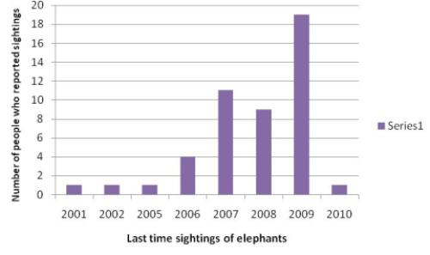

Figure 2: Last time sightings of elephant’s vs Number of People who reported sightings

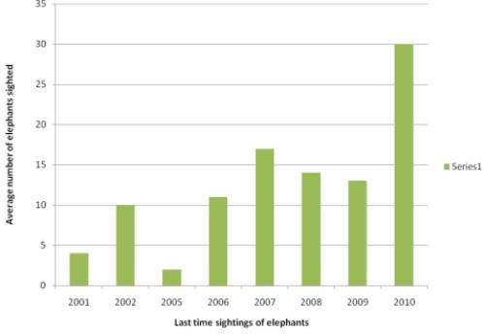

Figure 3: Last time sightings of elephant’s vs Average number of elephants sighted

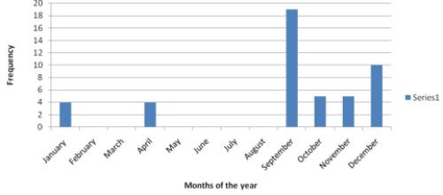

Figure 4: Frequency of elephant sightings around Kamuku National Park across months of the year

Table 2: Areas where elephants have been sighted around Kamuku National Park

Community | Areas where elephants have been sighted | Distance from community
Dagara I | Lambu tutuntime | 500 m
 | Kangon Dagara | 3 km
 | Gidan Maigora | 4 km
 | Likoro | 3 km
 | Yelwa | 4 km
 | Tundun Dimbi | 500 m
 | Maifantayi stream | 3 km
Dagara II | Magajiya | 1 km
 | Kangon magajiya | 1.5 km
 | Tsaunin Kura | 1 km
 | Mazuga | 3 km
 | Dandama | 1km
Bugai | Bugai-Dutse route | 500 m
 | Kangon Bugai | 5 km
 | Tsaunin Bugai | 10km
 | Kangon Tofa | 15 km
 | Kangon Shiri | 15 km
 | Kangon Tahuwa | 10 km
 | Kangon Kukeshe | 30m
Kakangi | Shuwaka | 10 km
 | Mashigi | 15 km
 | Kango Kurgi | 30 km
 | Shuwakan dawa | 50 km
 | Ganda | 10 km
 | Dakworo | 20 km
 | Kupai pai | 10 km
 | Yelwa | 15 km
Kuiga I | Masoki stream | 1.5 km
 | Unguwan Alhaji Ruwa | 5 km
Kuiga II | Kango Kuiga | 2.5 km
 | Gonan Barshi | 2 km
 | Babbar Fadama (Gwaska road) | 1.5 km
 | Kangon Passala | 1 km
Goron Dutse | Gwaska- Goron Dutse route | 2.5 km
 | Goron Dutse | 2 km
 | KADP Old site | 3.5 km
 | Unguwan Marafa | 3 km
 | Gudungu river (Goron Dutse) | 1.5 km
 | Inside Park | 2 km
Gwaska | Rafin Tamba | 1.5 km
 | Mai tsiga | 2 km
 | Mararaban Gwaska | 3 km
 | Gwaska - Kuiga route | 2 km
 | Gwaska | 1 km
 | Kangon Zagizagi (inside Park) | 14 km
 | Inside Park (Mai tsororo) | 7 km
 | Babban Fadama | 2 km
Nabango | Inside Park (Yar maidaki) | 4 km
 | Inside Park (mai tsororo) | 4 km
 | Nabango - Kuyambana route | 2 km
 | Ruwan Dawanaga | 6 km
 | Ture | 2.5 km
 | Farin Ruwa | 5 km
 | Baja | 1 km
 | Dandalla | 2 km
 | Kango mahuta | 6 km
 | Lambatu | 3 km

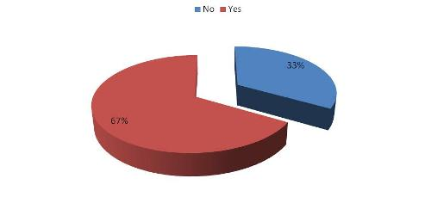

Figure 5: Awareness about the Existence of dead elephant route/habitat

Table 3: Areas of dead elephant route/habitat around Kamuku National Park

Area | Closest Community
Old Goron dutse | Gwaska
Gudungu stream | Gwaska
Kabago | Gwaska
Raffi- Kango Pasalla | Kuiiga II
Yakoma (Kuiga I) | Kuiga I
Pasalla area | Kuiga I
Matseri | Kuiga I
Raima | Bugai
Kango | Dagara II
Tsonim kura | Dagara II
Old Dagara | Dagara II

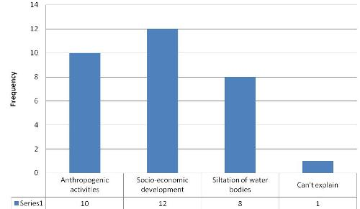

Figure 6: Reasons adduced for dead elephant route/habitat
3.1.2 Trend in Elephants Population in the Last Five Years

Most respondents (83%) believe that elephant population has been on the increase in the last five years (Figure 7). The growth in elephant population is attributed to reproduction success, park protection efforts, access to food from neighbouring farmlands, access to water from the Mariga river (a river bordering the Park and Kuyambana Game Reserve in Zamfara State) and immigration from other areas (Table 2). By contrast, 15% of survey respondents consider elephant population to have fallen in the last five years. Disturbance from anthropogenic activities was ascribed as a major factor in the declining trend. Other factors were socio-economic development, inadequate access to water, migration and the need to establish new territory by the elephants. Nevertheless, there was more likelihood to accept that the Kamuku elephant population is on the rise when we consider number of elephants sighted and last time sightings of elephants by respondents as indicated in Table 4.

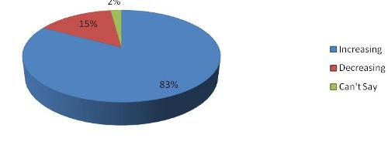

Figure 7: Perceived trend in elephant population in the last five years

Table 4: Reasons for perceived trend in Elephant population in the last five years

Reasons for increased  trend in population | *Frequency | Reasons for decreased trend  in population | *Frequency
Park patrol/awareness  campaign | 18 | Need to establish new territory | 1
Reproduction success | 24 | Disturbance from  anthropogenic activities | 4
Access to food from  farmlands | 11 | Socio-economic development | 2
Access to water from Mariga  river | 3 | Inadequate access to water | 1
Immigration from other  areas | 3 | Emigration to neighbouring  States | 1
*multiple responses were allowed.

3.1.3 Damage caused by Elephants

Crop-raiding was the main elephant problem voiced by all the respondents. In all the sampled communities, guinea corn, maize, water melon, calabash tree, groundnut, rice, sugarcane, sweet potatoes, cowpea, cassava and millet are the most affected crops (Table 5 and Figure 8). As previously noted, the incidences of crop-raiding by elephant often correspond with harvesting period of major crops in the area. Guinea corn and maize appear to be the preferred food for the elephant when these crops are available. Given their strong intelligence and sharp memory, nonetheless, elephants seem to have established regular raiding patterns that correspond with the maturity period of major crops.

Table 5: Crops mostly raided by elephant in adjoining communities of KNP

Scientific name | Common name | Frequency | Percentage
Arachis hypogeal | Groundnut | 6 | 5.77
Citrullus lanatus | Water melon | 5 | 4.81
Crescentia cujete | Calabash tree | 4 | 3.85
Ipomea batatas | Sweet potatoes | 3 | 2.88
Manihot esculantus | Cassava | 6 | 5.77
Oryza sativa | Rice | 4 | 3.85
Panicum miliasia | Millet | 2 | 1.92
Saccharum officinarum | Sugarcane | 2 | 1.92
Sorghum bicolor | Guinea corn | 33 | 31.73
Vigna unguiculata | Cowpea | 9 | 8.65
Zea mays | Maize | 30 | 28.85

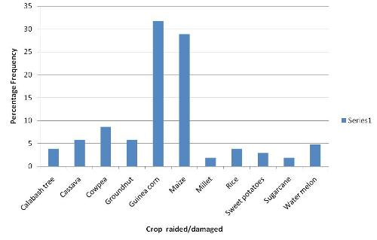

Figure 8: Crops mostly raided by elephant in adjoining communities of KNP

3.1.4 Measures for tackling human-elephant conflict

Strategies used by farmers in dealing with crop raiding by elephants range from individual and household efforts to community supports (Figure 9). Keeping vigil and drum beating are one of the most prevalent measures used by farmers to ward off elephants. Making fire to generate smoke and planting tobacco as hedge plant are also used to scare off and deter elephants from farmlands.
Communally, farmers’ group grant aids as a form of assistance to victims of elephant-induced damage. Most of the respondents also cited fencing and Park supports in form of compensation as expected control measures.

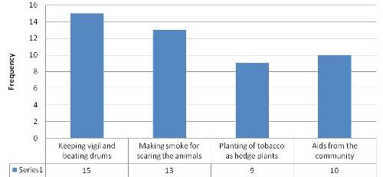

Figure 9: Measures for tackling human-elephant conflict

3.1.5 Respondents’ Attitude towards Elephant Conservation
Respondents’ perception towards elephant conservation was examined by using seven common attitude statements. The summary of the responses obtained is presented in Table 6. Weighted frequency estimates in this table illustrate the respondents’ attitudes towards elephant’s conservation. Although some variations existed in the responses, the majority of respondents interviewed were ostensibly in favour of the conservation of elephants.

Table 6: Likert Scale (%) Indicating Respondent’s Attitude towards Elephant Conservation

Attitude-statements | Strongly  Agreed | Agreed | Undecided | Strongly  Disagreed | Disagreed
Existence of elephants in Kamuku National Park and its environs obstruct people’s source of livelihood. | 57.4 | 29.3 | 0.0 | 12.9 | 1.4
Conservation of elephants is not important for any economic and  non-economic reasons. | 23.7 | 11.1 | 0.0 | 51.3 | 13.9
Elephants should be protected while Government pays more attention to  the mitigation of Human-Elephant Conflict in Kamuku district | 74.3 | 26.7 | 0.0 | 0.0 | 0.0
Protection of elephants will make the animals available long into the future. | 65.2 | 33.8 | 0.0 | 0.0 | 0.0
Elephant conservation will help promote and expand tourism for the  good of the people | 82.1 | 17.9 | 0.0 | 0.0 | 0.0
Elephant conservation creates inconveniences and offers no benefit to the people. | 27.3 | 29.4 | 0.0 | 32.8 | 10.5
Elephants are created by God and need to be preserved. | 72.8 | 27.2 | 0.0 | 0.0 | 0.0

3.2 Transect and Recce Survey Findings

Within the Doka range, dung and footprints of elephants were found around Budungu stream; open woodland with Isoberlinia spp dominant. Dung piles decay state were within D and E (Old and decayed dung pile) while footprint diameters were around 0.41m, 0.36m and 0.38m. For the Dagara range, dung and footprints were found within a fadama ground; open woodland with no specific plant species dominance. The dung piles decay state were also within D and E (Old and decayed dung pile) while footprint diameters were around 0.35m and 0.31m. For survey around villages/farmlands, fresh dung, footprints, trails and play ground of elephants were found in Gwaska village/farmlands only. The major crops within the farms are; guinea corn, maize, cassava, cowpea, rice and groundnut. There were indications of clipping, uprooting and trampling of crops by elephants. The farmlands where elephant indices occurred were also very close to a major river in the Gwaska area, river Kumunanu. Footprint diameters range from 0.17m to 0.49m. Overall estimates of elephant population from dung and footprint diameter measurements revealed that there were about thirteen (13) individuals, with probably four (4) to six (6) adult to sub-adult and three (3) to two (2) young ones within the group (Table 7).

The estimate of thirteen individuals as probable number of elephants in and around the Park agrees with the mean elephant group size computed from the qualitative data collected. Meanwhile, more indices of elephant occurrence were found in the Doka range and its surrounding farmlands compared to the Dagara range. The Gwaska, Goron-dutse, Nabango and Kuyambana junction were also found to be important migration routes for the Kamuku elephants. Figure 10 shows the georeferenced areas where signs of elephants were recorded.

Table 7: Data Collected from Transects and Recce Survey

Site | Coordinates | Elevation | Observation on  Transect line | Observation on Recce line | Dung piles  decay state | Footprint  Diameter | Estimated No. of Elephant and  precise location of indices
Doka Range  (Goron dutse track) | N10o 56’ 32.1”:  E06o 34’ 03.1” | 516.1m | Dung and Footprints around Budungu stream; open woodland with Isoberlinia spp dominant | Dung | D and E (Old and decayed  dung pile) | 0.41m  0.36m  0.38m | 3  ( N 10o 55’ 58.9”: E 6o 33’37.6”)  (N 10o 54’ 37.5”: E 6o 32’38.4”)
Doka Range  (Nabango junction) | N10o 55’ 28.3”: E06o 34’ 58” | 505.7m | Nil | Nil | - | - | -
Dagara Range  (Dandama track) | N10o 45’22.8”:  E06o 22’19.8” | 426.1m | Dung and Footprints within a fadama ground; open woodland with no specific plant species  dominance | Nil | E (Old and  decayed  dung pile) | 0.35m  0.31m | 2  ( N 10o 44’ 20.5”: E 6o 21’21.6”)
Dagara Range  (Dandama track) | N10o 44’ 22.7”:  E06o 21’20.7” | 426.1m | Nil | Nil | - | - | -
Gwaska Village/ Farmlands | N10o 56’ 53.0”:  E06o 35’ 04.8” | 507.0m | Trails and playground were  observed in the  farmlands close to  Sabongari | Nil | A (Dung  intact, very  fresh, moist  with odour) | - | N 10o 56’33.4”: E 6o 34’ 58.2”
Gwaska Village/ Farmlands | N10o 56’ 53.0”:  E06o 35’ 36.0” | 488.0m | Dung and  Footprints | Nil | A (Dung  intact, very  fresh, moist  with odour) | 0.26m  0.32m  0.49m  0.43m  0.45m | 5  ( N10o 54’30.3”: E 6o 34’ 14.2”)
Gwaska Village/ Farmlands | N10o 44’ 22.7”:  E06o 21’20.7” | 426.1m | Dung and Footprints close to river  Kumunanu | Nil | A (Dung  intact, very fresh, moist  with odour) | 0.30m  0.17m  0.29m | 3  ( N10o 53’20.5”: E 6o 34’ 10.1”)

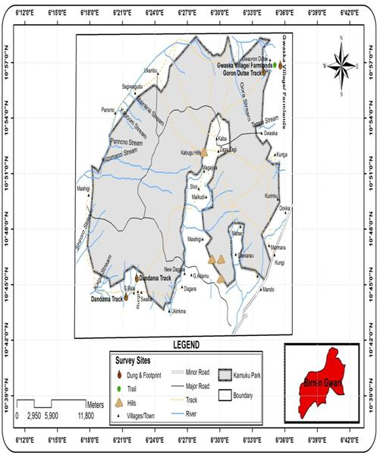

Figure 10: Map showing areas where signs of elephants were recorded during the survey

3.3 Monitoring Elephant Dung Decay Process

Dung decay categorization was done following the description of Barnes and Jensen (1987; Table 8).

Table 8: Dung decay categories as devised by Barnes and Jensen (1987)

STAGE DESCRIPTION
A Boli intact, very fresh, moist, with odour.
B Boli intact, fresh but dry, no odour.
Ca Some of the boli have disintegrated but more than half are still
intact.
Cb Less than 50% of the boli are distinguishable, the rest have
disintegrated.
D All boli completely disintegrated; dung pile now forms an
amorphous flat mass.
E Decayed to the stage where it would be impossible to detect at
2m in the undergrowth; it would not be seen on a transect
unless directly underfoot.

Dung Production date: 26/08/2010

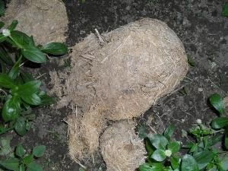

A (Boli intact, very fresh, moist, with odour): 26/08/2010/ - 08/09/2010

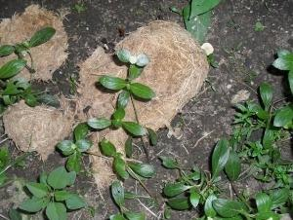

B (Boli intact, fresh but dry, no odour): 09/09/2010 - 24/09/2010

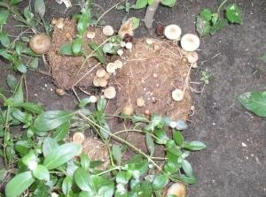

B (Boli intact, not fresh but dry, no odour (growth of mushroom)): 25/09/2010

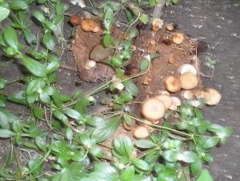

B (Boli intact, not fresh but dry, no odour (growth of mushroom)): 27/09/2010

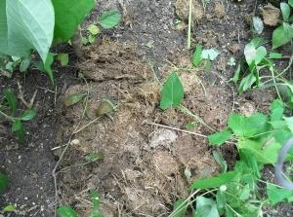

Ca (Some of the boli have disintegrated but more than half are still intact): 30/09/2010- 02/10/2010

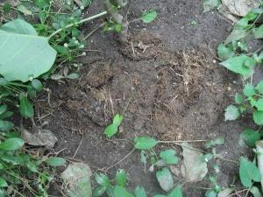

Cb (Less than 50% of the boli are distinguishable, the rest have disintegrated): 03/10/2010

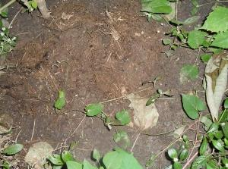

Cb (Less than 50% of the boli are distinguishable, the rest have disintegrated): 04/10/2010

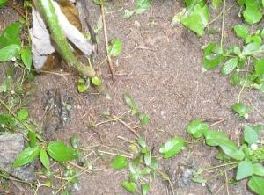

D (All boli completely disintegrated; dung pile now forms an amorphous flat mass): 07/10/2010

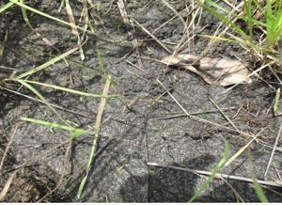

E (Decayed to the stage where it would be impossible to detect at 2m in the undergrowth): 11/10/2010

*Total number of days taken for boli to decay from A-E = 51 Days

3.4 Important locations in the landscape

Informal survey with Park staff, rangers and locals revealed that some areas within the project site are important locations that serve as migration route for the Kamuku elephants. These are shown in table 9 below:

Table 9: Important locations in the landscape serving as migration route for the elephants
S/N Location Approximate Distance to the Park

i. Kirazo- along Funtua Road, 20km
Birnin Gwari Local Government Area, Kaduna State

ii. Kiriyoyi- along Funtua Road, 20km
Birnin Gwari Local Government Area, Kaduna State

iii. Labi- along Kaduna Road, 70km
Birnin Gwari Local Government Area, Kaduna State

iv. Unguwanyako- along Kaduna Road, 85km
Birnin Gwari Local Government Area, Kaduna State

v. Mando Forest Reserve- 50km
Chukun Local Government Area, Kaduna State

vi. Kuyambana Game Reserve- < 0.5km
Zamfara State

vii. Alawa Game Reserve- Niger State 105km

3.5 Threats to habitat status and elephant conservation

General observations in the course of the project revealed that KNP indeed represents a treasure in the savannah, as it embodies beacon of hope when compared to its surrounding landscape mosaic which has been ravaged by host of human activities. However, the park’s biodiversity is under threat for exactly the same underlying reason as its surrounding landscape. From field observation during the survey and accounts of local people, a number of threats to habitat and elephant conservation could be identified. They include slash and burn agriculture, pastoralism, poaching, increased settlements and habitat encroachment due to rising human population as well as poor communities’ participation in conservation.

Slash and burn agriculture/pastoralism

Certain activities of farmers such as opening of new farms across elephant migration routes are incompatible to elephant’s prospects in the project area. This problem is exacerbated by migratory nature of livestock/ pastoral societies. Pastoralism is probably among the threats which have made many elephant routes die.

Poaching

Until recently, illegal wildlife off-take was a major threat to the viability of KNP. Most animals which fall victim of being poached are the antelopes. Elephants are most likely to abandon some important routes too because of fear of being killed. This will certainly lead to decrease in elephant frequency of movement and dispersal in their ranging areas.

Increasing human population and habitat encroachment

The increase of human population in different villages across the project area is another major threat which stresses the environment due to increase in land demand and human activities. For example, Sabongari is a new area which has just been opened up. In this respect, elephant migration routes are encroached and replaced by new settlements and farms. Worse enough peasant farmers in most of the SZCs cultivate their farmlands very close to the boundary of the Park without any appreciable buffer gap. This will result in continued shrinkage of elephant corridor and ranging areas. This predictably will increase human-elephant conflicts.

Poor communities’ participation in conservation

Although the Park management authorities currently engaged in host of developmental intervention in some of the SZCs, there seems to be generally poor level of community participation in conservation in the project area. Apart from conservation education engagement aimed at garnering the supports of the villagers, active community participation in conservation activities will improve wildlife worthiness and give sense of ownership to villagers, which will in turn help mitigate threat to elephant and other species.

Terrain

Observation on terrain particularly in the Doka axis of the Park is off-putting. The entire road structure including major bridge and culverts are in a state of total disrepair. To make an important connection in stimulation of eco- tourism activities and derivation of other ecosystem services, the state of the road in this part of the Park i.e. the Doxa axis, need to be taken into serious consideration. Generally, both roads within the Park and the access routes should be given adequate attention in order to attract more tourists to the Park.

4. SUMMARY OF FINDINGS AND PROJECT ACHIEVEMENTS

4.1 Summary of Findings

The survey revealed that elephants with mean group size hovering around thirteen (13) individuals traverse the Kamuku National Park (KNP) area on yearly basis. Also, more indices of elephant occurrence were found in the Doka range and surrounding farmlands compared to the Dagara range.

Elephants in and around KNP are often sighted beginning from the month of August/September through to November/December. This may be due to the presence and abundance of farm produce, as well as the availability of water pools around these periods.

The non variation in seasonal sightings of elephants for both dry and wet season, and the lack of correlation in the number of elephants sighted by local residents with the season of the year, could be due to the high migratory nature of the elephants.

Local residents have varying opinion on whether elephants in the area were increasing or decreasing, but the likelihood to accept that the Kamuku elephant population is on the rise was more.

Crop damage by elephants is a significant and growing problem in the project area. Although we did not quantify the extent, magnitude and socio-economic impacts of crop damage by elephants, respondents’ opinions suggest that impacts of crop damage may be catastrophic for some households while it is medium to low-level in others.

The methods used by respondents in dealing with crop raiding by elephants are typically traditional. These include: keeping vigil and beating drums; making fire to generate smoke; planting tobacco as hedge plant and; granting aids as a form of assistance to victims of elephant-induced damage. Some of these have been criticized as largely ineffective, especially in the long term (Osborn and Parker, 2002; 2003; Nelson et al., 2003) as elephants often become habituated to them.

Majority of local residents interviewed for this project are ostensibly in favour of the conservation of elephants. However, conflict between wildlife and people is an important factor affecting the relationship between protected areas and the people who live near them (Studsrod and Wegge, 1995; Hill, 1998). This often hinders efforts to save endangered species and protected areas. Human elephant conflict will decrease support from local people for conservation efforts. Therefore, intensified elephant induced damage may erode local support for conservation of the animals. This is particularly pertinent in the project area since majority of the inhabitants are predominantly farmers.

4.2 Project Achievements

The successful implementation of this project has achieved substantially its set objectives. These among others include:
▪ Strengthening the capacity of the locals and Park rangers on systematic elephant survey, monitoring and reporting for conservation objectives.

▪ Stimulating environmental sensitivity through conservation education and joint action towards the protection of the Kamuku elephants and wildlife resources in general.

▪ Establishment of community-based elephant conservation/ monitoring committees in selected villages.

▪ Conducting a first round of participatory and systematic survey of the Kamuku
elephant.

▪ Determining the conservation status, population and distribution of elephant in and around Kamuku National Park.

▪ Successfully implementing a participatory approach that shares the planning, research activities and use of results between different groups of people who have an interest in the sustainability of the project.

▪ Preparing a comprehensive survey document and recommendation for conservation and management of elephants in and around Kamuku National Park.

5. RECOMMENDATIONS AND CONCLUSIONS

5.1 Recommendations

Based on our findings in the course of this project, the following recommendations are proposed for conservation and management of elephants in and around Kamuku National Park:

1) There is the need to provide water holes and construction of earth dams for stable water supply for the animals;

2) There is also the need for habitat improvement as well as restoration of preferred food resources of the animals in and around the park;

3) In the meantime, elephants route need to be protected from various anthropogenic activities such as bush burning, farming, livestock grazing, fuel wood exploitation and logging within the project area;

4) There is need for the Park management authorities, community leaders and local residents to jointly work out proactive measures to reduce elephant-induced damage. Most of the local residents often cited fencing and Park supports in form of compensation as expected control measures. However, compensation only addresses the effects of elephant-induced damage, not the cause;

5) Options to reduce elephant-induced damage include that; farmers across the buffer zones of the Park and in areas of elephant migration route should plant less attractive crops such as chilli (pepper) and other capsicum species (that are greatly detested by elephants) as hedge plants. Apart from this, farmers may have to choose some other areas for agricultural use where chances of elephant visitations are less;

6) It is important to identify and understand the movement patterns of the elephants, as well as their resource needs and availability along migration routes. The migration routes also need to be identified and geo-referenced by the Park management authorities. Efforts should thereafter be made to cordon off these places from all form of human activities. Elephants often migrate through defined corridors. There is thus, the need to ensure that the routes and habitats used by the animals are protected in line with the Bonn Convention to which Nigeria is a signatory;

7) The last-mentioned point is very relevant to the current move of the Park management authorities to discuss with relevant stakeholders on the need for trans-boundary joint patrol activities and sensitization campaign within the Kuyambana Game Reserve and its support zone communities in Zamfara State. This is very significant towards ensuring the viability of the Kamuku elephants as the game reserve and other areas have been identified as important haven of the elephants. This is also important so as to develop a coherent strategy for the conservation and management of the species;

8) It is further recommended that a more detailed study of elephant movement in the study area
using radio/satellite tracking be initiated;

9) There is also the need for continuous sensitization, support and empowerment of local people through community initiatives outside protected areas in the landscape to ensure they participate in the conservation and protection of wildlife and natural resources.

5.2 Conclusions

This project has provided a methodical insight into the conservation status of the Kamuku elephants through a collaborative survey work involving researchers, conservation managers and local residents. A number of important findings have been accordingly brought into the fore. Among others, the survey revealed that elephants with mean group size hovering around thirteen (13) individuals traverse the Kamuku National Park (KNP) area on annual basis. The survey also exposed the presence of threats against elephant routes, ranging and dispersal areas. A widespread trait of all the threats to the elephant population is habitat loss and fragmentation. For effective protection of the elephants and other wildlife species in the area, therefore, there is need for unrelenting patrols, imposition of stiffer penalties and firm enforcement of all park laws with a view to curbing the menace of habitat loss and fragmentation. More so, conservation of wildlife species can only occur if their habitats are well maintained.

ACKNOWLEDGEMENTS

We express our sincere gratitude to Rufford Small Grants Foundation (for nature conservation) for providing the financial support to carry out this work. We profoundly appreciate the moral support received from the Provost- Federal College of Wildlife Management, Dr. A.J. Meduna at ensuring the success of the project. We deeply appreciate the assistance in logistics and personnel provided by the Nigerian National Park Service/Kamuku National Park management authorities. We also thank all village leaders and communities in the project area for providing the enabling environment to carry out the survey. Despite the threats of elephant-induced damaged on cultivated crops in the area, the unusual level of communities’ support towards protection of the Kamuku elephants as demonstrated in the course of this project is quite remarkable. We sincerely thank the community-based elephant conservation/monitoring committees, members of survey corps as well as staff and rangers of Kamuku National Park.

REFERENCES

Barnes, R. F. W., and K. L. Jensen. 1987. How to count elephants in forests. Technical bulletin 1. African Elephant and Rhino Specialist Group, World Conservation Union, Gland, Switzerland.

Barnes, R. F. W, 1988. A Short-cut Method for Obtaining Preliminary Estimates of Elephant Abundance. Wildlife Conservation International.

Cumming, D.H.M., Du Toit, R.F. and Stuart S.N. 1990. African elephants and rhinos. Status survey and conservation action plan. IUCN, Gland, Switzerland.

Hill, C.M. 1998. Conflicting attitudes towards elephants around the Budongo Forest Reserve, Uganda. Environmental Conservation 25: 244–250.

Nelson, A., P. Bidwell and C. Sillero-Zubiri 2003. A review of human–elephant conflict management strategies. People and Wildlife Initiative, Wildlife Conservation Unit, Oxford University.

Osborn, F.V. and G.E. Parker 2002. Community-based methods to reduce crop los to elephants: experiments in the communal lands of Zimbabwe. Pachyderm 33, 32–38.

Osborn, F.V. and G.E. Parker 2003. Towards an integrated approach for reducing the conflict between elephants and people: A review of current research. Oryx 37, 80–84.

Parker, I.S.C. and A.D. Graham 1989. Elephant decline (Part I): downward trends in African elephant distribution and numbers. International Journal of Environmental Studies 34, 287–305.

SPSS. 2001. Statistical Package for Social Sciences. SPSS for Windows, Rel. 11.0.1. 2001. Chicago: SPSS Inc.

Studsrod, J.E. and Wegge, P. 1995. Park-people relationships: the case of damage caused by park animals around the Royal Bardia National park, Nepal. Environmental Conservation, 22: 132-142. Strategy for the conservation of West African elephants. IUCN, Gland, Switzerland.

APPENDICES

I. Questionnaire on Qualitative Data Collection

Participatory Survey of Elephants in Kamuku National Park and its Environ

Dear Sir/Ma,

This questionnaire is designed to solicit your opinion on knowledge of elephants, their use of habitats and conservation in this area. Your responses will be treated with utmost confidentiality.

Thanks for your anticipated co-operation.

I) Village: ………………………….. II) Date: …………………....…

1. Where can elephants be found in your area?
Local Area Name:
i………………………………………………………………………...............…........……
ii……………………………………………………………………….......................……...
iii………………………………………………………………….......................…………..
iv…………………………………………………………………….......................………..
v………………………………………………………………………......................………

2. How far are these/this area from the village (km?)
Local Area Name:
i…………………………………………………………………………..........................…
ii…………………………………………………………………………….........................
iii…………………………………………………………………………......................…..
iv…………………………………………………………………………......................…..
v………………………………………………………………………….....................……

3. (a) When did you last see an elephants? ………...............................................….….
(b) How many? …….............................................................................................…….….
(c) Where? ……….............................................................................................……….…..

4. Are lone elephants ever seen?
Yes……….........……….. No…….......................…….….

5. Why do you think Elephants are found (or found more often) in the area earlier stated above?
…………………………………………………………………………………………..…
…………………………………………………………………………………………..…
…………………………………………………………………………………….…...…

6. Were elephants ever found in different areas where they are no longer found today (e.g. nearer the village)?
Yes……………................ No……….......................…….

7. Why are they no longer found in those areas?
………………………………………………………………………………………….…
………………………………………………………………………………………….…
………………………………………………………………………………………….…
…………………………………………………………………………………………….

8. In the last five years has the number of elephant increased or decreased?
Increased…….......……. Decreased……….........….….

9. Why?
………………………………………………………………………………………...……
………………………………………………………………………………………...……
………………………………………………………………………………………...……
………………………………………………………………………………………...……

10. When was the last time an elephant was shot by a hunter from this village?
……………………........................................................................................................…..

11. Please give details of the incidence vis-à-vis:
(a) Date: ………………........................................................................................………..
(b) Age of elephant: ………....................................................................………………..
(c) Sex: ……………...........................................................................................………….
(d) Place: ………….....................................................................................………….…..

12. What happens to the elephant meat and body parts?
………………………………………………………………………………………………
………………………………………………………………………………………………
………………………………………………………………………………………………
………………………………………………………………………………………………

13. Are body parts of elephants used for any specific purpose in this area?
Yes……………………. No…………………….....................…..

14. If Yes, kindly state:
……………………………………………………………………………………………
……………………………………………………………………………………………
…………………………………………………………………………………………..…
………………………………………………………………………………………….….

15. Is human-elephant conflict a problem in your area?
Yes……………………. No……………………....................…..

16. If Yes, kindly state the nature of the problem:
………………………………………………………………………………………………
………………………………………………………………………………………………
………………………………………………………………………………………………
………………………………………………………………………………………………

17. How is this problem currently being tackled?
………………………………………………………………………………………………
………………………………………………………………………………………………
………………………………………………………………………………………………
………………………………………………………………………………………………

18. Are you satisfied with the current arrangement?
Yes………………….… No……………………......................…..

19. If No, what is your own perspective on tackling human-elephant conflict in your area?
………………………………………………………………………………………………
………………………………………………………………………………………………
………………………………………………………………………………………………
………………………………………………………………………………………………

20. (a) If you had your way would you want all elephant dead or alive?
Yes……………………… No……………........................…………

(b) Why?
………………………………………………………………………………………………
………………………………………………………………………………………………
………………………………………………………………………………………………
………………………………………………………………………………………………

21. Do hunters from outside come here to shoot elephant?
Yes…………………… No……………………...................…..

22. How do you think elephant population can be better enhanced in your area and within the
Kamuku National Park?
………………………………………………………………………………………………
………………………………………………………………………………………………
………………………………………………………………………………………………
……………………………………………………………………………………………..

Attitude statements | Strongly  Agreed | Agreed | Undecided | Strongly  Disagreed | Disagreed
Existence of elephants in Kamuku National Park and its environs
obstruct people source of livelihood.
Conservation of elephants is not important for any
economic and non-economic reasons.
Elephants should be
protected while
Government pays more attention to the
mitigation of Human
Elephant Conflict in
Kamuku district.
Protection of elephants will make the Animals available long into the future.
Elephant conservation
will help promote and
expand tourism for the good of the people.
Elephant conservation
creates inconveniences
and offers no benefit to the people.
Elephants are created by God and need to be
conserved.

II. Recording sheet for Transects and Recce survey

Sheet Reference No: _______________________ Date: ___________________
Survey Site: ______________________________________________________________
Longitude: ______________ Latitude: ________________Altitude: __________________
Season: _________________Weather condition: __________________________________
Time Start: _______________Time Finish: ___________________________
Transect Length: ________________________________________
Surveyor (total team composition): __________________________

Distance from start  of Transect (m) | Bolus state &  Diameter | Perpendicular Distance of dung from Transect (m) | Vegetation type and  general observations

No of dung recorded from recce survey

A:

B:
III. List of community-based elephant conservation/ monitoring committees

S/N | COMMUNITIES | MEMBERS
1 | Dagara I | Abdullahi Gambo  Umar Auta  Isa Makashi  Abubakar Shuaibu  Sirajo Isa
2 | Dagara II | Ismail Garba  Tasiu Audu  Abdullahi Lale  Abdullahi Jigo  Ibrahim Jatau
3 | Bugai | Muntari Gambo  Abdullahi Ibrahim  Abubakar Shuaibu  Rabiu Dogo
4 | Kakangi | Aliyu Labaran  Ismaila Taila  Ibrahim Dangude  Ibrahim Pawa  Abubakar Isa  Muhammadu Nahants
5 | Kuiga I | Muazu Bala  Ango Magaji  Umaru Makeri  Ango Magaji
6 | Kuiga II | Lawal Aliyu  Tukur Abdullahi  Sani Musa
7 | Goron Dutse | Abubakar Danladi  Galadima GoronDutse  Danjuma Salihu  Adamu GoronDutse  Danlami Wakili  Idris Danlami
8 | Gwaska | Usman Amadu  Useni Audu  Sadi Abdullahi  Mako Umar  Dahiru Abdullahi
9 | Nabango | Muhammadu Akawu  Adamu Dangwari  Mairana Danjuma  Hansi Alhassan  Muhammadu Mijintaya

IV. List of Recruited Survey corps

S/N | COMMUNITIES | MEMBERS
1 | Dagara I | Saidu Musa  Sadi Umar
2 | Dagara II | Muhammad Usman  Muhammad Garba
3 | Bugai | Abdul-Mumini Muntari  Abubakar Haruna
4 | Kakangi | Abubakar Isa  Ahmed Musa
5 | Kuiga I | Umaru Makeri  Ango Magaji
6 | Kuiga II | Tukur Abdullahi  Sani Musa
7 | Goron Dutse | Sanusi Muhammad  Bala Danbai
8 | Gwaska | Ibrahim Musa  Muhammad Usman
9 | Nabango | Bashir idris  Umar Ibrahim

PHOTO SPEAK

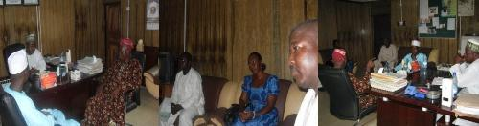
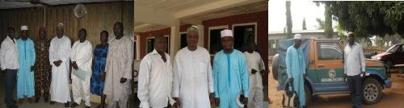

Project planning and setting out



Development of Work Plan

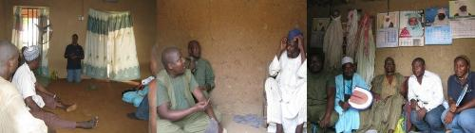
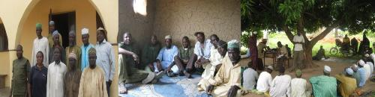

Sensitization and planning meetings with community stakeholders

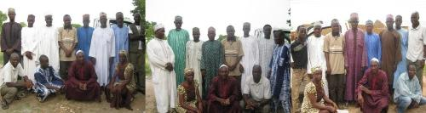
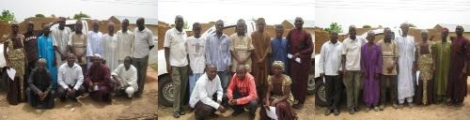
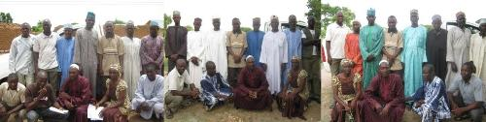

Establishment of community-based elephant conservation/ monitoring committees
and Recruitment of survey corps

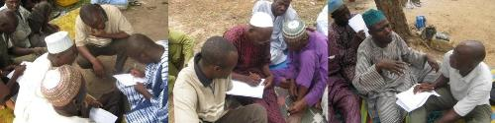
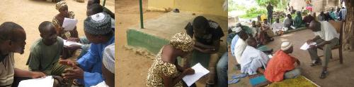

Gathering qualitative data on elephant status and conservation in KNP and its environ

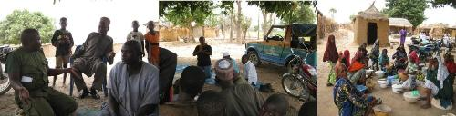
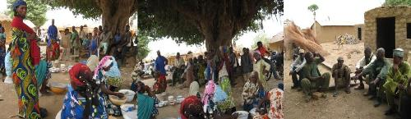

Community-wide conservation outreach

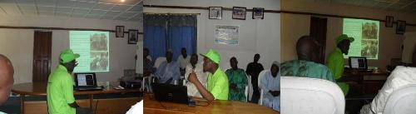

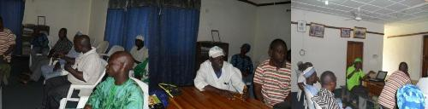
Capacity building program/workshop on participatory survey, monitoring and reporting for
recruited survey corps as well as park rangers on elephant survey procedure

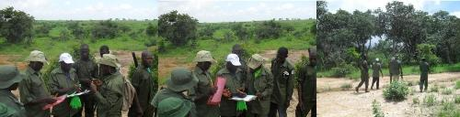
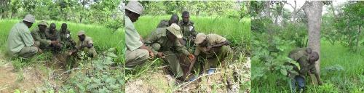
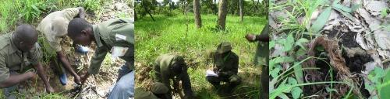
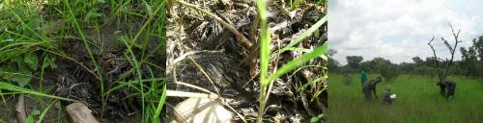
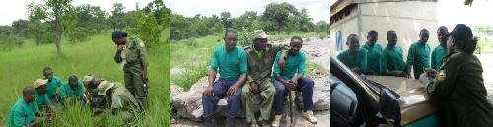
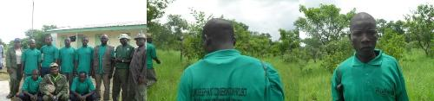

Participatory survey of elephants in Kamuku National Park and its environ

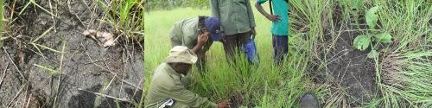
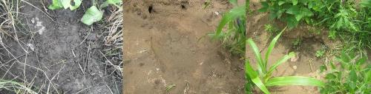
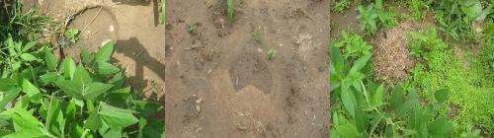
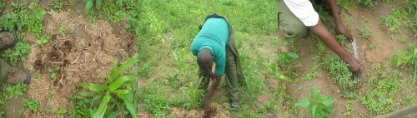
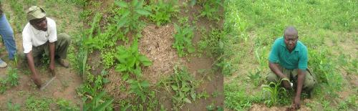

Participatory survey of elephants in Kamuku National Park and its environ

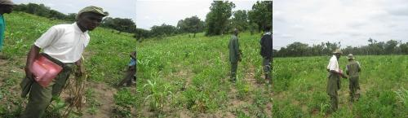

Incidence of Crop raiding by a group of elephant

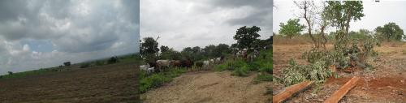

Threats to habitat status and elephant conservation

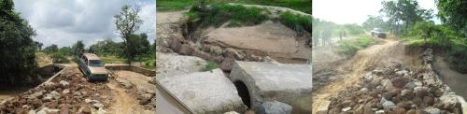
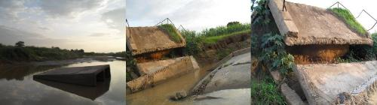

Terrain

