Project Update: November 2014

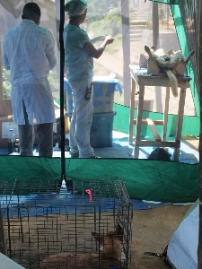
Our team recently wrapped up our first field season working in the Ranomafana National Park region of south-east Madagascar. We were able to vaccinate and spay/neuter 50 dogs across four villages bordering this important protected area. Further, we carried out 255 household surveys concerning local’s views towards domestic and feral dogs, including their evaluation of the impact of dogs on local biodiversity and their approach to husbandry and management of litters/offspring. By understanding and quantifying local peoples’ values and views on this important topic we will greatly improve our chances of effectively managing dogs long-term. Finally, we also recently completed our first 2-month photographic survey (camera trapping) across vital edge forest habitat. These expansive photo data will allow us to investigate how many dogs are using forest habitat, where they are accessing the forest, which native species are using edge forest, and how these native and exotic carnivores are interacting.

