

MONTHLY PROGRAMME ACTIVITY REPORT

JUNE 2013
SUMMARY

The projects highlighted under this month’s programmatic work are:

- Joint Wildlife Protection Team
- Marania Wildlife Guards
- Horse Patrol Team
- Fencing updates
- Elephant Corridor Team
- Environmental Education and Awareness
- Tree Planting and Reforestation

The report covers MKT activities for the period 31st May to 30th June 2013. Reports were provided by the following field employees: Humphrey Munene on Education and Awareness initiatives as well as Tree Planting and Reforestation work. Northern sector reports were provided by the Marania Wildlife Guards; the Elephant Corridor Team, the Horse Patrol Team as well as the northern area supervisor – Mr. Maurice Thure on several related conservation initiatives and security. Eastern and southern sector updates were collated by the Joint Wildlife Protection Team led by Edwin Kinyanjui Ngure. The June report was compiled by Maurice Nyaligu.

1. INTRODUCTION

Programmatic activities discussed under this month’s field interventions are:

- Elephant mortality incidents
- Other wildlife mortality related incidents
- Snaring, poacher signs and related incidents
- Fence destruction and manipulation
- Arrests and apprehensions
- Destruction by elephants
- Illegal logging
- Education and awareness initiatives
- Tree planting and reforestation
- Visits and meetings

1.1 Programme patrol and operational areas

The following are the areas focused upon by MKT field based teams this June. These are:

- Tree planting and reforestation in Ontulili (Meru County) – Field coordinator
- Meru County (Ontulili) on education and awareness - Field coordinator
- Kihari and Ruthumbi and immediate surrounding areas – Joint Wildlife Protection Team
- Marania forest, Mlima Ngaita area, Corridor, Chemi Chemi ya Ndovu area, Kimbo area, Kisima forest, Mlima Surua, Rutundu area, Mlima Ndinga and Kiwanja ya Ndaya areas - Marania Wildlife Guards
- Marania forest, Embori area, Mlima Ngaita, Solo Camp, River Marania, Moorland and School of Adventure areas - Horse Patrol Team
- The Elephant Corridor and Ntirimiti area - Elephant Corridor and Fencing Team

Field based teams were joined by visitors and volunteers on varying dates for patrols and other community initiatives.

2. PROJECT UPDATES

2.1 Elephant mortality incidents

Two elephant mortality incidents were reported by the Joint Wildlife Protection Team on the 9th and the 14th of June. The two old carcasses had their tusks missing but cause of death could not immediately be adduced as the remains were relatively very old. Details are as summarized in the table below:

# | SITE | COORDINATES | DATE & TIME | TEAM | AGE & SEX | OBSERVATIONS /REMARKS | PHOTO
1. | Kihari | 37M 0290242, UTM 9991530 | 9th June 0945hrs | JWPT | 60 - 70 yrs, sex indeterminate | Relatively old significantly decomposed carcass, cause of death unknown. Tusks missing. | 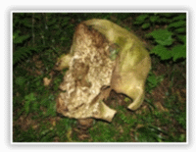
2. | Ruthumbi | 37M 0336029, UTM 9960148 | 14th June 1323hrs | JWPT | Sub-adult. Sex indeterminate | Old carcass. Tusks missing. Cause of death suspected to result from snaring due to presence of a snare near the carcass. | 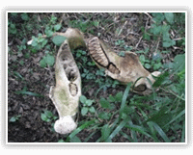

2.2 Other wildlife mortality related incidents

Other poaching related incidents in June were reported by the Marania Wildlife Guards and the Horse Patrol Team. These incidents are tabulated below:

# | DATE & TIME | AREA | TEAM | PARTICULARS | COORDINATES | PHOTO
1. | 10th June 1007hrs | Embori farm area | Horse Patrol Team | Fresh carcass of a Hyrax discovered. Cause of death indeterminate. No external injuries observed. | 37N 0317119, UTM 0004945 | 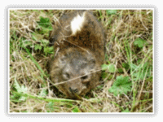
2. | 22nd June 1130hrs | Corridor | Marania Wildlife Guards | A fresh waterbuck carcass discovered. Cause of death, suspected to have been the result of fighting between two (2) males. No external injuries observed. | 37N 0328899, UTM 0009463 | 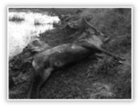

2.3 Snaring, poacher signs and related incidents

Several snares, a number of poacher sightings and related incidents were reported by the JWPT, the HPT and Marania Wildlife Guards as summarized in the table below:
# | DATE & TIME | COORDINATES | AREA | TEAM | OBSERVATIONS /REMARKS | PHOTO
1. | 1st June 1015hrs | 37N 0329608, UTM 0005813 | Embori area | Horse Patrol Team | One (1) snare capable of entrapping large mammals was found and disabled | 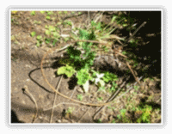
1. | 1st June 1100hrs | 37N 0320623, UTM 0003787 | Embori area | Horse Patrol Team | Two (2) lame Zebras in a group of 51 spotted
2. | 2nd June 1141hrs | 37M 0296136, UTM 9965802 | Kihari | Joint Wildlife Protection Team | One bushbuck snare removed | 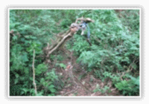
3. | 4th June 0923hrs | 37N 0321511, UTM 0003498 | Solo camp area | Horse Patrol Team | One (1) lame Zebra spotted in a herd of nine (9) | 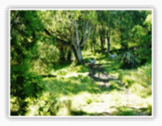
3. | 4th June 0950hrs | 37N 0326141, UTM 0005612 | Chemi Chemi ya Ndovu | Marania Wildlife Guards | One (1) lame Zebra observed in a group of three (3)
3. | 4th June 1122hrs | 37N 0321149, UTM 0003394 | Solo camp area | Horse Patrol Team | One (1) lame Zebra spotted | 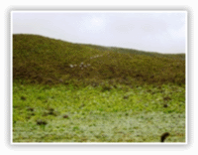
4. | 5th June 0750hrs | 37N 0328381, UTM 0008191 | Corridor area | Marania Wildlife Guards | One (1) lame Waterbuck observed in a group of thirteen (13)
4. | 5th June 1100hrs | 37N 0319137, UTM 0004437 | Embori area | Horse Patrol Team | Two (2) lame Zebras spotted in a herd of eighteen (18) | 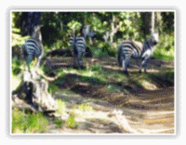
5. | 6th June 0935hrs | 37N 0321751, UTM 0004171 | Mlima Ngaita | Horse Patrol Team | One (1) lame Zebra spotted in a herd of fifty (50)
6. | 9th June 0826hrs | 37N 0322335, UTM 0005597 | Mlima Ngaita | Horse Patrol Team | One (1) lame Zebra observed in a herd of 15
6. | 9th June | 37N 0329860, UTM 9995366 | Rutundu | Marania Wildlife Guards | Several suspected poachers spotted in Rutundu amongst them a former Trust employee
7. | 10th June 1016hrs | 37N 0316972, UTM 0004822 | Embori area | Horse Patrol Team | Two (2) snares with the capability of entrapping large mammals discovered and destroyed | 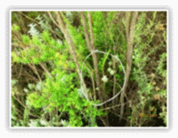
7. | 10th June 1045hrs | 37N 0318395, UTM 0005396 | Embori area | Horse Patrol Team | Two (2) snares with the capacity of snaring large antelopes immobilized and destroyed
8. | 11th June 0826hrs | 37N 0321597, UTM 0003612 | Solo camp area | Horse Patrol Team | Two (2) lame Zebras seen with injuries due to snaring | 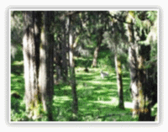
9. | 12th June 1445hrs | 37N 0323799, UTM 0004668 | Mlima Ngaita | Marania Wildlife Guards | Suspected poacher footprints noted, Kimbo to Embori area through Chemi Chemi ya Ndovu
10. | 13th June 0839hrs | 37N 0322162, UTM 0005499 | Solo camp area | Horse Patrol Team | Suspected poachers’ footprints from Embori to Kimbo area seen
10. | 13th June 1625hrs | 37M 0337459, UTM 9992020 | Ruthumbi | Joint Wildlife Protection Team | Two (2) snares designed to entrap bushbucks removed | 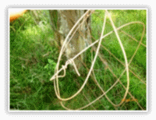
11. | 14th June 1308hrs | - (cloudy conditions, GPS failure) | Ruthumbi | Joint Wildlife Protection Team | One (1) medium sized mammal snare disabled and removed
11. | 14th June 1419hrs | 37M 0334573, UTM 9991346 | Ruthumbi | Joint Wildlife Protection Team | Two (2) suspected poachers’ dogs shot dead in the forest
12. | 17th June 0920hrs | 37N 0322437, UTM 0005095 | Solo camp area | Horse Patrol Team | Two (2) lame Zebras spotted
13. | 18th June 1735hrs | 37M 0339238, UTM 9990258 | Ruthumbi | Joint Wildlife Protection Team | One (1) suspected poachers’ dog shot dead by the team | 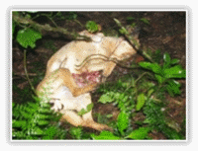
13. | 18th June 1820hrs | 37M 0339082, UTM 9992046 | Ruthumbi | Joint Wildlife Protection Team | Laid an unsuccessful ambush for illegal poachers and loggers
14. | 20th June 0827hrs | 37N 0321679, UTM 0003980 | Embori area | Horse Patrol Team | Two (2) lame Zebras spotted amongst a herd of 21
14. | 20th June 0909hrs | 37N 0318878, UTM 0004287 | Embori area | Horse Patrol Team | Suspected poachers’ footprints leading from Kimbo area towards Embori | 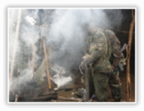
15. | 22nd June 1422hrs | 37M 0338330, UTM 9993108 | Ruthumbi | Joint Wildlife Protection Team | Team encountered a fire place used by poachers’
15. | 22nd June 1508hrs | 37M 0337709, UTM 9992906 | Ruthumbi | Joint Wildlife Protection Team | One (1) snare designed to entrap bushbucks disabled and removed | 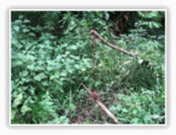
15. | 22nd June 1508hrs | - (cloudy conditions, GPS failure) | Ruthumbi | Joint Wildlife Protection Team | A large elephant snare disabled and removed | 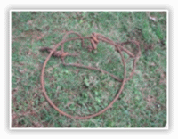
16. | 23th June 1133hrs | 37M 0336531, UTM 9990104 | Ruthumbi | Joint Wildlife Protection Team | Three old snares disabled and removed
17. | 28th June 1105hrs | 37N 0315585, UTM 0004962 | Embori area | Horse Patrol Team | One (1) lame Zebra spotted
17. | 28th June 1730hrs | - Cloudy and wet conditions (GPS failure) | Ruthumbi | Joint Wildlife Protection Team | One (1) small mammal snare removed and disabled | 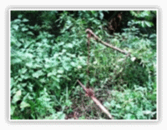

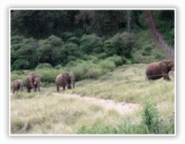
2.4 Fence destruction and manipulation

During the month, the number of elephants observed utilizing the main Corridor increased in comparison with previous months. However, no breakage or damage to fence lines by elephants was noted. Given prevailing dry weather conditions, the Corridor maintenance team had a busy month chasing intruders trying to gain access into the Corridor precincts’. The rate of trespass into the Corridor perimeter by surrounding communities has been on the decrease relative to similar periods last year. The Corridor fence maintenance team was also engaged in the repair of the short fence in Marania forest which had been damaged by elephants and resulted in destruction of farm produce in the vicinity.
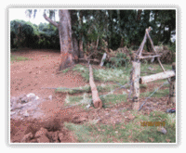
2.4.1 Ntirimiti short fence
The Ntirimiti short fence was the subject of several significant intrusions by elephants this June despite efforts to repair damaged sections. On Tuesday 11th June, three (3) elephants managed to bring down a gate on the eastern side of the fence. The Trust was able to quickly mobilize resources and with the support of two (2) corridor fencers and some community members, the gate was repaired the following day on Wednesday 12th. Despite all this, the three (3) elephants were able to return the same night and break the fence at the same location.

A combined MKT and KWS fencing team then sought to reinforce the fence through joint efforts on Friday 14th. The same group of elephants revisited the site tried once to break through at 10.00 p.m. Friday, but were unable to cause damages. At 3.00 a.m., the group damaged one of the main gates. Upon investigations, it was discovered that a leakage in the voltage output was responsible. Following repairs on Tuesday 18th the voltage was upscaled to 7.2kv from 5.4kv. Since these repairs, no further damages have been reported.

2.5 Arrests and apprehensions
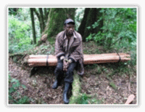
On the 6th of June at about noon, a team led by the northern area supervisor while patrolling the middle corridor area came across an intruder Francis Kinoti who was found in possession of 15 red cedar (Juniperus procera) posts. Subuiga police station was informed following his arrest and booked him at the station OB: 10/6/6/2013. The case is still being investigated as it involved a chain of people. On the 27th of June at about 1800hrs, two of MKT fencers Robert Murega and Ali Mpara managed to arrest one Steven Koome in possession of firewood from the Corridor. He was arrested and taken to Subuiga police station OB: 12/27/6/2013.

2.6 Destruction by elephants
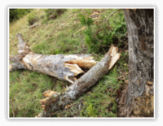
There were limited but significant destruction of trees by elephants around the Corridor vicinity this June. Several unidentified indigenous trees and some shrubs were observed on a number of occasions to have been destroyed by elephants. These observations were made by the Marania Wildlife Guards, the Corridor team and the Horse Patrol Team.

2.7 Illegal logging

Several incidents relating to illegal logging were reported by the JWPT, Marania Wildlife Guards and the Horse Patrol Team as summarized in the table below:

# | DATE & TIME | AREA | TEAM | OBSERVATIONS /REMARKS | COORDINATES | PHOTO
1. | 5th June 0837hrs | Kihari | JWPT | Eleven (11) women caught illegally chopping indigenous trees for use as firewood | 37M 0292820, UTM 9965144
2. | 6th June 1112hrs | Kisima area of Marania forest | Marania Wildlife Guards | Red cedar (Juniperus procera) logging by use of power saws | 37N 0324020, UTM 0006277 | 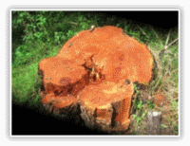
2. | 6th June 1250hrs | Kisima area of Marania forest | Marania Wildlife Guards | Red cedar (Juniperus procera) logging by use of power saws | 37N 0323837, UTM 0006092
2. | 6th June 1320hrs | Kisima area of Marania forest | Marania Wildlife Guards | Logging of Rose wood (Hagenia abyssinica) | 37N 0323448, UTM  0005747 | 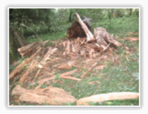
3. | 10th June 0930hrs | Embori area | Horse Patrol Team | Logging of different indigenous trees by suspected firewood sellers | 37N 0318795, UTM 0005468
4. | 12th June 1204hrs | Ruthumbi | JWPT | Muringiti trees cut for use as fencing posts. A Land Rover KAA 007W confiscated for carrying ninety nine (99) posts from Themwe campsite. Suspects taken into custody at Ruthumbi Forest station | 37N 0303588, UTM 0000755 | 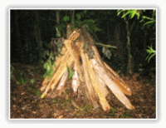
5. | 13th June 1430hrs | Chemi Chemi ya Ndovu area | Marania Wildlife Guards | Rose wood logged by a power saw and transported | 37N 0325983, UTM 0004880
6. | 15th June 1740hrs | Ruthumbi | JWPT | Ten (10) Podocarpus spp. trees cut for use as timber | - (cloudy and unfavourable conditions for GPS reading) | 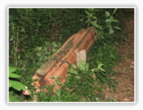
6. | 15th June 2027hrs | Ruthumbi | JWPT | Twelve (12) pieces of Meru oak (Vitex keniensis) recovered at a homestead after a tip-off | 37M 0341439, UTM 9983336 | 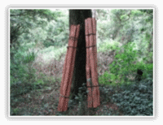
7. | 19th June 1610hrs | Ruthumbi | JWPT | Unidentified indigenous tree discovered cut for use as timber | 37M 0343519, UTM 9981856 | 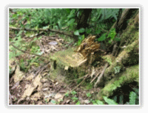
7. | 19th June - hrs | Ruthumbi | JWPT | Three (3) Camphor (Ocotea usambarensis) cut with power saw and timber taken | - (cloudy and unfavourable conditions for GPS reading) | 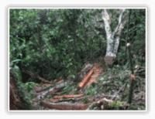
7. | 19th June - hrs | Ruthumbi | JWPT | Two (2) Muringiti trees cut for use as fencing posts | - (cloudy and unfavourable conditions for GPS reading) | 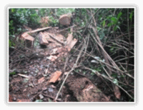
8. | 20th June 1000hrs | Embori area | Horse Patrol Team | Logging for timber with vehicle tyre marks leading to Embori gate | 37N 0318792, UTM 0005531 | 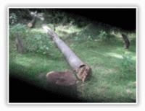
9. | 21st June 1656hrs | Ruthumbi | JWPT | Three (3) unidentified indigenous trees cut for firewood use | 37M 0339399, UTM 9986122 | 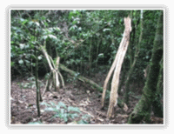
10. | 23rd June 1133hrs | Ruthumbi | JWPT | One (1) Red cedar (Juniperus procera) chopped for use as a fencing post | 37M 0336531, UTM 9990104 | 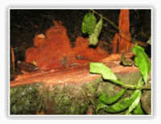
11. | 25th June 1350hrs | Ruthumbi | JWPT | Two (2) Podocarpus spp. trees cut for use as timber | 37M 0343233, UTM 9992046

2.8 Education and awareness initiatives

The Trust’s field coordinator participated in an Environmental Educators’ Workshop organized by the Laikipia Wildlife Forum at Old House Hotel in Nanyuki (19th to 21st). The objective of the workshop was to create a networking platform where institutions involved in environmental education could share experiences and envisage modalities of how to improve in the dissemination of environmental education in the region. A number of organizations directly or indirectly involved with environmental education either at a resource centre or through a mobile unit within Laikipia and the neighbouring regions were at hand to share their experiences. As a way forward, participants agreed to form a network that will spearhead harmonization of environmental education activities in the country. A steering committee comprising representatives from the Laikipia Wildlife Forum, the Giraffe Centre, Langalanga Primary school and Karatina University was selected to drive the initial process. The committee was mandated with the following tasks:

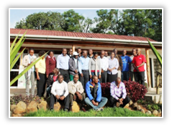
- Develop a draft concept necessary to start the formation of a network of environmental educators in the country
- Ensure the concept captures, gaps in our current education system that the network aims to bridge
- Develop objectives of the network
- Develop mechanisms for the operationalization of the network
- Identify a name for the network
- Stipulate the vision and mission of the network

The goal of the network is to build capacities for environmental education in the country while the immediate objective /task of the network is to produce a common training curricula for the training of trainers in the field of environmental education. The curricular will be designed as a one month course and the Karatina University have indicated willingness to accredit the course. It is expected the course will draw participation from the teaching fraternity and people working in the field of environmental conservation in the region and beyond.

2.9 Tree planting and reforestation
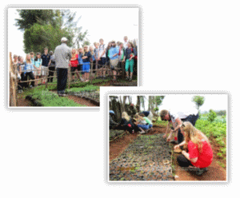
The Trust hosted a group of students on a one day familiarization tour of the women group at the tree nursery site in Ontulili on the 19th. The students’ visit was facilitated by a non governmental entity - Community Health Africa Trust (CHAT) programme. Students had the opportunity to experience firsthand, work undertaken by women group members in raising tree seedlings. The occasion also served as an opportunity for the women group members to get help with the tree nursery work and interact with the students. It was indeed a very exciting time for the group members.

2.10 Visits and meetings

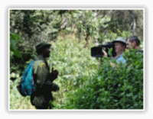
In June, a film crew from Tusk Trust was on Mount Kenya to film the Trust’s Senior Community Wildlife Officer (Edwin Kinyanjui Ngure) who is amongst a group of five nominees shortlisted for one of two awards from Tusk Trust. These awards will be given in recognition of their exemplary commitment to conservation in Africa. The winner of the Tusk Award, which is being supported by Land Rover and Investec amongst other sponsors, will be announced at the awards ceremony in the UK on the 12th of September 2013.

The Marania wildlife guards is a team comprised of Kipruto Kosgey, Julius Mutuma Kalonga, Joseph Gitonga, Paul Kithinji and Jasper Muthuma
The Horse patrol team comprises of Joseph Michubu, Pius Mutuma, Samuel Gikunda Japhet and Martin Murugu Gachienja
JWPT is composed of Edwin Kinyanjui Ngure, Dominic Gitonga, Charles Nyaga, George Mwenda, and Francis Wachira.

