Project Updtae May 2024
Background
Astripomoea hyoscyamoides (Vatke) Verdc, commonly referred to as the Kongwa weed and locally known as “Mahata”, is an invasive plant species posing significant challenges in central Tanzania. The weed causes negative consequences to native species, ecosystems and has negative consequences for pastoralists and agriculturalists. The semi-arid region of central Tanzania has been highly infected by Kongwa weed, which has the tendency of aggressive invasive plants that out-compete the native species. The weed adversely affects food security, biodiversity, and human as well as livestock health, therefore affecting community at large. Little information has been documented about the extent of weed spread, its effects on agricultural and biodiversity and the control mechanisms in the region. Due to this in this study we aimed to address the following objectives.

- Mapping distribution of Astripomoea hyoscyamoides (Vatke) Verdc in in Dodoma region central Tanzania.
- Determination of the impacts of Astripomoea hyoscyamoides (Vatke) Verdc in the biodiversity.
- Assessment of social economic impact of Astripomoea hyoscyamoides (Vatke) Verdc on livelihood of farmers and pastoralists.
- Comparison of the effectiveness of biological and cultural control of Astripomoea hyoscyamoides (Vatke) Verdc.

Activities conducted in the period of March-May 2024.
During the first quarter of the project implementation, we have conducted several activities as tables below;
Objective | Activities | Implementation status |  |  | Comments
Objective | Activities | Not achieved | Partially achieved | Fully achieved | Comments
Mapping distribution of Astripomoea hyoscyamoides (Vatke) Verdc in Dodoma region central Tanzania. | Project inception |  |  | V | Project inception phase has successfully completed, which involved defining the project's scope, revisiting objectives, and stakeholders, and developing a comprehensive project plan. All foundational elements were established, resources allocated, and the project team and stakeholders were aligned and prepared for execution
 | Mapping distribution of Astripomoea hyoscyamoides (Vatke) Verdc in Dodoma region central Tanzania. |  |  | V | Six districts and one town council of the Dodoma Region have been visited, and mapping of the Astropomea conducted. Out of seven seven locations, in six (Kongwa, Mpwapwa, Chamwino, Bahi, Chemba districts and Dodoma town council) Kongwa weed was present but in different intensity, while in Kondoa district there were no invasion of the weed.
 | Preparing Astripomoea hyoscyamoides (Vatke) Verdc distribution map in central Region Tanzania |  | V |  | We have the GPS coordinates of the distribution of the weed in central Tanzania.  Distribution map with infestation intensity will be prepared.
Determination of the impacts of Astripomoea hyoscyamoides (Vatke) Verdc in biodiversity | Site spots for diversity analysis |  |  | V | Two sites have been identified in Kongwa District for diversity analysis. Description of the sites one is highly infected with the weed and adjacent site with minimal or not infected with the weed. Selected sites are Chunyu and Machenje
 | Sampling of diversity data | V
Assessment of social economic impact of Astripomoea hyoscyamoides (Vatke) Verdc on livelihood of farmers and pastoralists | Selection of survey villages |  |  | V | Four villagers were selected for conducting social impact assessment of kongwa weed on the livelihood of farmers and pastoralists. Selected villages Vilundiro and Machenje (Kongwa District) and Kidoka and Kambi ya Nyasa villages (Chemba District).
 | Questionnaire design and pre-testing, correction and adding inputs |  | V |  | Questionnaire Prepared and ready for pre-testing.
 | Assessing social economic impact by conducting interviews, focused group discussion in villages affected by the weed. | V
Comparison of the effectiveness of biological and cultural control of Astripomoea hyoscyamoides (Vatke) Verdc |  | V

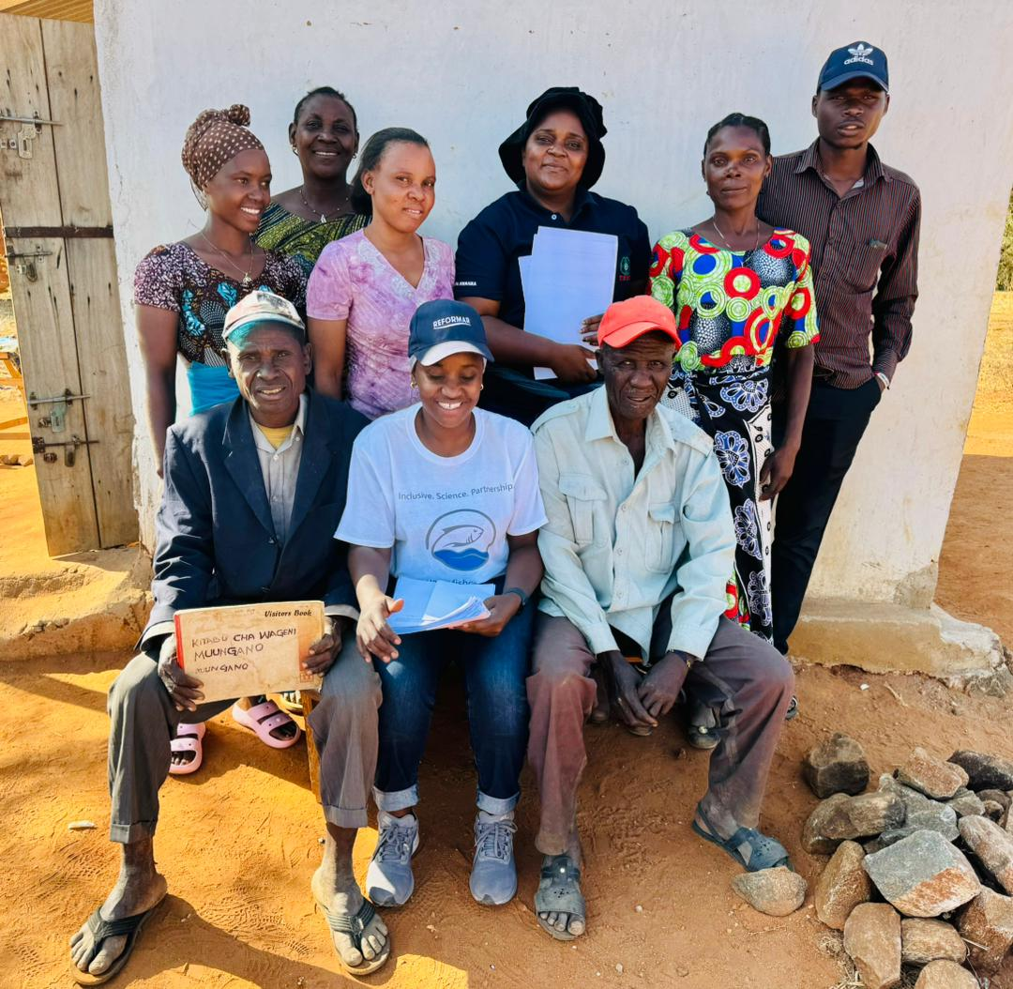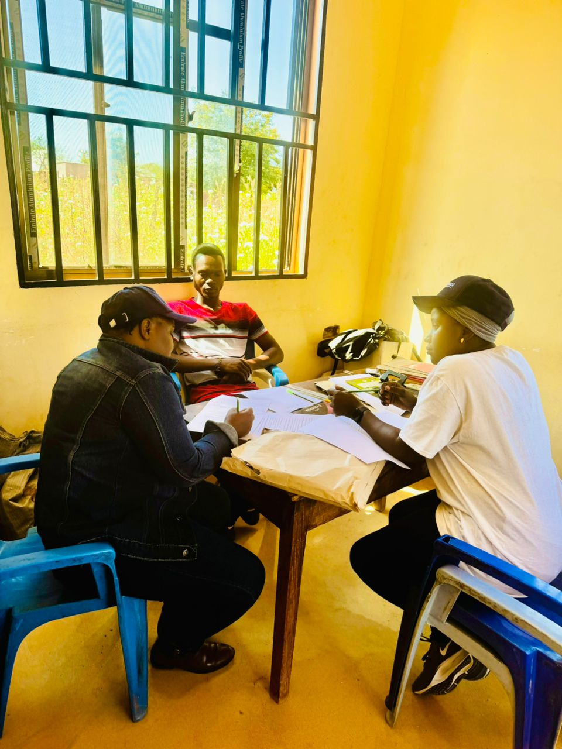
Pic: 1. Project Inception for Villagers and leaders (March 2024)

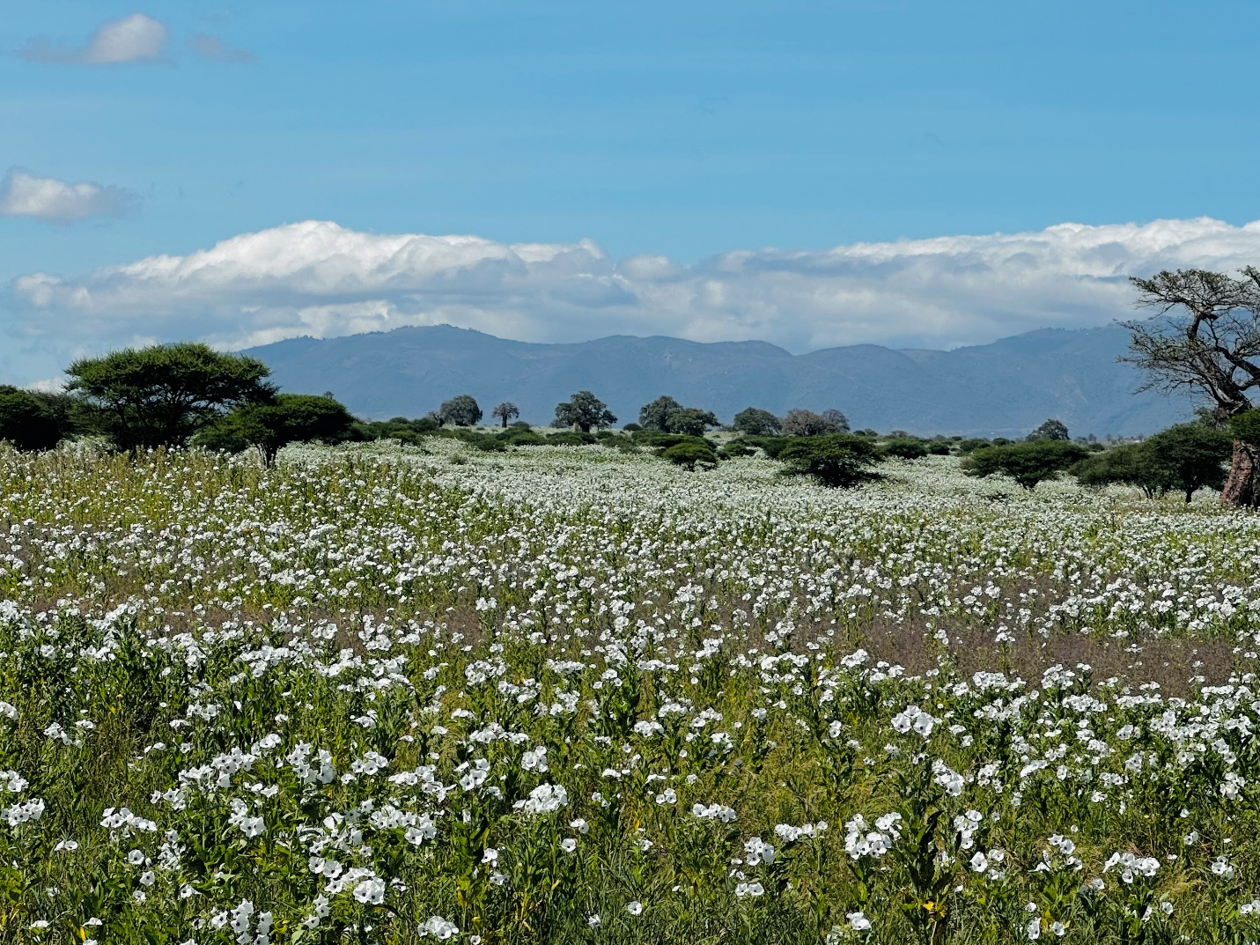
Pic. 2: Kongwa Ranch area affected by Kongwa weed. ( April 2024)

